**MONICOMLAB: COMPUTER LABORATORY REAL-TIME MONITORING AND TROUBLESHOOTING**

**FOR IT HELPDESK**

A Capstone Project

Presented to the

Faculty of College of Computer Studies  
Laguna State Polytechnic University

Siniloan (Host) Campus

# TITLE PAGE

In Partial Fulfillment of the Requirements for the Degree

**BACHELOR OF SCIENCE IN INFORMATION TECHNOLOGY**

By:

**RIALYN MOLE PONCLARA**

**KHARLLE MAE BUCALAN EKLING**

**CHRISLYN PANGUITO SAN JOSE**

ADVISER

**ARCHIEVAL M. JAIN**

**July 2025**

**BACHELOR OF SCIENCE IN INFORMATION TECHNOLOGY**

# VISION, MISSION, QUALITY POLICY, CORE VALUES, COLLEGE GOALS, AND PROGRAM OBJECTIVES

**VISION**

LSPU is a center of technological innovation that promotes interdisciplinary learning, sustainable utilization of resources, collaboration and partnership with the community and stakeholders.

**MISSION**

LSPU, driven by progressive leadership, is a premier institution, providing technology-mediated agriculture, fisheries, and other related and emerging disciplines significantly contributing to the growth and development of the region and nation.

**QUALITY POLICY**

LSPU delivers quality education through responsive instruction, distinctive research, sustainable extension and production service. Thus, we are committed with continual improvement to meet applicable requirements to provide quality, efficient and effective services to the university stakeholder's highest level of satisfaction through an excellent management system imbued with utmost integrity, professionalism and innovation.

**CORE VALUES**

LSPU Develops:

**S**pirited **T**ransparent **U**pright **D**isciplined **E**fficient **N**oble **T**rustworthy **S**killful

**COLLEGE OF COMPUTER STUDIES GOALS**

The College of Computer Studies aims to develop globally competitive graduates equipped with knowledge, skills and values necessary for Information Technology Education programs in undertaking instruction, research, extension and production.

**THE OBJECTIVES OF THE PROGRAM (BSIT)**

The Bachelor of Science in Information Technology graduates are professionals that can adapt with the fast-paced computing trends responsive to global IT demands.

It is designed to enable students to achieve the following by the time they graduate:

1. Apply knowledge for solving computing problems employing design and development solutions for business-driven application, installation, processes, operation, maintenance and administration of IT hardware and software.
2. Utilize modern computing tools and techniques in research and development projects.
3. Communicate effectively as a member or leader of the computing society with social, moral and legal responsibilities to accomplish a common goal.
4. Engage in life-long learning as foundation for continuing professional advancement.

# APPROVAL SHEET

The capstone project entitled **“COMPUTER LABORATORY REAL-TIME MONITORING AND TROUBLESHOOTING FOR IT HELPDESK,”** prepared and submitted by **RIALYN M. PONCLARA**, **KHARLLE MAE B. EKLING, CHRISLYN P. SAN JOSE** in partial fulfillment of the requirements for the degree of **BACELOR OF SCIENCE IN INFORMATION TECHNOLOGY**, major in **NETWORK ADMINISTRATION**, is hereby recommended for approval and acceptance.

|  |  |  |
| --- | --- | --- |
|  |  | **ARCHIEVAL M. JAIN, DIT** |
|  |  | Capstone Adviser |

================================================================

Approved by the Committee on Oral Examination with a grade of ___________.

|  |  |  |  |  |
| --- | --- | --- | --- | --- |
| **MERVIN JOMMEL T. DE JESUS** | |  | **GLAIZESS P. SALISI** | |
| Subject Specialist | |  | Technical Editor | |
| **DR. AIMEE CONCEPTION C. CHAVEZ** | |  | **AIRA M. DE JESUS** | |
| Statistician | |  | Language Critic | |
|  | **ZERAH-JANE M. ASTOVEZA** | | |  |
| Research Coordinator | | | | |

================================================================

Accepted and approved in partial fulfillment of the requirements for the degree of **BACHELOR OF SCIENCE IN INFORMATION TECHNOLOGY**, Major in **NETWORK ADMINISTRATION.**

**FRANCIS F. BALAHADIA, DIT**

Dean

|  |  |  |
| --- | --- | --- |
| **MA. CECILIA C. GATBONTON** |  |  |
| Chairperson, Research and Development |  | Date Signed |

|  |  |
| --- | --- |
| **RESEARCH CONTRIBUTION NO.** |  |

# DEDICATION

*This study is wholeheartedly dedicated to myself and my co member, for the perseverance, patience, and determination I have shown in completing this research. Despite the challenges and difficulties, I continued to strive and remain committed to finishing this work.*

*To my friends, who have given me encouragement, strength and constant support throughout the journey. Their presence served as a reminder that every hardship can be overcome with true companionship.*

*To our instructors, who have patiently guided and shared their knowledge with us. Their dedication and commitment to teaching inspired me to push forward and accomplish this study with purpose.*

*To my parents, who have been my greatest source of motivation. Their endless support, sacrifices, and unconditional love have given me the strength to achieve this*

*And above all, this work is dedicated to Almighty God, who has been my greatest source of wisdom, strength, and guidance. Without His blessings, none of this would have been possibles thank you for your grace.*

*From the bottom of our hearts, thank you.*

# ACKNOWLEDGMENT

The researchers would like to take this opportunity to thank everyone who helped them along the journey and contributed to fulfilling the requirements for the capstone project. The researchers appreciate all the suggestions and comments they received while doing this project. First to God for His continuous blessings and for allowing the researchers to conduct this study.

**Mr.** **Archieval M. Jain**, Adviser, for his assistance and advice and for providing insightful ideas.

**Mr. Mervin Jommel T. De Jesus**, Subject Specialist, for his valuable assistance in the data analysis process, ensuring the accuracy and reliability of the statistical results used in the study.

**Ms. Aimee Conception C. Chavez**, Statistician, for her valuable assistance in the data analysis process, ensuring the accuracy and reliability of the statistical results used in the study.

**Ms. Glaizess P. Salisi**, Technical Editor, for her meticulous review of the technical components of the documentation, ensuring that the structure and formatting adhered to academic standards.

**Ms.** **Aira M. De Jesus**, Language Critic, for her critical eye and helpful feedback that improved the clarity, grammar, and coherence of the manuscript.

**Ms. Zerah-Jane M. Astoveza**, Capstone Project Instructor/Research Coordinator, for the lesson she gave, her ideas after reviewing the study, her remarks, and encouraging the researcher to carry out this research.

**Mr. Sid Menguito Rosin** Assist in testing the system functionality in Laboratory.

Mr. Charles Alfred A. Cruz our Client for this Research, for being patient during the development of the system.

To all the panelists who showcase excellent talents and skills in their profession, as seen in the important guidance, corrections and suggestions they gave to guide the team to a better result of this research.

**THE AUTHOR/S**

# ABSTRACT

**Ponclara, Rialyn M.**, **E kling, Kharlle Mae B., San Jose, Chrislyn P. of Bachelor of Science in Information Technology, Laguna State Polytechnic University, 2025, MONICOMLAB: Computer Laboratory Real-Time Monitoring and Troubleshooting for IT Helpdesk, Co-Author: Mr. Archieval M. Jain.**

MONICOMLAB: A Computer Laboratory Real-Time Monitoring and Troubleshooting System for IT Helpdesk was developed to improve the management of computer laboratory devices and ensure efficient IT support. The system integrates monitoring and troubleshooting features to automatically detect issues in PCs, servers, routers, and switches. Once problems such as software, hardware errors, or network interruptions are identified, they are recorded in the log’s module, generating tickets with details such as device name, issue type, severity and status. This enables IT staff to efficiently track incidents, prioritize urgent cases and resolve them in a timely manner. The system also provides troubleshooting suggestions for common issues, assisting technicians in faster resolution and reducing downtime. A centralized dashboard displays real-time device status and logs, allowing administrators to maintain awareness of laboratory conditions. This promotes accountability and ensures that reported problems are properly documented and addressed. The study employed an experimental-developmental approach, with testing conducted at the Laguna State Polytechnic University College of Computer Studies. Results showed that the system improved issue detection, minimized manual monitoring and enhanced helpdesk response. Findings suggest that MONICOMLAB strengthens laboratory management, improves service reliability, and increases productivity.

# TABLE OF CONTENTS

**Page No.**

TITLE PAGE i

VISION, MISSION, QUALITY POLICY, CORE VALUES, COLLEGE GOALS, AND PROGRAM OBJECTIVES ii

APPROVAL SHEET iv

DEDICATION v

ACKNOWLEDGMENT vi

ABSTRACT viii

TABLE OF CONTENTS ix

LIST OF TABLES xi

LIST OF FIGURES xii

LIST OF APPENDICES xiii

DEFINITION OF TERMS xiv

Operational Terms xiv

Technical Terms xiv

CHAPTER I INTRODUCTION 1

Project Context 1

Research Objectives 3

Conceptual Framework 5

Project Purpose 9

Scope and Limitation of the Study 10

CHAPTER II REVIEW OF RELATED LITERATURE 14

Studies and Literature **Error! Bookmark not defined.**

Related System 14

Synthesis 28

CHAPTER III METHODOLOGY 29

Research Design 29

Population of the Study 29

Sampling Design 30

Data Collection Instrument 31

Statistical Treatment 33

Project Design 33

CHAPTER IV RESULTS AND DISCUSSION 45

CHAPTER V SUMMARY, CONCLUSIONS AND RECOMMENDATIONS 64

Summary 64

Conclusions 64

Recommendation 65

REFERENCES 67

APPENDICES 72

# LIST OF TABLES

|  |  |  |
| --- | --- | --- |
| **Table No.** | **Title** | **Page No.** |
|  | Comparisons of Related System | 28 |
|  | Sampling design | 29 |
|  | Likert Scale of ISO 25010 | 31 |
|  | Likert Scale Measurement for the TAM | 32 |
|  | Statistical Treatment Table | 33 |
|  | Software used and its functions | 36 |
|  |  |  |

# LIST OF FIGURES

|  |  |  |
| --- | --- | --- |
| **Figure No.** | **Title** | **Page No.** |
|  | Conceptual Frameworks of the study | 8 |
|  | Agile Methodology Model | 34 |
|  | Software flow | 36 |

# LIST OF APPENDICES

|  |  |  |
| --- | --- | --- |
| **Appedix Letter** | **Title** | **Page No.** |
| A | Technical Background |  |
|  | * Planning & Requirement Analysis Phase |  |
|  | * Specification & Design Phase |  |
|  | * Project Schedule |  |
|  | * Hardware and Software Resources |  |
|  | * Input/Output/Reports Screen Shots |  |
|  | * Testing & Evaluation Instruments |  |
|  | * Implementation Plan |  |
|  | * User’s Manual |  |
| B | Communication Letters & Forms |  |
|  | * Request Letter |  |
|  | * Pre-proposal Approval |  |
|  | * Proposal Approval |  |
|  | * Recommendation for Final Oral Defense |  |
| C | 5 pager IMRAD Format |  |
| D | Plagiarism Results |  |
| E | Conference Presentation Narrative Report |  |
| F | Curriculum Vitae |  |

# DEFINITION OF TERMS

## Operational Terms

**Router.** To direct and manage data traffic between different networks, providing internet connectivity to multiple devices.

**Switch.** To connect multiple devices within a local area network and efficiently forward data to the correct destination of device.

**Server.** To store, process and manage data or services, providing resources to client devices on a network.

**Laptop.** To serve as a portable personal computer for mobile computing, communication, and productivity.

**Desktop.** To function as a stationary personal computer for work, entertainment, or data processing tasks.

**PC.** To provide general computing capabilities for personal or office use, running applications and connecting to networks.

## Technical Terms

**Internet.** A global network of interconnected computers and devices that enables the exchange of data, communication, and access to online resources and services.

**Wireless.** A method of transmitting data or communication signals without using physical cables, typically using radio waves, such as Wi-Fi or mobile hotspots.

**CHAPTER I**

# INTRODUCTION

Issues have emerged in computer networking, especially when it comes to handling real-time processes and maintaining network security. Many systems still rely on manual checks and outdated methods, which often lead to delays in detecting errors and make it harder to maintain stable performance (Somarapalli et al., 2024). As networks grow and data traffic continues to rise, these weaknesses become even more obvious, leading to slower performance, unsolved problems and lower efficiency. The rise in cyberattacks shows that current tools are not enough to detect new and more advanced threats. There is a clear need for better monitoring and intrusion detection systems that can provide reliable and secure computer networks. Diana et al., (2025).

Additionally, many companies still struggle to provide an efficient helpdesk system for their employees. Poor service quality often leads to delay, miscommunication and lower productivity (Fadilah et al., 2023). Real-time monitoring of network traffic is also a challenge, as traditional methods cannot detect problems quickly and accurately. This often results in downtime, unstable performance and difficulties in handling large amounts of data (Ukon et al., 2021). The lack of effective solutions in both helpdesk services and network monitoring continues to create problems for IT management in organizations

Moreover, in organizations, especially in schools and government offices, real-time monitoring of network devices has become essential to ensure continuous operations and quality services. Delay in detecting and resolving network issues often lead to reduced productivity, disrupted workflows and poor user experiences. Safrianti et al. (2021) highlighted that SNMP-based network monitoring systems enable IT teams to quickly identify device problems, resulting in faster responses and improved network performance. Batitis et al. (2019) demonstrated that integrating SMS notifications into monitoring systems, particularly those using technology, enhances communication by ensuring that responsible personnel receive important alerts immediately. Despite these advancements, some institutions still rely on manual reporting and troubleshooting methods, which often cause delays and reduce the efficiency of IT operations.

Consequently, the lack of an automated network monitoring and notification system remains a significant challenge for IT support teams. Kurnaedi et al., (2022) emphasized that manual helpdesk ticketing processes make it difficult to track reported issues, monitor their progress and resolve them quickly. In many cases, miscommunication between users and IT staff further contributes to unresolved or repeated problems, resulting in extended downtimes. These challenges highlight the need for a web-based monitoring and automated alert system that provides real-time device status, improves teamwork between users and IT staff and minimizes service interruptions. The proposed system aims to integrate real-time monitoring with automated notifications to assist IT teams in addressing issues promptly, improving efficiency, and delivering better IT services.

So, in managing their ICT network resources because of disconnected systems and manual processes. Without a centralized platform, IT teams often experience delays, confusion, and slower response times in resolving technical issues. Belvis et al. (2024) explained that using separate systems causes repeated tasks and makes it difficult to properly monitor the network. IT staff are also required to work with multiple tools, which slows down troubleshooting and increases the chances of errors. Serrano (2023) stated that the lack of standardized procedures and proper documentation often results in repeated problems and incorrect system configurations. These limitations lead to longer downtimes and lower productivity within organizations. Therefore, a centralized monitoring and helpdesk system is needed to improve efficiency, minimize errors, and enhance IT support services.

However, real-time tracking and accessible helpdesk services at the College of Information and Communication Technology (CICT) of the Nueva Ecija University of Science and Technology (NEUST) has negatively affected operations, especially in monitoring on-the-job training (OJT) activities. This problem led to the creation of an interactive monitoring and helpdesk system with SMS notifications to improve communication and management. due to limited access to support and ineffective tracking of reported problems. To address these problems, there is a need for a centralized and automated monitoring platform that provides real-time updates, improves coordination and ensures faster resolution of technical concerns. Oliveros (2022).

**Project Context**

Real-time system monitoring and effective IT support are essential to maintaining uninterrupted learning and administrative operations. Real-time monitoring systems help to minimize downtime and quickly and effectively resolve technical issues. In this regard, network and device monitoring systems are being used in schools to monitor the health status and performance of computers and connected devices such as servers, switches and routers (Belvis et al., 2024).

However, Using technologies Simple Network Management Protocol (SNMP), Domingo et al., (2021). institutions can monitor traffic detect anomalies and manage resources with minimal human intervention (Alhilali, 2023). These systems help improve network stability and ensure uninterrupted access to digital services. Furthermore, the use of centralized and automated helpdesk systems allows for faster issue reporting and resolution through support ticket management, which improves service quality (Oliveros, 2022).

In the Philippines public schools and universities in developing areas still rely on outdated, manually operated systems. In such cases, network downtimes, slow IT responses, and inefficient troubleshooting reduce productivity and negatively impact to the users. A study by Abbas et al. (2018). emphasized the importance of efficient scheduling of monitoring tools and automated detection of issues to enhance system reliability.

At Laguna State Polytechnic University Siniloan Campus, particularly in the college of computer studies, there is currently no real-time monitoring system for devices and networks. This results in issues software and hardware issues which connected devices are going undetected until they disrupt classes or administrative tasks. Network related problems often remain unnoticed for extended periods, leading to delay and interruptions in both academic and office operations. The centralized reporting and logging make it difficult for IT staff to track issues or identify root causes, resulting in ongoing troubleshooting and wasted time. There has no automated alert to inform the admin or technicians when a problem is found, causing longer downtimes and slower responses. Even minor issues require manual intervention, consuming valuable IT resources that could otherwise be used for more complex tasks. This inefficiency negatively impacts to students and faculty, leading to disrupted classes, delayed submissions, missed online sessions and decreased overall productivity.

To address this concern, this project develop MONICOMLAB: A Computer Laboratory Real-Time Monitoring and Troubleshooting for IT helpdesk. The system include functionality including Device monitoring, Troubleshooting, logs, alerts, support ticketing system, tracking hardware status, automated issue detection and fix remotely. When the system encounters a software or hardware issue such as with the keyboard, mouse or other peripherals. it will send an alert to the admin along with suggestions for manual resolution. The system can also send an email notification to the assigned technician, specifying the room or pc where the problem occurred. This ensures a faster response and more accurate troubleshooting by the IT staff. The system also has an automatic troubleshooting feature fix remotely, but it can only resolve basic problems.

The system will use tools such as SNMP to communicate with devices and web-based dashboards to visualize real-time performance. This project provides a modern approach to the IT helpdesk, while minimizing the service interruption to improve support of the computer laboratory for students and faculty when executing their academic responsibilities.

**Research Objectives**

This study aimed to develop a system MONICOMLAB: Computer Laboratory Real-time Monitoring and troubleshooting for IT Helpdesk with a web-based platform.

Specifically, MONICOMLAB system aims to achieve the following objectives:

1. To develop a centralized interface that allows administration to access and manage the core functionalities of the system with the following features:

1.1 Dashboard to view CPU usage, RAM usage and Data analytics

1.2 Device Monitoring

1.3 Troubleshooting

1.4 Logs

1.5 Alerts

2. To develop an automated alert system that notifies the admin if any issue is detected and provides suggested solutions to address the issue.

3. To measure the reliability of the developed system.

4. Determine the software quality using ISO 25010.

**Conceptual Framework**

The system MONICOMLAB: Computer Laboratory Real-Time Monitoring and Troubleshoot for IT Helpdesk will be developed to monitor devices and networks inside the computer laboratory. The process starts with the admin login using email and password, which connects to the database that stores user accounts, device details, logs and alerts. Once logged in, the admin is directed to the Dashboard where they can view CPU and RAM usage, recent alerts, recent logs, and notifications. From the dashboard, Admin can access the main modules of the system including Device Monitoring, Troubleshooting, Logs and Alerts.

In addition, the Device Monitoring shows the list of rooms and devices with their corresponding status such as CPU usage, RAM usage, disk activity, and running applications. Admins can create rooms, add devices, and start monitoring data. If the issue is detected like a disconnected device, abnormal activity or high resource usage the system generates an alert containing the device name, IP address, room, issue status, and suggested actions. Alerts are categorized as connected devices, disconnected devices, online issues, and offline issues. The system also provides actions to mark issues as resolved/unresolved, suggestion to fix the issue, delete, or perform a remote fix for common issues.

Furthermore, Troubleshooting allows the submission and management of tickets for unresolved problems. Each ticket contains details such as device, issue type, category, severity, status, description and email status. Tickets are tracked as pending, unresolved, or resolved, and are stored in the troubleshooting log. Meanwhile, the Logs module records all system activities including detected issues, tickets and resolutions, which can be viewed daily, weekly or monthly for download report. The Alerts module provides real-time notifications on the dashboard and through email to ensure that admins and technicians are immediately informed of any device or network issues.

Through this framework, MONICOMLAB will integrate device monitoring, troubleshooting, logging, and alerting into one centralized platform. This setup will allow admin and technicians to respond quickly to issues, reduce downtime and ensure that the computer laboratory will remain functional for both students and faculty.

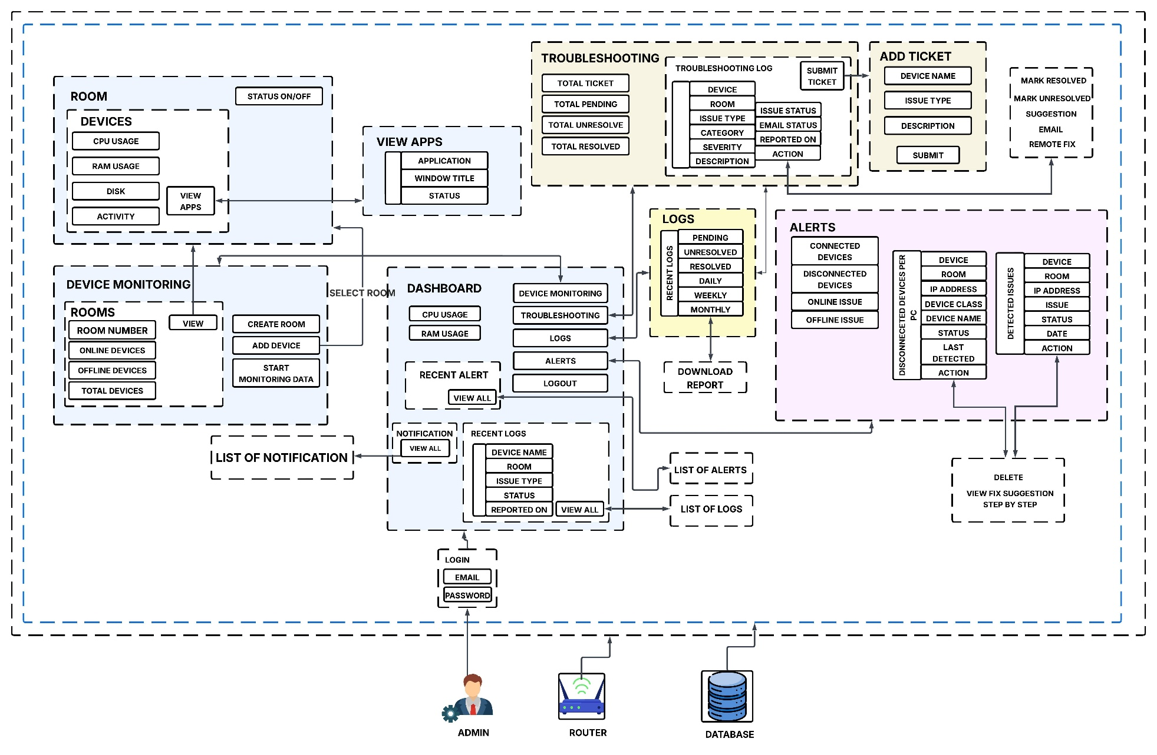

***Figure 1.*** *Conceptual Framework of the study.*

## Project Purpose

By developing a Computer Laboratory Real-Time Monitoring and Troubleshooting for IT Helpdesk for Connected devices in computer lab. This system may help to monitor real-time to minimize manual intervention and meet the suggested growth requirements for monitoring. Also, the following individuals and organizations will benefit in developing this project.

**IT Department Network Administrator.** They may benefit greatly from the use of this system as it provides a centralized interface to monitor and troubleshoot multiple laboratory devices in real-time, thereby improving system uptime and support efficiency.

**Head of the ICT Department.** manage both the system and the staff. provides the admin with a **dashboard view of the entire laboratory's performance**, helping them monitor, tracking the problems and make better decisions regarding maintenance, upgrades or man power deployment. them will be able to send an email notification using the system to the assigned technician, specifying the exact room and PC where the issue occurred, allowing faster response and accurate troubleshooting.

**Technician.** They may assist technicians by providing real-time alerts, allowing them to quickly locate and fix problems in the computer laboratory without needing to check each unit manually.

**Faculty.** The members may use the laboratory during their computer-related classes. by providing reliable access to computer laboratory resources needed for teaching and academic-related tasks. It helps instructors monitor laboratory usage, manage class activities, and ensure that students can effectively utilize the computers during learning sessions.

**Student.** by ensuring continuous access to computer laboratory resources for their academic activities, such as programming, research and system-based tasks. It aims to provide a stable and efficient environment where students can perform their work without interruptions caused by technical issues.

**Future Researcher.** This study may serve as a guide for future projects that want to improve monitoring, problem detection and IT support in schools.

## Scope and Limitation of the Study

This study intended focuses on developing computer laboratory real-time monitoring and troubleshooting using remote fix for basic common problem or manually. The system focus will be on connected devices such as routers, switches, server and PCs. The system has also need to set up or install the script to another PC and configuration both server and pc before add this to the device monitoring and also the system is for one is to one connection on network. The system will check whether these devices are functioning according to specifications whether they are online, offline or experiencing connection issues. It will also monitor user activity with connected devices. When the system encounters a software, hardware, network issue such as disconnected keyboard, mouse or other peripherals, will display to alert and once return it connected it will automatically remove, the system will send an alert to the admin along with step by step suggested solutions to fix. Also has an automatic troubleshooting feature such as remote fix to control or stop the running application, but it can only resolve some basic problems. Also, staff can notify the issue to technician using email to know what are the problem of devices and where the location to solve the issue and after to resolve the issue it can email staff to inform the problem is already resolved, Admin or staff allow for categorization of status as pending, unresolved or resolved.

However, the system will have certain limitations. It will not be able to recognize problems occurring outside of the local network, such as issues caused by the internet service provider or external web services and the system will not be able to detect if a computer has been moved from one room to another, and it also cannot know if the computer’s IP address has changed. Although the system can provide troubleshooting suggestions, it will not perform automatic fixes for complex problems. In terms of hardware, the system will only be able to detect certain issues. It will not be capable of identifying all types of hardware issue for like, physical damage or broken cables, and defective components cannot be detected it can only detect weather remove it from connection. The system is limited to monitoring and identifying software-related issues, while more complex or physical problems will still require manual check and repair by Technician. Despite these limitations, the system remains a valuable tool for IT helpdesk operations, as it simplifies device monitoring and enables faster responses to common problems within the laboratory. And for more advanced issues, it provides a Remote fix option that allows administrators or technicians to resolve the problem remotely.

**CHAPTER II**

# REVIEW OF RELATED LITERATURE

This section discusses the features, capabilities, and limitations of existing researches, IT concepts. Theoretical Framework and software applications that is relevant and closely related/similar to the proposed topic. The researchers can present their review of the literatures either in the chronological order or thematic order.

**Studies and Literature**

*Device Monitoring*

Device and network monitoring is important role in maintaining the stability, security and performance of modern IT infrastructures. Abbas et al., (2018) emphasized the importance of scheduling limited resources monitoring devices for fast issue detection and network control, highlighting the need for practical methods for handling large networks smoothly. Similarly, Alhilali (2023) designed and implemented a real-time network traffic management system using the SNMP protocol, enabling administrators to monitor bandwidth utilization and detect problem quickly. In addition, Alkenani et al., (2022) investigated network monitoring measurements for improving Quality of Service (QoS), highlighting the importance of data for better IT decisions.

In addition, advanced technologies to enhance real-time monitoring and traffic analysis. Mistry et al., (2016) discuss a method for measuring and analyzing network traffic to identify usage patterns and detect potential issues quickly. Haxhibeqiri et al., (2021) proposed an in-band network monitoring technique to support SDN-based wireless networks, which significantly improved of checking data and speeding up transfers. Khan et al., (2018) developed an automated monitoring and reporting system, enabling IT admin to receive timely insights on network performance and reduce manual intervention in network troubleshooting.

Moreover, Real-time monitoring system are becoming more important as enterprise networks become more complex. Safrianti et al., (2021) implemented a network device monitoring system using the SNMP model, which allowed IT teams to visualize device status and receive instant alerts on connectivity issues. Ukon et al., (2021) presented a virtual-network-traffic monitoring system powered by an FPGA accelerator, showing better performance in managing large amounts of data. Wang et al., (2018) discuss FlexMonitor, a flexible SDN-based monitoring framework that adapts to different network architectures, enhancing system growth and detect better.

Lastly, integrating monitoring system with security focused on frameworks. Ogogo (2021) highlighted how real-time monitoring enhances network security by quick detecting of issues and responding to unauthorized access attempts. Azmi et al., (2021) proposed a SIEM-based network behavior monitoring framework using deep learning, which significantly enhanced issue detection within the campus system. Likewise, Rey (2023) designed a centralized SDN-based network management architecture for an academic institution, demonstrating that consolidating monitoring, control and automation improve operational efficiency and reduces downtime.

*Alert System*

Alert system monitoring becomes important for maintaining safety, sustainability and efficient resource management in various environments. Ali et al., (2022) developed a real-time smart monitoring system designed to increase laboratory safety awareness in educational institutions by providing instant alerts and safety steps. Similarly, Ebron et al., (2024) integrated the Internet of Things and Artificial Intelligence to monitor water quality in Laguna Lake, offering real-time data on temperature, pH levels and cloudiness to support environmental protection. Rapada et al., (2021) also implemented an Internet of Everything (IoE)-based water detection system to monitor the Langkiwa River, which improves response times during environmental hazards such as flooding or pollution. These studies highlight how IoT-based solutions enhance data collection and promote automated decision-making in environmental management. By using real-time data analytics, these systems help reduce environmental risks and improve public awareness of potential hazards. Collectively, these technologies provide educational institutions and local communities with effective tools for maintaining safety and sustainability*.*

In addition, monitoring environmental conditions, IoT-based systems are also being utilized to enhance security and emergency response. Rabia et al., (2024) proposed an intelligent environmental monitoring and alert system using IoT technology, enabling automatic identification of unusual conditions and sending real-time notifications to relevant authorities. Similarly, Omede et al., (2024) developed IMANOBAS, a multi-mode IoT-based alert notification system designed to prevent security gaps and combining environmental sensors with emergency defense mechanisms. These systems demonstrate how real-time monitoring, integrated with smart notifications, strengthens both safety and security measures. By combining IoT, automation and data-driven insights, they improve response times to environmental and security threats. Moreover, these studies emphasize the importance of centralized monitoring frameworks to ensure effective managing actions during urgent situations. IoT-powered solutions are become important in managing environmental challenges and securing IT infrastructure. These improvements keep changing how environmental system are managed in schools, homes and industries.

*Ticketing Systems*

Ticketing system are important in making better IT helpdesk operations by improving issue reporting and tracking. Kurnaedi et al., (2022) developed a web-based IT helpdesk ticketing system that allowed employees to report technical issues efficiently and receive quickly updates on their status. Fadilah et al., (2023) analyzed employee satisfaction with helpdesk websites and found that integrating a structured ticketing process significantly improved user experience and response times. Similarly, Masongsong and Damian (2016) proposed a Helpdesk Management System that optimized workflow by automating ticket creation, prioritization and escalation. These studies emphasize that automated ticketing improves communication between IT support teams and end-users, ensuring faster issue resolution. Real-time tracking also allows IT administrators to monitor the progress of reported problems, reducing delays and operational problem. Overall, these systems provide structured workflows that enhance IT service quality and support organizational productivity.

In addition, improving issue reporting in modern ticketing system that integrate advanced technologies to enhance speed and ease of use. Oliveros (2022) designed and developed an interactive On-the-Job Training Monitoring and Help Desk System with SMS notifications, allowing students and faculty to receive updates about their requests instantly. Similarly, Serrano (2023) created an IT helpdesk playbook for ABC Philippines, providing standardized troubleshooting guides and automated processes for configuring applications and resolving software or hardware errors. These studies highlight the growing importance of combining ticketing systems with intelligent notification features and Information based tools. Integrating real-time alerts and documentation makes it easier to fix common problems quickly and supports decision-making in IT operations. Moreover, the combination of ticketing and monitoring improves collaboration between support teams and stakeholders. By automating repeat tasks, IT teams can focus more on important technical problems. Modern helpdesk ticketing systems significantly enhance IT operations and user satisfaction.

*Real-Time Incident Response*

Real-Time Incident Responseis more important as organizations face growing to their network infrastructures. Diana et al., (2025) provided an overview of Intrusion Detection Systems and highlighted their role in identifying unauthorized activities and potential attacks in computer networks. Similarly, Ceronmani et al., (2024) proposed an advanced cybersecurity helpdesk framework that integrates machine learning techniques to enhance problem detection and automate responses. Sallay et al., (2015) also discussed intrusion detection alert management for high-speed networks, emphasizing their needs for effective monitoring tools to process and analyze large volumes of security data. These studies demonstrate that integrating IDS with automated frameworks enhance network security by minimizing response delays and reducing risks. Real-time monitoring and data analytics enable IT teams to detect potential problems quickly. Overall, a head of the problem cybersecurity measures is essential to maintaining system integrity and protecting sensitive information from emerging threats.

In addition, automation and advanced security architecture designs. Yuhong et al., (2024) introduced a secure network architecture for smart campuses in the Philippines, which integrates access controls, encrypted communications and centralized monitoring to secure institutional information. Similarly, Kämppi et al., (2024) explored automated solutions for mobile network security operations, presenting methods to make it easier to detect issues and react quickly. These studies highlight the growing need for intelligent security frameworks that adapt to dynamic network environments. By using automation, IT teams can reduce human error while improving efficiency in managing cyber incidents. Furthermore, the adoption of AI-powered security system enhances real-time decision-making for identifying and fixing problems. Integrating these technologies not only to improves protection but also ensures compliance with modern security standards. Organizations can keep their IT systems safe and stronger against growing cyber threats.

*Troubleshooting*

Troubleshooting in computer networks are important role in ensuring the stability and reliability of IT infrastructures. Aldea et al., (2023) developed an integrated system architecture for real-time monitoring and management of hardware and software resources in different computer networks, which helps find problems quickly and keep system running. Similarly, Rozaki (2019) designed and implemented an automated network troubleshooting system using data mining techniques, allowing IT teams to identify repeating problems and generate quick solutions. These studies highlight the importance of integrating automated troubleshooting processes into network monitoring system to reduce manual actions. By using automating for issue detection, organizations can improve operational efficiency and optimize resource application. Furthermore, real-time data analytics enable administrators to quick resolve potential problems before they increase. Overall, these approaches ensure better network stability and enhance overall IT helpdesk support services.

In addition, automation and virtualization enhance troubleshooting efficiency in complex environments. Gravano et al., (2021) proposed a remote quality control and instrument troubleshooting solution designed for shared laboratory environments, enabling IT support teams to manage devices even during limited access on site. Cinque et al., (2023) evaluated the use of virtualization in fog monitoring systems to manage real-time applications within different levels of importance in environments, ensuring quick error detection and recovery. These studies demonstrate how advanced technologies simplify the troubleshooting process by enabling remote management and reducing downtime. By integrating virtualized environments, IT teams It can test problems and solutions without affecting the actual system. Additionally, automation improves response times and supports the deployment of fixing measures with minimal manual effort. Combining virtualization and automation can creates a more reliable and enhance troubleshooting framework. These advancements create the way for better IT helpdesk operations and better network maintenance strategies.

*Automated Lab Monitoring*

Automated lab monitoring focusing on integrating advanced technologies to improve resource management and academic operations. Belvis et al., (2024) proposed a centralized ICT network management framework that enhances connectivity, method processes, and optimizes the use of institutional resources. Loyola et al., (2019) developed an internet-based electric meter system with issue detection and energy consumption monitoring, enabling real-time insights to improve security and efficiency. These studies highlight the role of IoT-based solutions in creating sustainable and automated educational environments. By adopting smart technologies, institutions can improve operational efficiency and support better decision-making.

In addition, Recent innovations also focus on providing remote access and learning tools using technology for campuses. Domski (2022) discus a remote laboratory framework provided as a hardware service platform, allowing students and researchers to access laboratory resources via the internet. Similarly, Kadham et al., (2025) proposed an IoT-based remote monitoring system for online laboratories, enabling real-time trial and practical learning from distant locations. These studies demonstrate how IoT and cloud-based technologies enhance accessibility and flexibility in education. By integrating remote monitoring systems, academic institutions can provide more adaptive and collaborative learning environments. These developments support digital transformation and improve learning experiences for students.

*Remote Monitoring*

Remote monitoring system are important for maintaining real-time awareness and control over networks, devices and operational environments. Anuar et al., (2024) developed a forest fire detection, monitoring and alert system that uses IoT-based sensors to provide early warnings and enhance disaster response. Domingo et al., (2021) proposed a remote monitoring and security system for local area networks, which improves network performance tracking and detects risks of unauthorized access in real time. Smart lab management system that monitors number of people and laboratory activities using edge computing and deep learning techniques to optimize resource allocation. Santhi et al., (2025) These studies demonstrate that IoT-based monitoring enables efficient automation and enhances decision-making by giving useful information from data. With real-time alerts and automated responses, institutions can reduce operational risks and downtime significantly. Overall, remote monitoring ensures higher security, better efficiency and improved resource management in modern environments.

In addition, IoT, mobile technologies and automation integrate to enhance monitoring system and emergency response capabilities. Nuruzzaman et al., (2025) conducted a review of IoT-enabled condition monitoring in power distribution system, which incorporates SCADA-based automation and real-time analytics to achieve better energy management. Nuevas et al., (2024) developed a mobile GPS-based incident reporting and emergency response system for Abuyog, Leyte, enabling faster communication and coordination during disaster situations. Similarly, Shaffi et al., (2025) discus an intelligent incident reporting and monitoring framework that combines real-time data processing with secure decision-support systems. These innovations show how IoT-driven solutions improve response times and enhance system reliability. With mobile accessibility, stakeholders can remotely monitor and manage resources anytime and anywhere.

*AI-Driven Monitoring and Troubleshooting*

Technological innovations improved the speed and management of schools and IT systems. Adekunle et al., (2024) developed a web-based laboratory management system that improves resource tracking and ensures effective allocation of laboratory equipment. Alamsyah et al., (2025) discus knowledge management strategies to optimize helpdesk operations, enhancing service quality and quick response times. Somarapalli et al., (2024) implemented automated software process discovery with real-time monitoring to streamline IT workflows. These studies demonstrate that adopting digital tools and automated processes can improve operational efficiency and decision-making. Overall, the integration of innovative technologies allows institutions to manage resources and services more effectively.

In addition, Automation and IoT-based solutions also transformed how industries and communities monitor systems and respond to important events. Alzubi et al., (2023) applied automated monitoring technologies in construction projects to enhance productivity and improve project management. Sharma et al., (2021) developed a disaster management framework using IoT-connected devices, enabling real-time monitoring and early response. Batitis et al., (2019) implemented SMS notifications via IoT to improve community alert systems in Barangay Labas, Laguna. highlight the role of automation and IoT in ensuring timely data collection and useful information. By integrating these innovations, organizations can enhance operational efficiency and minimize risks. Technologies also support proactive management in both educational and non-educational environments.

Moreover, Artificial intelligence applications an advanced operational innovation and decision support systems. Bahaa et al., (2023) examined the role of AI in higher education, demonstrating its potential to enhance learning and administrative processes. Liu et al., (2023) explored the use of AI-generated suggestions from ChatGPT to optimize clinical decision support systems, improving accuracy and efficiency. Garcia et al., (2021) analyzed the significance of IoT during the COVID-19 pandemic, emphasizing its role in enabling remote monitoring and continuity of services. These studies indicate that combining AI with IoT can enhance automation, monitoring and decision-making capabilities. Institutions applying AI technologies can improve service delivery, predictive analytics and resource management. Overall, AI innovations are important for creating smarter, more flexible and faster systems

## Related System

The study conducted by Safrianti et al., (2021) took place at Laguna State Polytechnic University the study was conducted at ICT’s office. focused on developing a real-time network device monitoring system designed to provide administrators with instant updates on device status and network performance. The system utilized Simple Network Management Protocol to collect, analyze and visualize data on connected devices. Its web-based dashboard allowed admin to easy track device health and receive notifications when problems happened. the system emphasized monitoring rather than automated troubleshooting, limiting its capacity to resolve issues. The inclusion of real-time updates helped improve IT response times and minimize downtime within managed networks. The study demonstrated the effectiveness of using integrated monitoring techniques to improve IT operations.

Another study by Rozaki (2019) discuss an automated network troubleshooting system that integrates monitoring and problem resolution in a single platform. The system utilized codes to automatically identify connectivity issues and suggest possible solutions. By combining automation with network monitoring, the system aimed to reduce manual troubleshooting efforts and improve IT work. its coverage was limited to local networks and lacked compatibility with larger enterprise environments. The study highlighted the benefits of automation in enhancing IT helpdesk workflows. It also demonstrated the importance of integrating monitoring and troubleshooting in a centralized platform.

Moreover, helpdesk management system with SMS-based notifications to assist IT support operations. Oliveros (2022), the system allowed users to report technical issues, which were automatically logged and tracked through a centralized platform. Admin received updates on reported issues via SMS, enabling faster communication between users and IT staff. While the system improved helpdesk efficiency, its real-time monitoring of devices and networks. The study emphasized the role of notifications in reducing IT response times and improving overall service delivery. It also demonstrated the importance of providing accessible platforms for users to communicate with support teams.

The system developed by Domingo et al., (2021) focused on a real-time remote monitoring and security platform for IT infrastructure. It provided admin with the ability to monitor connected devices and detect security issues instantly. The system also supported alert notifications, enabling quick action when an anomaly was detected. While the study successfully implemented monitoring and security features, it did not provide a comprehensive troubleshooting module for resolving detected problems. The integration of remote accessibility highlighted the potential of centralized systems in IT operations.

Howerver, IT helpdesk ticketing system to simplify user support requests and manage technical issues. Kurnaedi et al., (2022) The system allowed users to create tickets, which were automatically categorized and assigned to appropriate technicians. Admin could track ticket status, monitor completion times, and generate performance reports. the study integrated device monitoring features, requiring manual identification of network-related problems. Its ticketing workflow highlighted the importance of structured helpdesk processes in improving IT operations.

Furthermore, real-time network monitoring system designed to track device performance and detect connectivity problems within LAN environments. Ogogo (2021) The system utilized SNMP to gather performance data and displayed results through a web-based dashboard. Administrators could monitor device availability and receive updates on network health. the study integrated troubleshooting solutions, requiring IT staff to resolve issues manually. The research demonstrated the benefits of implementing real-time monitoring to improve IT decision-making and response times.

To address this concern, this project will develop MONICOMLAB: A Computer Laboratory Real-Time Monitoring and Troubleshooting System for IT helpdesk. The system will include functionality including activity monitoring, hardware status tracking, automated issue detection and support ticketing system. When the system encounters a software or hardware issue such as with the keyboard, mouse or other peripherals. it will send an alert to the admin along with suggestions for manual resolution. The system can also send an email notification to the assigned technician, specifying the room or pc where the problem occurred. This ensures a faster response and more accurate troubleshooting by the IT staff. The system also has an automatic troubleshooting feature fix remotely, but it can only resolve basic problems.

|  |  |  |  |  |  |  |
| --- | --- | --- | --- | --- | --- | --- |
| Related System | Real-Time Monitoring | Troubleshooting | Device Monitoring | Notification Alerts | Admin Dashboard | Helpdesk Ticketing |
| System 1 | ✓ | ✗ | ✓ | ✓ | ✓ | ✗ |
| System 2 | ✓ | ✓ | ✓ | ✗ | ✓ | ✓ |
| System 3 | ✓ | ✓ | ✗ | ✓ | ✓ | ✓ |
| System 4 | ✓ | ✓ | ✓ | ✓ | ✗ | ✗ |
| System 5 | ✗ | ✓ | ✗ | ✓ | ✓ | ✓ |
| System 6 | ✓ | ✗ | ✓ | ✗ | ✓ | ✗ |
| System 7 | ✓ | ✓ | ✓ | ✓ | ✓ | ✗ |
| MONICOMLAB | ✓ | ✓ | ✓ | ✓ | ✓ | ✓ |

***Table 1.*** *Comparisons of Related System*.

## Synthesis

The MONICOMLAB system focuses on real-time monitoring of computer laboratories and provides automated troubleshooting for connected devices within the network. In terms of functionality, there is a significant difference between MONICOMLAB and other related systems. One main difference is that MONICOMLAB integrates a remote fix feature, which allows admin to resolve basic issues without manual intervention, making the system more ease of use for IT helpdesk operations.

Moreover, MONICOMLAB is developed as a web-based application, unlike some other systems that are limited to basic monitoring tools and do not provide centralized dashboards. The system displays the real-time status of connected devices, tracks user activity, and view health status of devices and sends notification alerts when the issues detected. While other related systems may include some of these features individually, MONICOMLAB combines them into a single platform.

There are tools present with other studies which were also used in MONICOMLAB, such as device monitoring and alert notifications, but MONICOMLAB introduces functionalities that are unique to this study. These include the integration of helpdesk ticketing, automated troubleshooting suggestions and the remote fix capability for basic software and peripheral problems. Among the other related systems, none provide a fully combined solution that handles real-time monitoring, alerts, troubleshooting, remote fixes and helpdesk support at the same time.

**CHAPTER III**

# METHODOLOGY

## This chapter, the proponents discussed the system guidelines and systematic procedure for the system proposal. In developing a system or a model system involved integrated studies, and developed in which different concepts and theories integrated

## Research Design

The research design used in this study is descriptive and developmental research design. In simplest form, descriptive research focus on observing, analyzing and documenting existing situations without handling any variables Alamsyah et al., (2025). This approach is applied to examine the current IT helpdesk operations, including how technical issues in computer laboratories are addressed, how support requests are managed and what problem of IT personnel are encounter. Descriptive design enables the researchers to collect both quantitative and qualitative data through surveys, interviews, and direct observations. The researchers used this approach because it provides a clear understanding of the problems within the existing setup, such as delayed response times, lack of centralized monitoring and absence of automated troubleshooting. The findings from this phase serve as the core for identifying the system requirements and essential features of the proposed solution.

This study also uses developmental research design as the researchers develop a real-time monitoring and troubleshooting system for IT helpdesk operations. According to Adekunle et al., (2024), developmental research within engineering and technology involves a systematic process of planning, designing, developing, and evaluating technological solutions to address identified problems. In this study, the researchers follow the Agile methodology, which focuses on iterative development and continuous feedback from stakeholders. This process includes the phases of planning, analysis, design, development, testing, deployment and evaluation to ensure that the system meets technical requirements and operational needs. The developmental design ensures that the proposed system is functional, efficient and user-friendly while aligning with the overall goal of improving IT helpdesk services.

**Population of the Study**

**Table 2.** Population of the study

|  |  |  |
| --- | --- | --- |
| **GROUP** | **NUMBER OF PARTICIPANTS** | **DESCRIPTION** |
| Faculty of Network Administration | 7 | monitoring and maintaining computer networks and laboratory systems. |
| Head of ICTs | 1 | View the system and staff, using device monitoring to monitor lab performance and guide maintenance decisions. |
| Technician | 1 | Receives email and system insights to quickly locate and resolve issues in the computer lab. |

The study is be client-based and focus on individuals who work in (ICTs) department. The participants are specifically including faculty of network administration, technician and head of ICTs who will be directly responsible for managing, monitoring and maintaining computer networks and laboratory systems. These individuals will be selected based on their professional roles, ensuring they will be involved in technical tasks such as troubleshooting, user support, and network performance monitoring. Additionally, participants will be required to have relevant experience working in environments with medium to large-scale network infrastructures, were network reliability, security will be essential to daily operations. Their active involvement in system management will make them suitable for providing valuable insights into the development and evaluation of the system.

**Sampling Design**

The researchers use a purposive sampling method to obtain a focused and relevant sample for evaluating the system. This sampling technique will be chosen because of the study will target a specific group of users who are expected to interact directly with the system we choose 11 experts on web-based and networking for evaluate the software quality using ISO. The purpose of the research is to monitor student using computers in the laboratory of Laguna State Polytechnic University and to enable quickly detect any issues so they can be quickly fixing the problem manually or fix by remotely.

## Data Collection Instrument

This section discusses the tools the researchers will use to collect the necessary data and information in the conduct of the study. The researchers can discuss the fact-finding techniques utilized in the conduct of the research.

**Interview Method**

The proposed system is a client-based system the researchers is used a descriptive interview with the client and gathered information about their computer laboratory real-time monitoring and troubleshooting for IT helpdesk. The purpose of this interview is to better understand the specific needs, challenges and workflows. Through the interviews the researchers aim to identify common problems in device monitoring and issue handling, as well as gather suggestions from participants about the features they want to see in the system. These suggestions are help to improve system functionality such as real-time alerts, automatic problem detection, activity logging and troubleshooting guides. The information gathered from the interviews will help make the system easier to use and more suitable for actual helpdesk tasks.

**Questionnaire**

The ISO, or the International Organization for Standardization, is globally recognized for developing and publishing international standards to ensure the quality, safety and efficiency of products and services (iso.org, 2015). ISO 25010, in particular will be part of the ISO/IEC 25000 series, also known as SQuaRE systems and software quality requirements and evaluation. This standard serves as the framework for evaluating the software quality of the developed system by focusing on key characteristics such as functionality, reliability portability, usability, Efficiency and maintainability (iso.org, 2015). In this study, the researchers will use a Likert Scale based on ISO 25010 to assess these software quality attributes. The ratings are 1 (1.00–1.79) – Very Not Functional/Reliable/Portability/Usability/Efficiency/Maintainabilty 2 (1.80–2.59) – Not Functional/Reliable/Portability/Usability/Efficiency/Maintainabilty; 3(2.60–3.39) – Neutral 4 (3.40–4.19) –Efficient Functional/Reliable/Portability/Usability/Effieciency/Maintainability; and 5 (4.20–5.00) – Very Functional/Reliable/Portability/Usability/Efficiency/Maintainability.

**Table 3.** Likert Scale of ISO 25010

|  |  |  |
| --- | --- | --- |
| **SCALE** | **RANGE** | **DESCRIPTIVE RATING** |
| 5 | 4.20 – 5.00 | Very Functional/Reliable/Portability/Usability  /Efficiency/Maintainability |
| 4 | 3.40 – 4.19 | Efficient Functional/Reliable/Portability  /Usability/Efficiency/Maintainability |
| 3 | 2.60 – 3.39 | Neutral |
| 2 | 1.80 – 2.59 | Not Functional/Reliable/Portability  /Usability/Efficiency/Maintainability |
| 1 | 1.00 – 1.79 | Very Not Functional/Reliable/Portability  /Usability/Efficiency/Maintainability |

**Statistical Treatment**

To interpret and analyze the results of the study, the proponents would utilize statistical instruments based on the data that will be collected. Descriptive statistics will be used to summarize the characteristics of the responses from the respondents. To evaluate how the respondents will rate the system, the proponents will compute the average weighted mean. This will help determine the level of acceptability and effectiveness of the system based on the feedback that will be gathered from the ICT Administrators.

The data collected will be organized into tables and analyzed using basic statistical methods to produce meaningful results. Descriptive statistics such as frequency, percentage, and weighted mean will be used to summarize the responses from the participants. These methods will help identify general patterns and trends in how the system will be perceived and used. This analysis will support the evaluation of the system effectiveness in improving network monitoring and troubleshooting tasks, particularly from the perspectives of IT helpdesk staff and network administrators, as will be guided by the work of Alamsyah et al. (2025).

**Table 4**. Statistical Treatment Table

|  |  |
| --- | --- |
| **Variables** | **Statistical Tools** |
| Evaluation of system functionality, reliability portability, usability, Efficiency and maintainability. | Average Weighted Mean |

## Project Design

**Agile Methodology** prioritizing continuous user feedback and collaboration throughout the process to ensure that the final product meets user needs effectively Adekunle et al., (2024). However, the methodology emphasizes adaptability by dividing the project into smaller phases such as planning, analysis and design, development, testing, deployment and evaluation which allows quick changes based on user requirements Alamsyah et al., (2025). Agile is a designed to improve efficiency and optimize resource utilization, making it suitable for systems like network monitoring and IT helpdesk operations where real-time performance and responsiveness are important (Alhilali, 2023; Belvis et al., 2024).

Figure 2 shows the Agile Model a method used in software development that focuses on step-by-step progress through planning, building, testing and getting feedback. This approach allows changes to be made during the development process. This model is used in the development of the system it supports making improvements along the way. The researchers chose the Agile Model it allows them to add updates and changes based on testing and feedback helping them build a system that works better for its users.

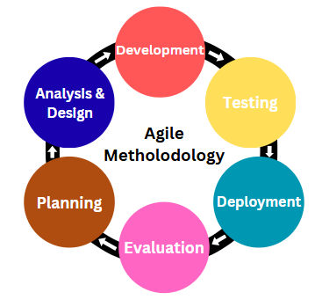

***Figure 2.*** *Agile Methodology Model*

***Planning Phase***

The researchers conducted brainstorming sessions with all group members to gather data and clearly define the objectives of the system. They collected initial information regarding existing challenges in device monitoring, user complaints, and IT helpdesk procedures to gain a clear understanding of the needs of the computer lab. The team also examined different platforms, frameworks, and tools that could be used to build a web-based monitoring system with real-time alerts, logging and automated troubleshooting suggestions. To confirm the system requirements and gather feedback on features of the system, the researchers scheduled interviews with IT staff and administrators.

The tools and equipment that supported system development and documentation included desktops or laptops for coding, design and testing integrated development environments (IDEs) such as Visual Studio Code local servers or software like XAMPP for backend and database testing reference of the system related literature and Figma for UI design, Lucid chart for conceptual frameworks and note-taking tools such as Microsoft applications for organizing notes. This phase ensured that all team members were aligned with the project objectives, resources were prepared and a solid foundation was established for the subsequent phases of system development.

|  |  |
| --- | --- |
|  |  |
|  |  |
|  |  |

***Figure 3.*** *Data Gathering*

**Table 5.** Software used and its functions

|  |  |
| --- | --- |
| **FUNCTION** | **SOFTWARE** |
| ***Visual Studio Code* -** code editor used for writing, editing and testing programs. It supports different programming languages. | File:Visual Studio Code 1.35 icon.svg - Wikimedia Commons |
| ***Xampp* –** local server environment for developing and testing web applications. It provides Apache for running websites, MySQL/MariaDB for databases, and PHP for server-side scripting, allowing developers to create and test projects offline before deployment. | Xampp Logo transparent PNG - StickPNG |
| ***Figma* –**collaborative design tool used for creating user interfaces, prototypes, and graphics. | Figma | macOS Icon Gallery |
| ***Lucid chart* –**visualizing systems, workflows, and ideas clearly and allows real-time collaboration for teams working on planning, analysis, and design. |  |

***Analysis & Design Phase***

In designing the application, the proponent followed the conceptual framework and the flowchart of the study. Also, the story board has been one of the references to the design and flow of the application. Below is the figure of how the system flows.

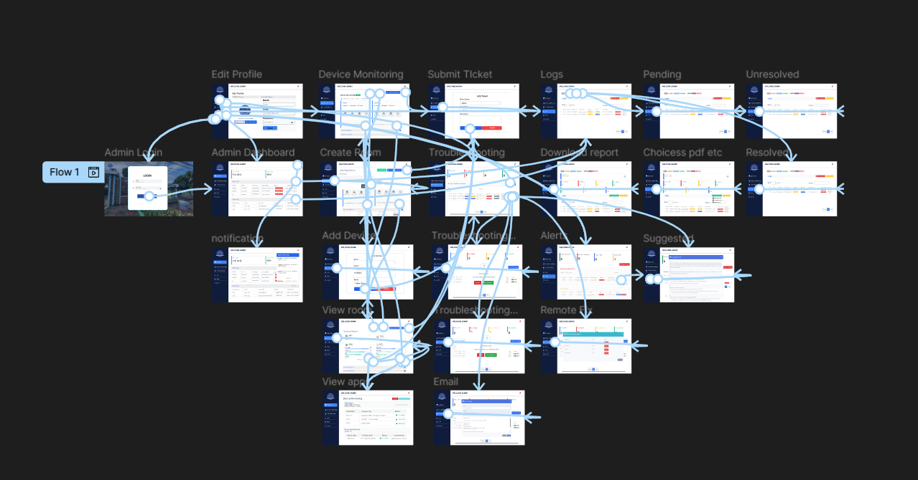

***Figure 4****. Software flow*

Moreover, the researchers interviewed the network admin and lab technicians to find out the common problems in device monitoring, troubleshooting and IT support in the computer lab. The information collected helped define the system goals, scope and main features, focusing on the device condition of the system status, alert types and user roles. The team also reviewed similar systems and past studies to help create a list of system requirements, including what the system should do and how well it should perform. Based on these, simple visual guides like system diagrams, process flows and sample user interfaces were made to help in building the system. Design tools like Figma were used to build the features such as the admin dashboard, alerts, troubleshooting and user experience was prioritized by making the interface intuitive, responsive and contemporary design. The designs were based on the feedback from users and finalized for development.

***Development Phase***

In this stage, the researchers used for the development of the web-based application various codes such as PHP, HTML, CSS, and JavaScript and executed them in Visual Studio Code to input the system functionalities. XAMPP was used to provide the necessary services such as PHP for backend programming, MySQL for managing the database, and Apache for hosting the local server. The backend developed in PHP managed system functionalities and PHP modules were used to make debugging easier and to support system updates in the future.

For the frontend, the researchers used HTML, CSS, Bootstrap, and SCSS to design and style the system user interface. Bootstrap made it easier to create a layout that worked well on both computers, while SCSS helped keep the styles organized. JavaScript and jQuery were used to make the system more interactive, and AJAX allowed data to be updated without refreshing the whole page. SweetAlert was added to show clean modern pop-up messages for alerts, confirmations, and notifications, making it easier for users to understand what was happening in the system. Motion UI effects were also used to allow for smooth animations and transitions which made the interface easier to use and more engaging for representing real-time data. Chart.js was used to create simple and clear graphs and charts, assisting users to quickly and easily see the status of the system. Font Awesome-free was used to display icons that made navigation easier. The system used a MySQL database which was designed with normalization principles to efficiently store and retrieve readings for devices, users’ activities, and logs for monitoring. Sensitive information was encrypted for further protection, and user access was controlled by a role-based permission system that limited some functions within the system to only the users with credentials required to use each function. The tools and technologies chosen in this phase were intended to be fully integrated and reliable, obviously secure, and a user-friendly monitoring system.

Figure 5 show, the web-based system was developed using Visual Studio Code as the main tool, and the developers made extensive use of its capabilities. Numerous alternatives and automated recommendation capabilities were provided by this flexible and highly configured platform for development process.

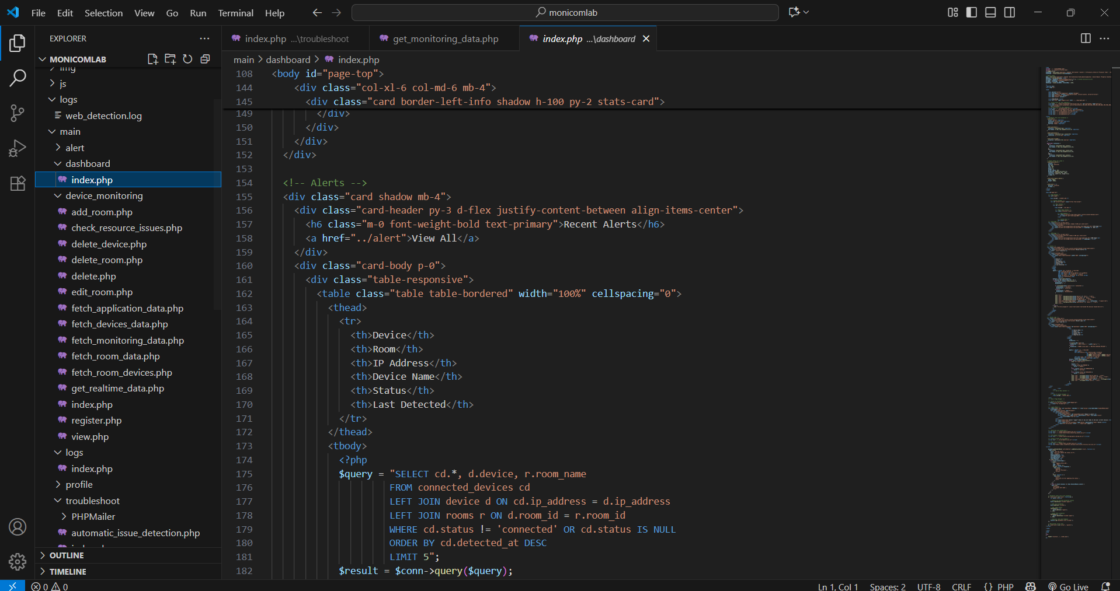***Figure 5.*** *Visual Studio*

***Testing Phase***

The researchers conducted testing to find and fix any bugs that could affect how the system worked or how easy it was to use. To make it sure if the system worked properly, was reliable, performed well, and gave users a good experience.

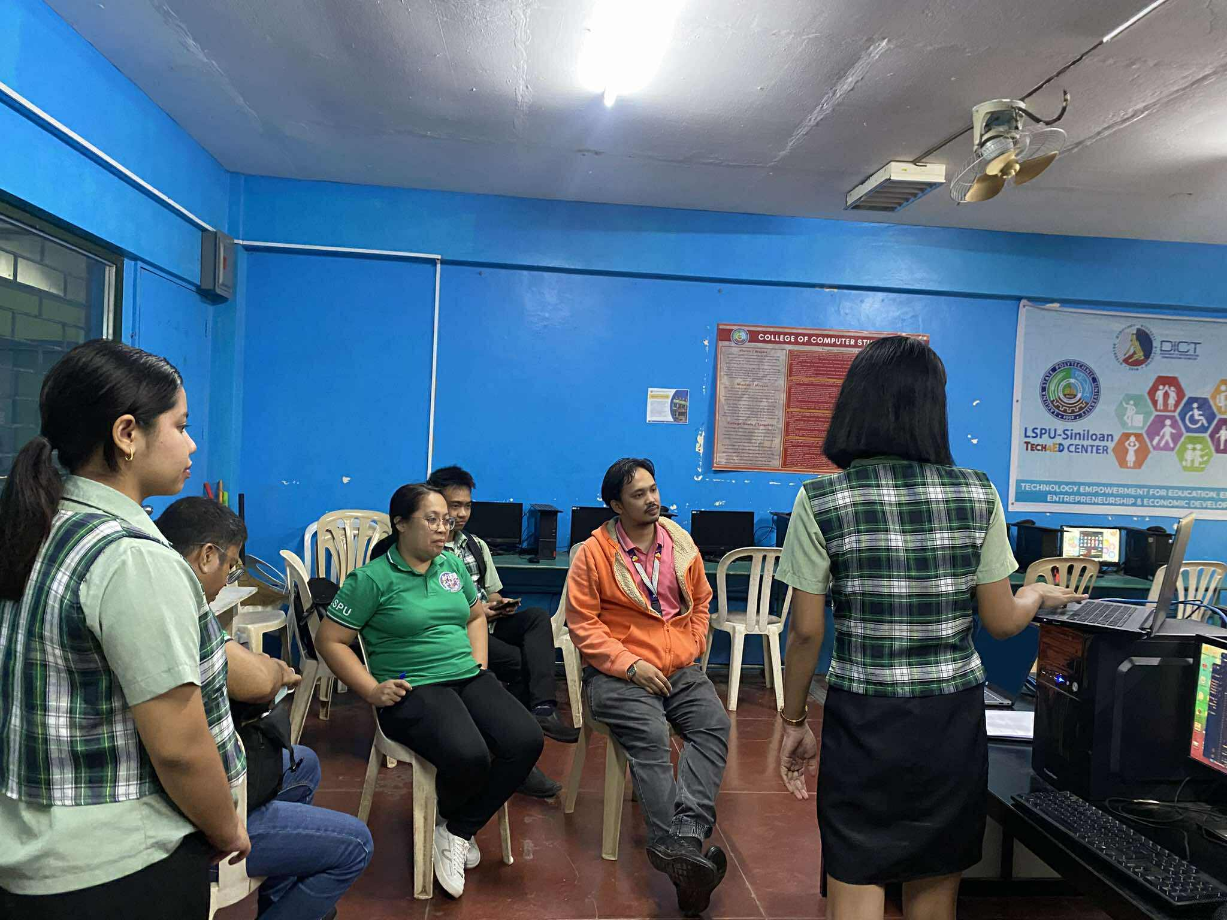

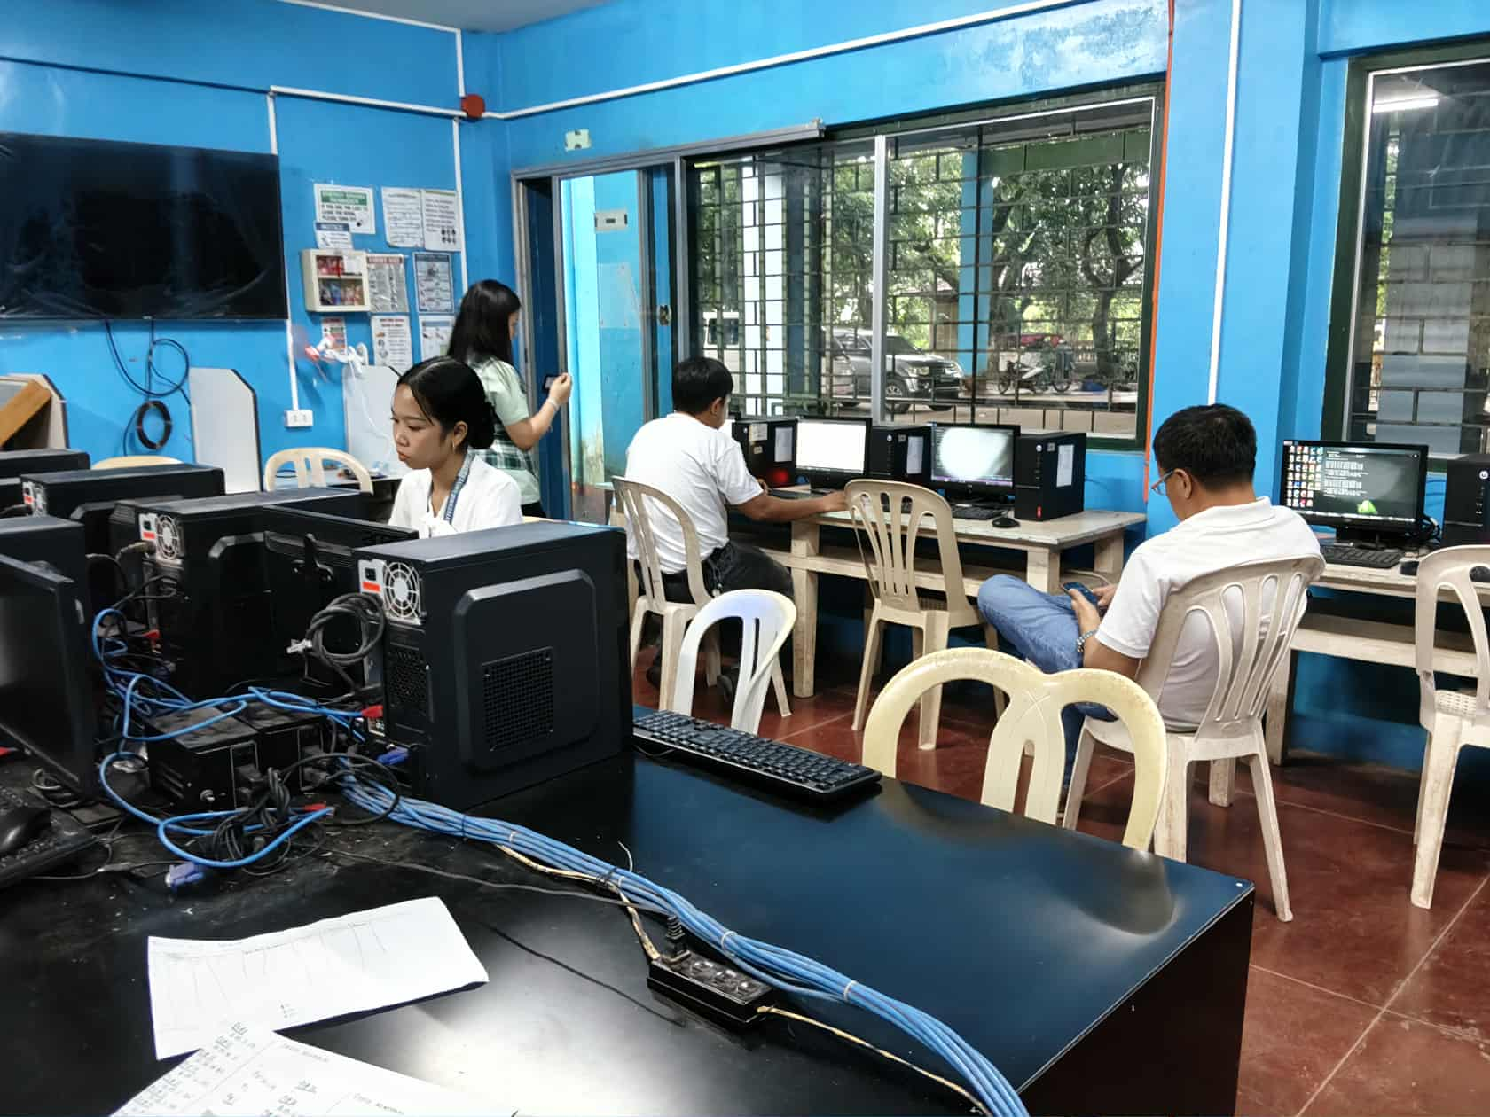

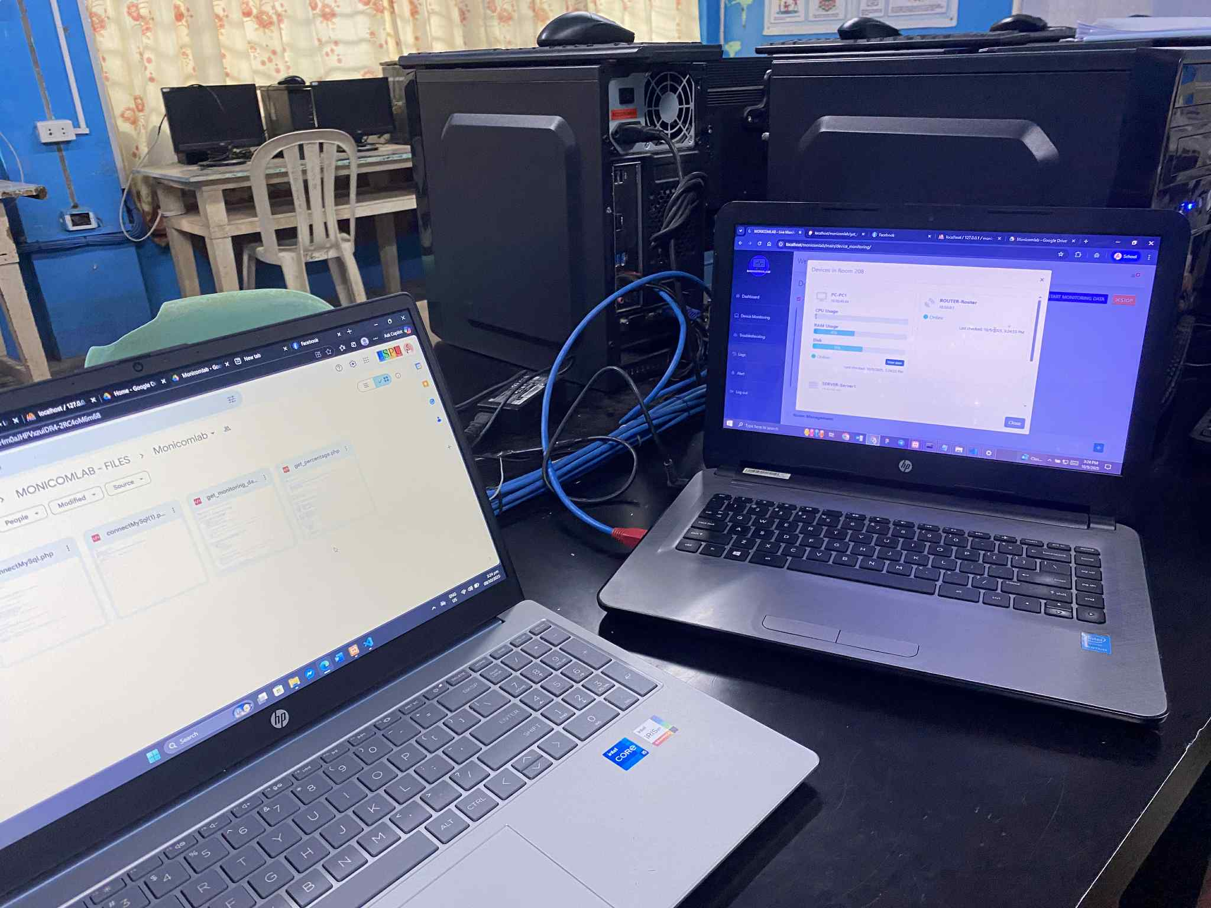

***Figure 6.*** *System Testing and demonstration*

The testing started with the creation of specific test scenarios and tasks that were meant to act like real-life use. These covered many different features and situations to see how the system would behave in different conditions. The goal was to check if the system reacted properly to user actions and if all parts of it worked as they should. To make sure the web application worked on different devices, it was tested on desktops and laptops. This helped confirm that the layout and features worked well on all screen sizes and platforms. During the testing sessions, users were guided through different system features and asked to perform common tasks. Users were asked to share any thoughts about problems they ran into while using the system. What they feedback the researchers find more issues with usability, confusing page layouts and slow loading times. The development team monitored how users interacted with the system, especially noticing when users looked confused or had trouble using it. They also checked how well the system performed such as how fast pages loaded, how quickly it responded, and how stable it was. The feedback from the testing helped the researchers understand what needed to be fixed or improved, making the system easier to use.

***Deployment Phase***

The technology was made available to the clients following extensive testing. The development team completed the system and show its functionality to clients and users at this phase. To make sure the system met their expectations, the clients will test it. The client feedback gathered during this stage is utilized to improve usability and make changes.

***Evaluation Phase***

After the development process is complete, the researchers conferred with a team of IT experts and faculty to evaluate the system's performance and decide if it is prepared for user deployment. To analyze the program's quality, the researchers utilized an assessment form based on ISO who use the system to evaluate the software quality. After IT specialists approve the system, the researchers got input from clients and independent contractors to determine user happiness and system acceptance.

**CHAPTER IV**

# RESULTS AND DISCUSSION

The outcomes that attempt to accomplish the goals outlined in the first chapter are discussed in this chapter. This chapter will explain and incorporate the outcomes of each target. This part considers the assessment’s overall conclusion and recommendations, as well as an overview of its purpose.

The goal of MONICOMLAB is to provide hardware and software that will automate the real-time monitoring and troubleshooting of computer lab environments. The outcomes of the system objectives are discussed as follows:

***To develop a centralized interface that allows administration to access and manage the core functionalities of the system with the following features.***

***1.1 Dashboard to view CPU usage, RAM usage.***

Figure 7 shows that the MONICOMLAB dashboard is designed to provide real-time monitoring and troubleshooting for computer laboratory systems. The displayed values include CPU usage, RAM usage, data analytics, recent alerts, and recent logs, which enable IT administrators to track device performance and quickly identify issues. By integrating monitoring, alerts, and troubleshooting tools into one platform, the system reduces downtime and enhances IT helpdesk efficiency, ensuring stable and reliable operations in the laboratory (Aldea et al., 2023).

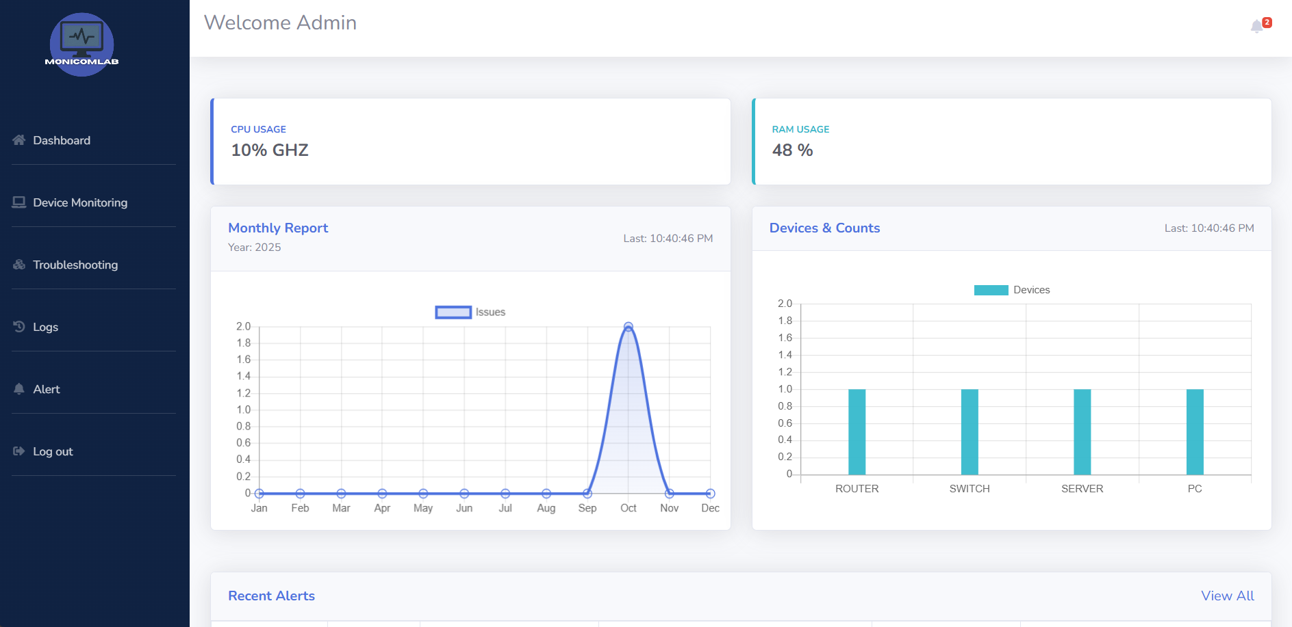

***Figure 7****. Real-time Dashboard of Monicomlab*

Figure 8 shows the notification, which serves as an essential tool for alerting IT admin about issues that may occur in the computer laboratory system. Notifications allow users to immediately see whether there are problems such as hardware or software warnings. This helps reduce downtime since administrators can quickly identify and respond to potential risks before they escalate. By centralizing notifications in the dashboard, the system minimizes the need for manual checking and ensures that no critical issue goes unnoticed. Furthermore, it enhances the efficiency of troubleshooting by providing a direct and visible update on the system health. Omede et al. (2024).

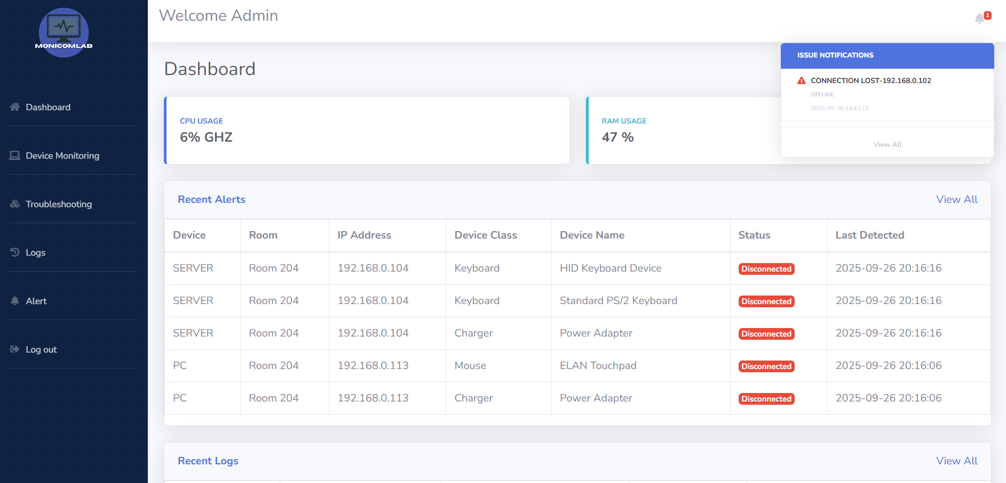

***Figure 8****. Notification*

***1.2 Device Monitoring***

Figure 9 shows the working device monitoring, which provides real-time visibility of all connected devices in the computer laboratory. This allows IT admin to track the status of devices such as PCs, servers, routers and switches, showing whether they are online or offline. By offering live updates the system enables quick detection of issues that may disrupt laboratory operations, Room management can edit or delete room and Device management can delete devices. Device monitoring also minimizes downtime by ensuring that potential problems are identified and resolved it. It improves efficiency by reducing the need for manual device checks, as all information is centralized in one platform. Safrianti et al. (2021).

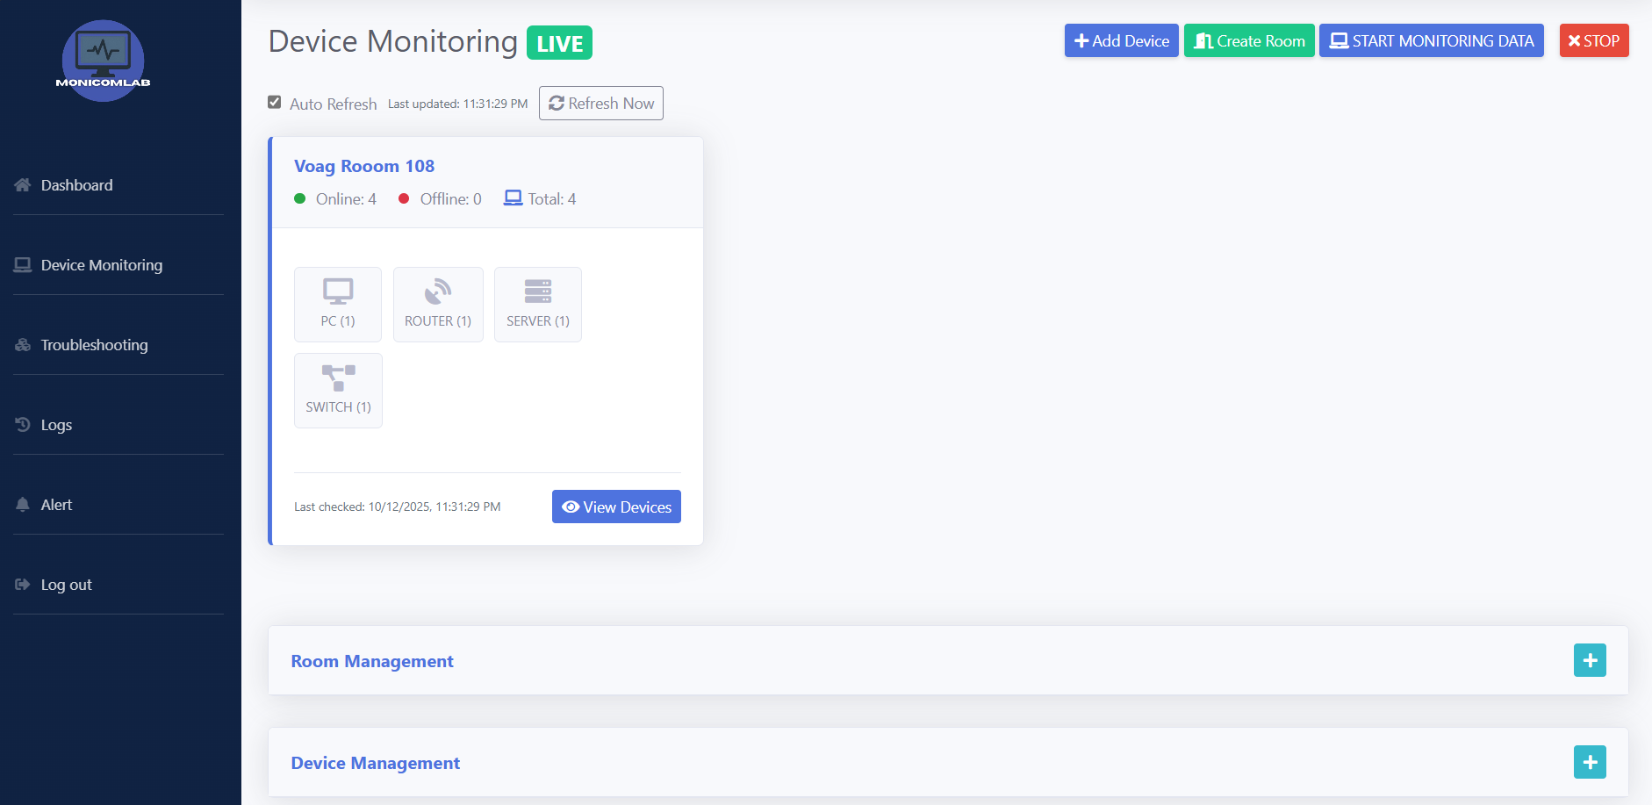

***Figure 9****. Device Monitoring*

Figure 10 shows View of all devices in real-time monitoring of all connected laboratory equipment such as PCs, servers, routers and switches. Its ensure that IT admin can easily track the status and performance of these devices, allowing quick identification of any that are offline or malfunctioning. By offering centralized visibility, this feature reduces manual checking and supports faster troubleshooting. It also helps maintain system stability and availability, which are crucial for uninterrupted laboratory operations. Safrianti et al. (2021).

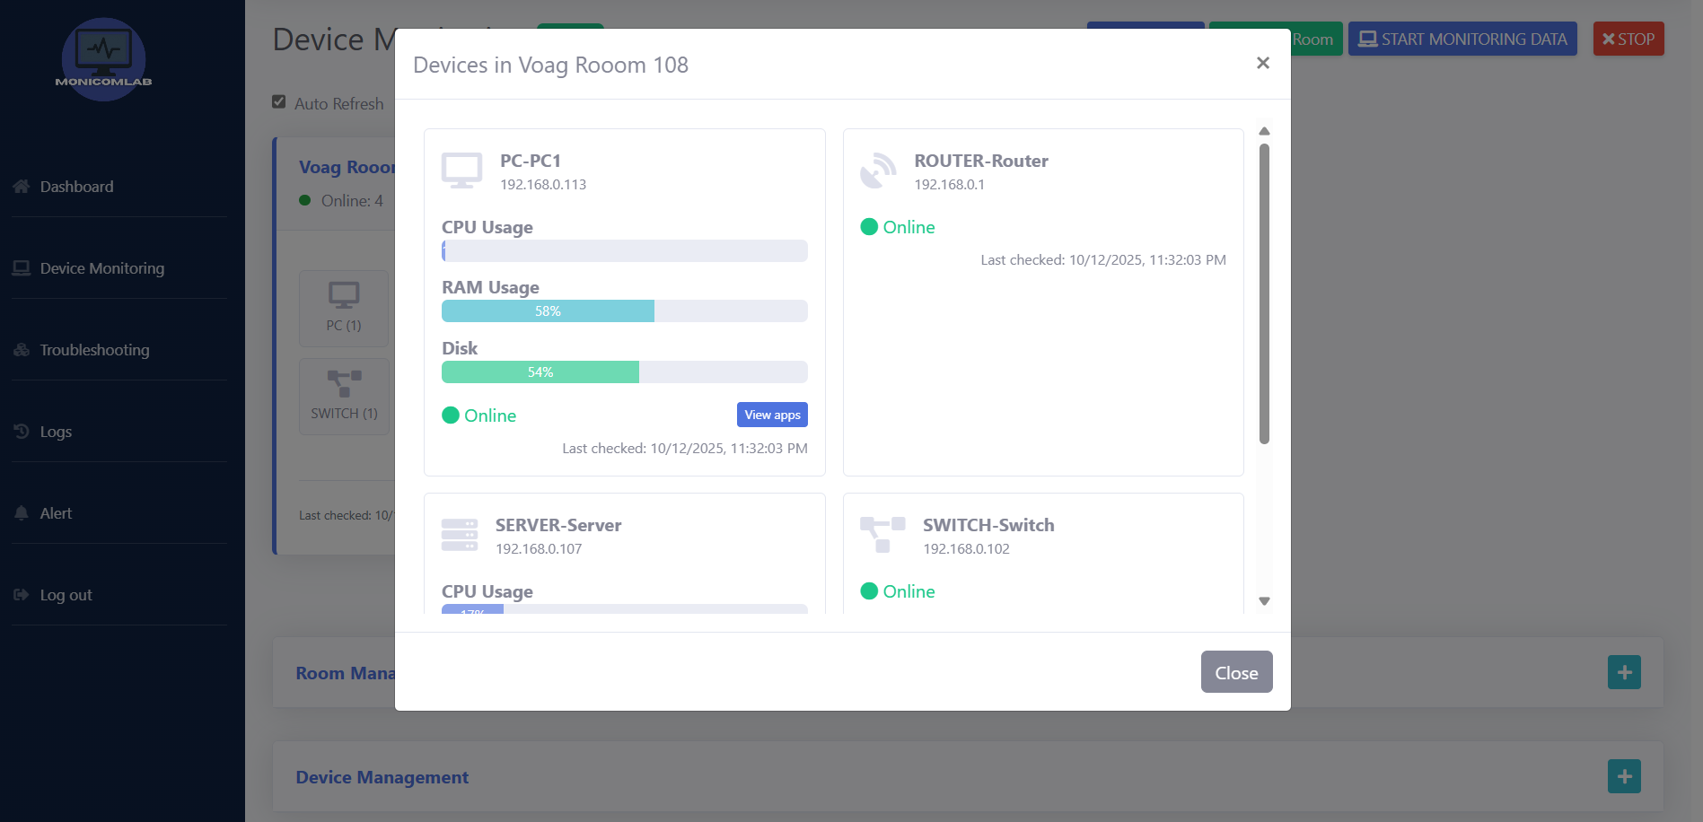

***Figure 10****. View Devices in room*

Table 6 shows the devices that were used to test and deploy the system application. The testing utilized 6 desktop computers, laptops and router to ensure proper functionality and reliability of the system. The desktop computers were used to simulate end-user activities such as browsing and running applications, while also validating the system ability to monitor multiple endpoints simultaneously. The laptops were essential for admin tasks, including deployment, database management and accessing the web-based monitoring interface to evaluate responsiveness and accessibility. Meanwhile, the router served as the network backbone, enabling connectivity between devices and allowing the system to test real-time alerts during network interruptions. These devices collectively ensured that the system was evaluated under realistic conditions, verifying both hardware and network performance for real-time monitoring and troubleshooting Aldea et al., (2023).

***Table 6****. List of devices used in System Testing*

|  |  |  |
| --- | --- | --- |
| **DEVICE** | **PROCESSOR** | **RAM** |
| Desktop Computer 10 | Intel(R) Core (TM) i3-9100 CPU @ 3.60GHz 3.60 GHz | 8.00 GB |
| Laptop 2 | 13th Gen Intel(R) Core (TM) i5-1334U 1.30Hz | 16 GB |
| Router | Qualcomm Atheros QCA9533 | 32 MB DDR |

Figure 11 shows the user activities and connected Devices, how devices are used in the computer laboratory. This user active sessions, running applications, and system usage, ensuring transparency and accountability in laboratory operations. It also displays the connected devices, such as PCs and other devices, allowing admin to monitor their performance and status. By centralizing this information, the system helps quickly detect irregular or unauthorized activities, reducing the risk of security breaches. It supports effective resource management by showing how devices and applications are utilized. Aldea et al. (2023).

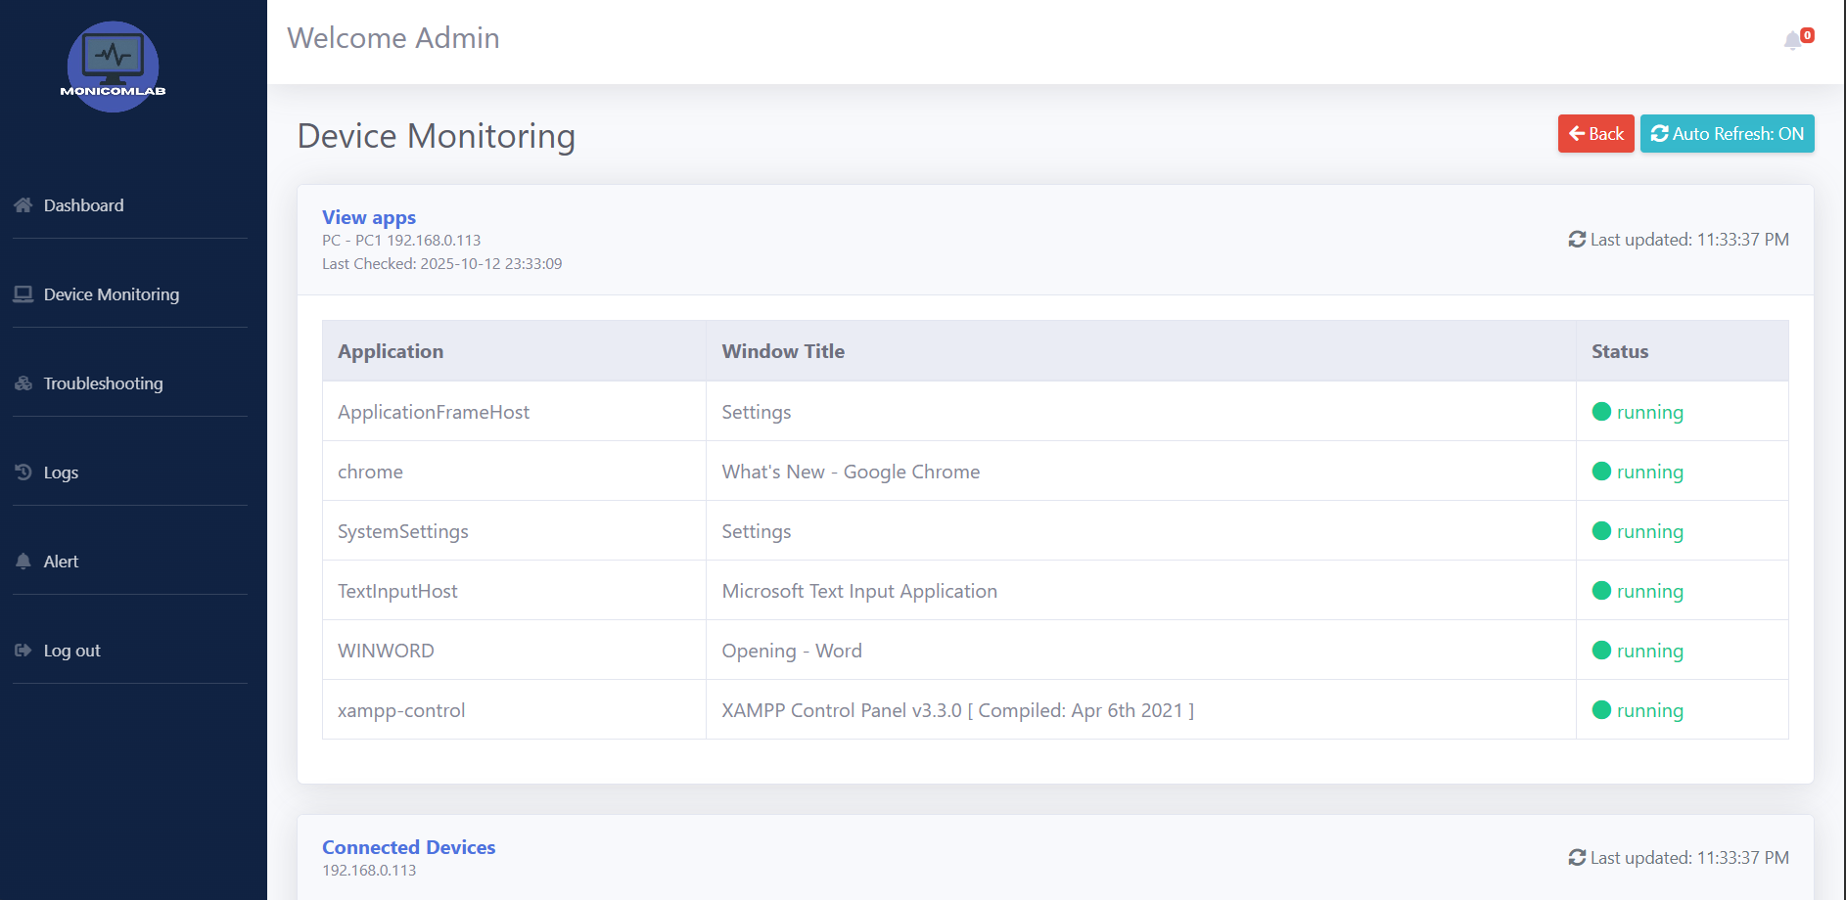

***Figure 11****. Users’ activities and Connected Devices*

Figure 12, 13 and 14 shows the Create Room, Add Devices, and Start Monitoring Data, The Create Room function allows admin to group devices by location, making monitoring more structured and efficient. Add Devices option enables IT staff to register PCs, servers, routers, and switches into the system, ensuring all hardware is tracked with relevant details such as IP address and room assignment. The Start Monitoring Data activates real-time monitoring, allowing admin or staff to observe device status and performance if it’s working and correct set up. Together, these functions support centralized management, reduce manual processes, and enable quick responses to technical issues. Adekunle et al. (2024).

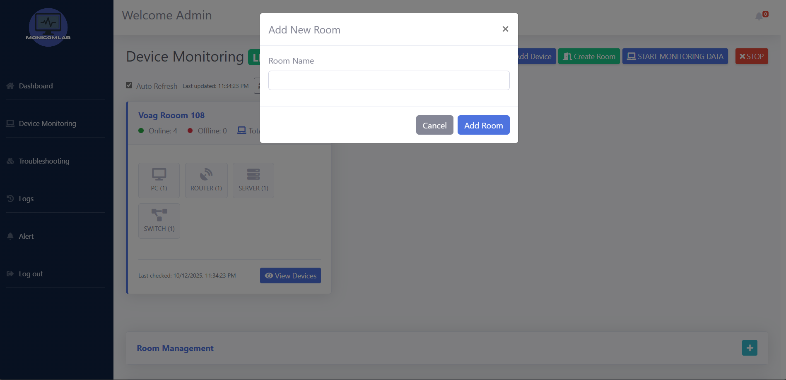***Figure 12****. Create Room*

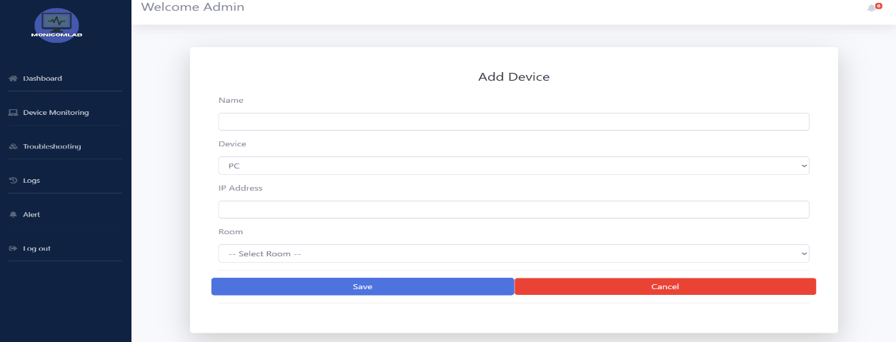 ***Figure 13****. Add Devices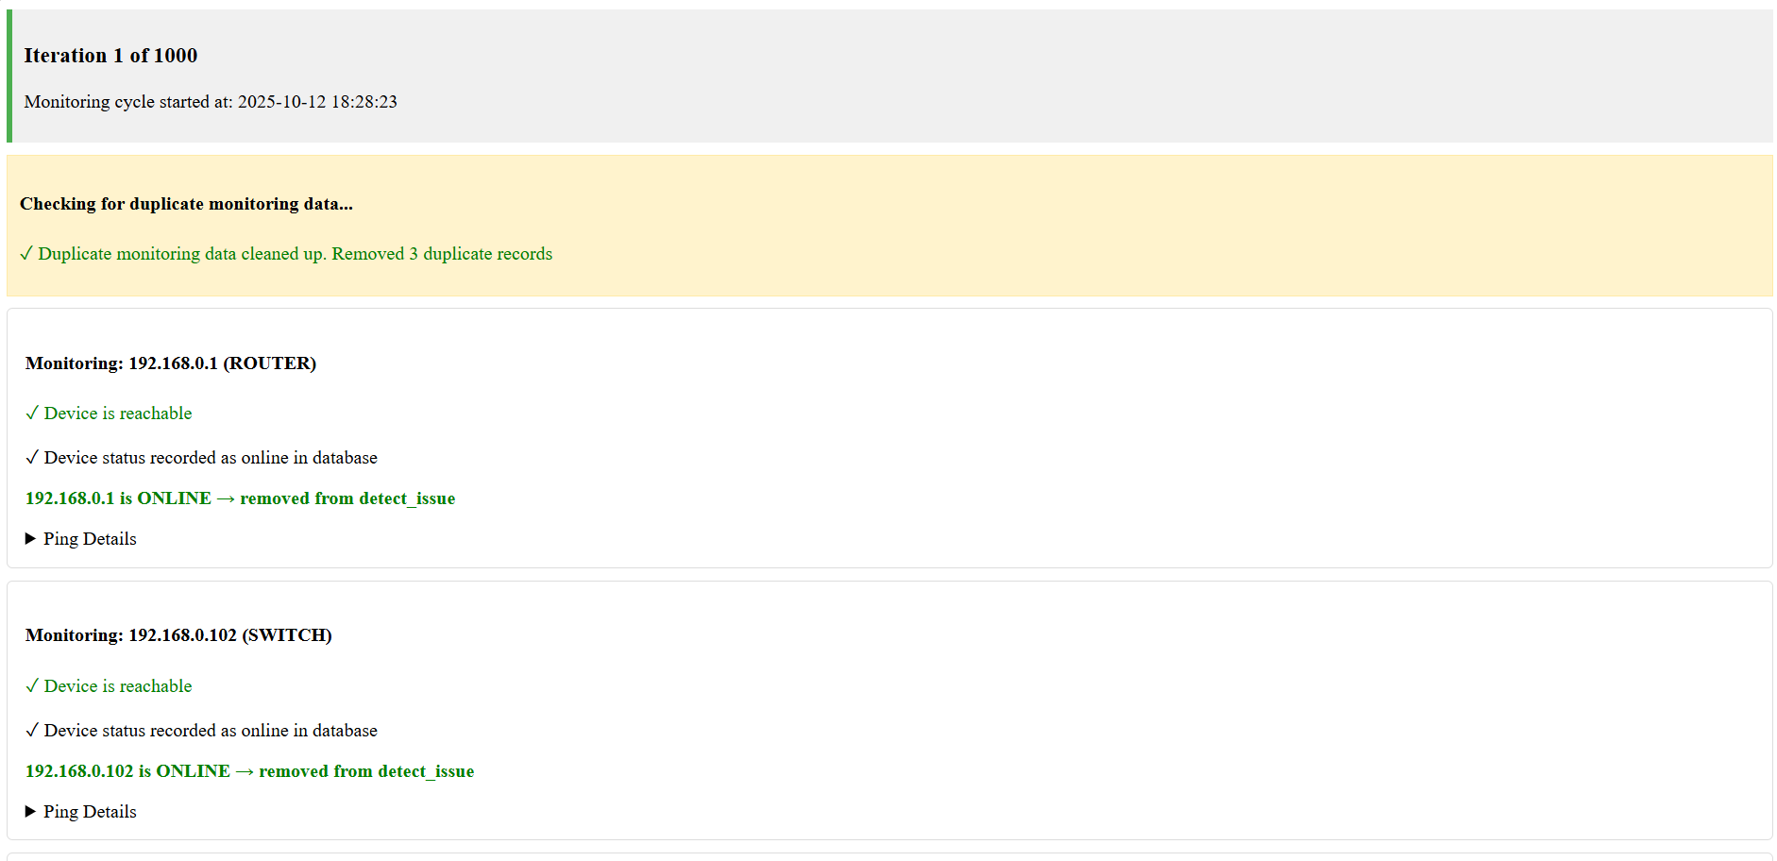* ***Figure 14.*** *Monitoring Data*

***1.3 Troubleshooting***

Figure 15 shows the working Troubleshooting of the system, which quickly find and fix problems in the computer laboratory. This automatically detects and displays all issues of all connected computers in laboratory. It provides real-time diagnostic information and suggested solutions and action button check and x button for resolved and unresolved, email and remote fix, making it easier and faster to solve common hardware and software problems. By collecting all troubleshooting data in one place, the system allows admin to identify the root cause of issues and reduce downtime. It also keeps a record of detected problems and solutions, improving accountability and track. It keeps the laboratory running smoothly, and supports proactive maintenance (Aldea et al., 2023).

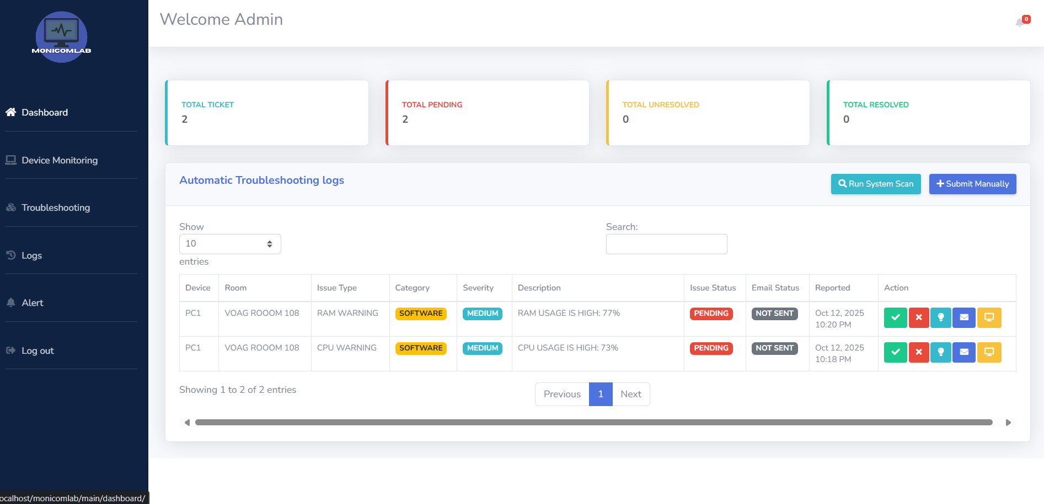***Figure 15.*** *Troubleshooting Feature*

Figure 16 shows the Add Ticket, which admin or staff manually create and submit tickets for device issues in the computer laboratory. easy way to report problems that may not be automatically detected by the monitoring system. By recording details such as the affected device, the type of problem and its urgency, it makes sure all incidents are properly logged and tracked. It also helps IT staff prioritize and assign tasks, making troubleshooting faster and more organized. Combining manual ticket submissions with automated alerts improves the accuracy of records and supports better decision-making. It also increases accountability because each ticket can be traced to the person who submitted it and the actions taken to resolve it. Kurnaedi et al. (2022).

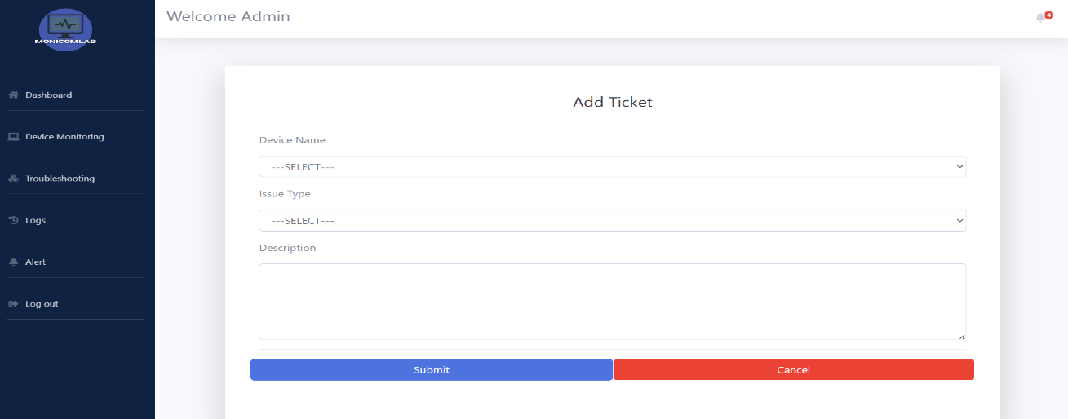

Figure 17 shows the Email Sending, which automatically generates email messages about device issues in the computer laboratory but requires the admin or staff to manually send. The system automatically fills in important details such as the recipient, subject, device name, and problem description, saving time and reducing errors. Admin or staff still reviews the message before sending it out. This approach allows flexibility, as staff can edit the message or add additional information when needed. By sending emails directly to Technician, this helps communicate urgent problems more effectively and ensures timely action. Batitis et al., (2019).

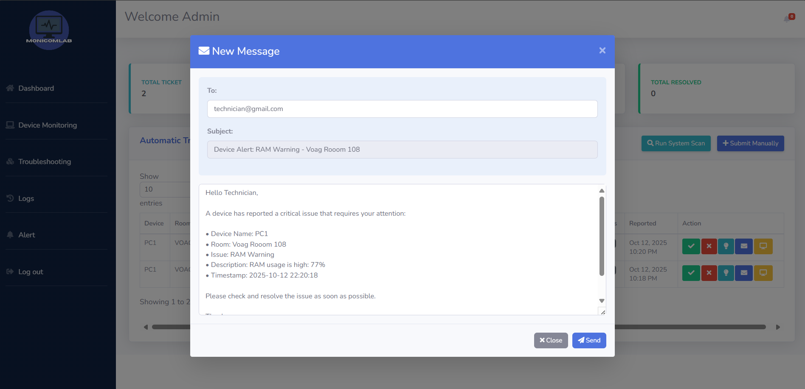***Figure 17.*** *Email Sending*

Figure 18 and 19 shows the Remote Fix, which admin allow to close or stop running applications on computers directly from a central dashboard. User allows to quick action on software problems, unauthorized programs, or applications using too many resources without needing to go to the actual device. It helps reduce downtime, improve security, and speed up troubleshooting in the computer laboratory. It also supports maintenance by solving issues. When combined with real-time monitoring, it ensures that actions are based on the latest information about device performance and user activities. Rozaki (2019).

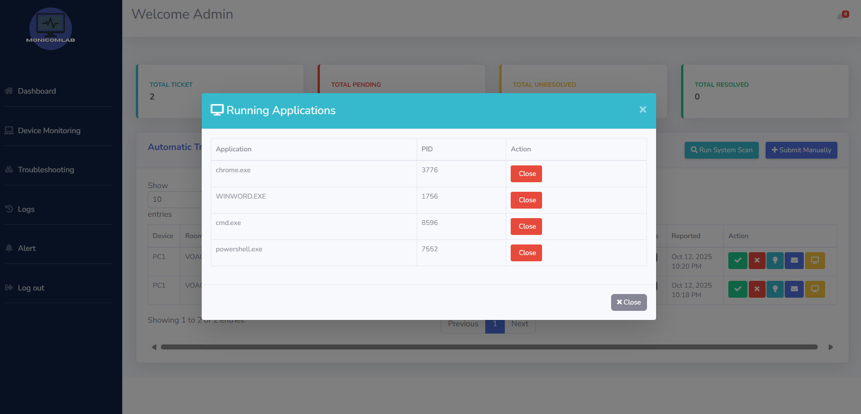

***Figure 18.*** *Remote Fix*

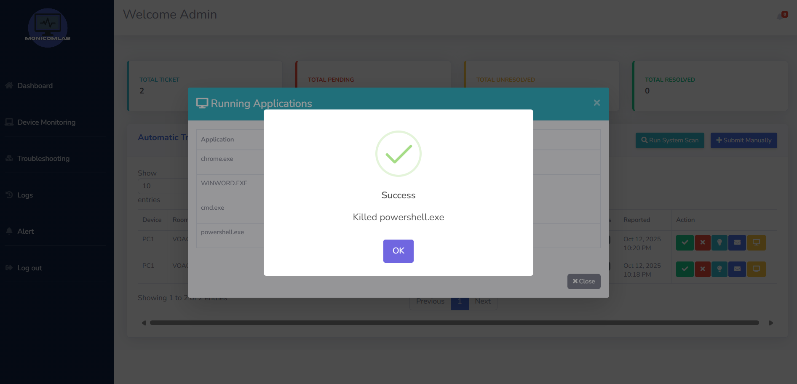

***Figure 19.*** *Successful fix*

***1.4 Logs***

Figure 20,21 and 22 shows the Logs, which serves as a centralized record of all detected and reported issues in the computer laboratory and download report. It displays essential details such as Device, Room, IP Address, Issue Type, Category, Severity, Description, Issue Status, and Date Reported, Daily, Weekly, Monthly, enabling the admin to efficiently track. review incidents and download report. By categorizing tickets into All, Pending, Unresolved and Resolved, this allows IT staff to prioritize urgent issues and monitor the progress of each case. (Ogogo, 2021).

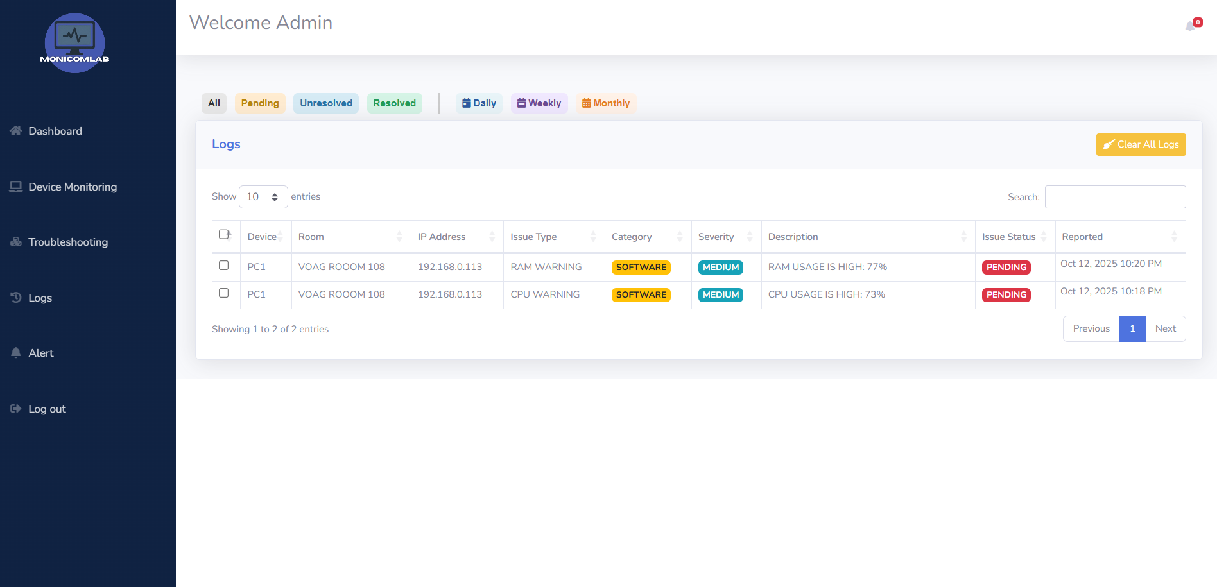

***Figure 20.*** *Logs Report*

*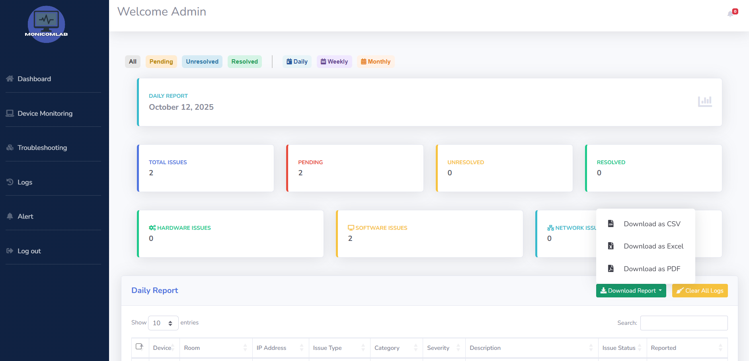****Figure 21.*** *Download Report*

*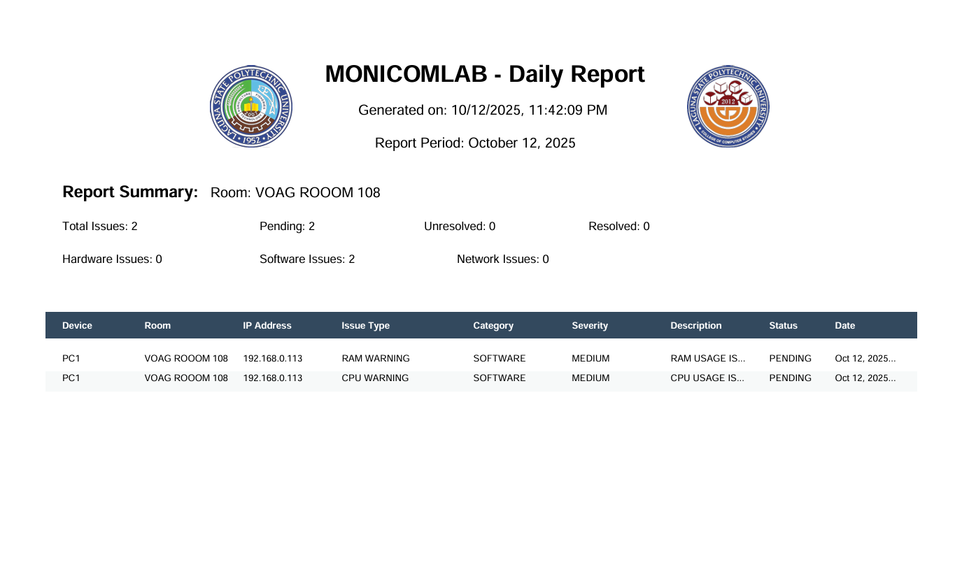****Figure 22.*** *Report*

***1.5 Alerts***

Figure 23 shows the Alert, which lists all disconnected devices in the computer laboratory and detected issues so that user can see which devices are offline. It also shows summary for connected devices, disconnected devices, online issues and offline issues to give a quick overview of the system status. Each disconnected device entry includes the Device, room, IP address, device class, status and the last time it was detected. Action buttons such as View Fix and Delete allow admin to quickly respond or remove issues. This layout saves time because admin don’t need to check multiple logs they can act right away. It also improves accountability because each issue is logged with its details and timestamp. Domingo et al. (2021)

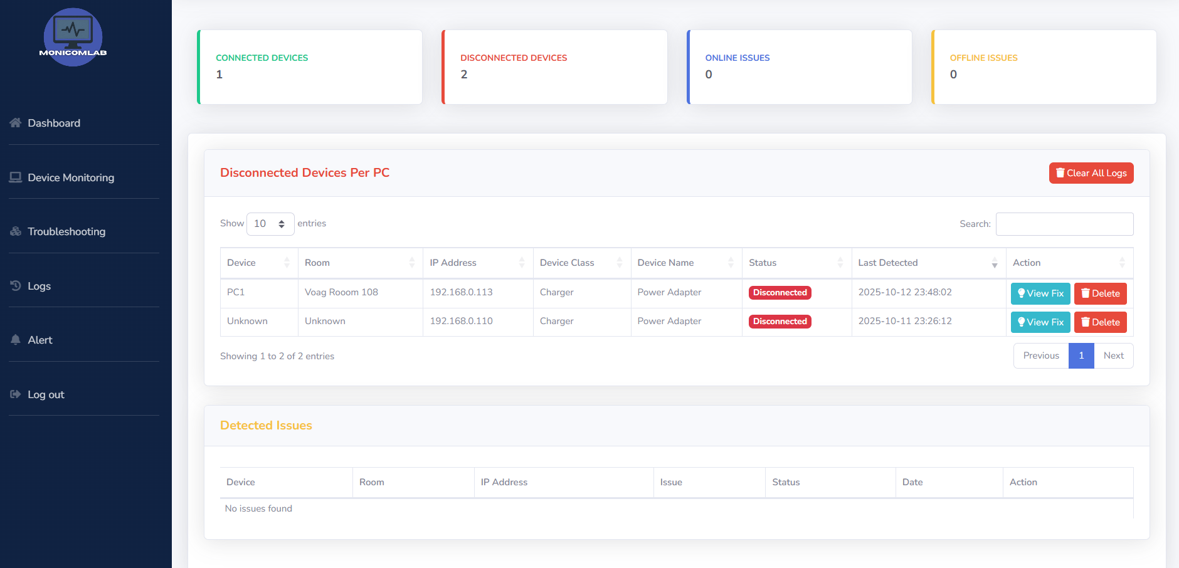

***Figure 23.*** *Alerts Feature*

***To develop an automated alert system that notifies the admin if any issue is detected and provides suggested solutions to address the issue.***

Figure 24 shows the Suggested Fix Solution, which automatically generates troubleshooting suggestions for detected device problems in the computer laboratory. It analyzes issues such as disconnected devices or power adapters and gives step-by-step instructions that guide IT staff. This feature reduces the time needed to check problems and allows quick action even for non-technical users. It works for both hardware and network issues, making it easier to identify causes like connectivity faults. Although the system automatically creates the suggestions, staff can still review and act on them manually, ensuring flexibility and control. Safrianti et al. (2021).

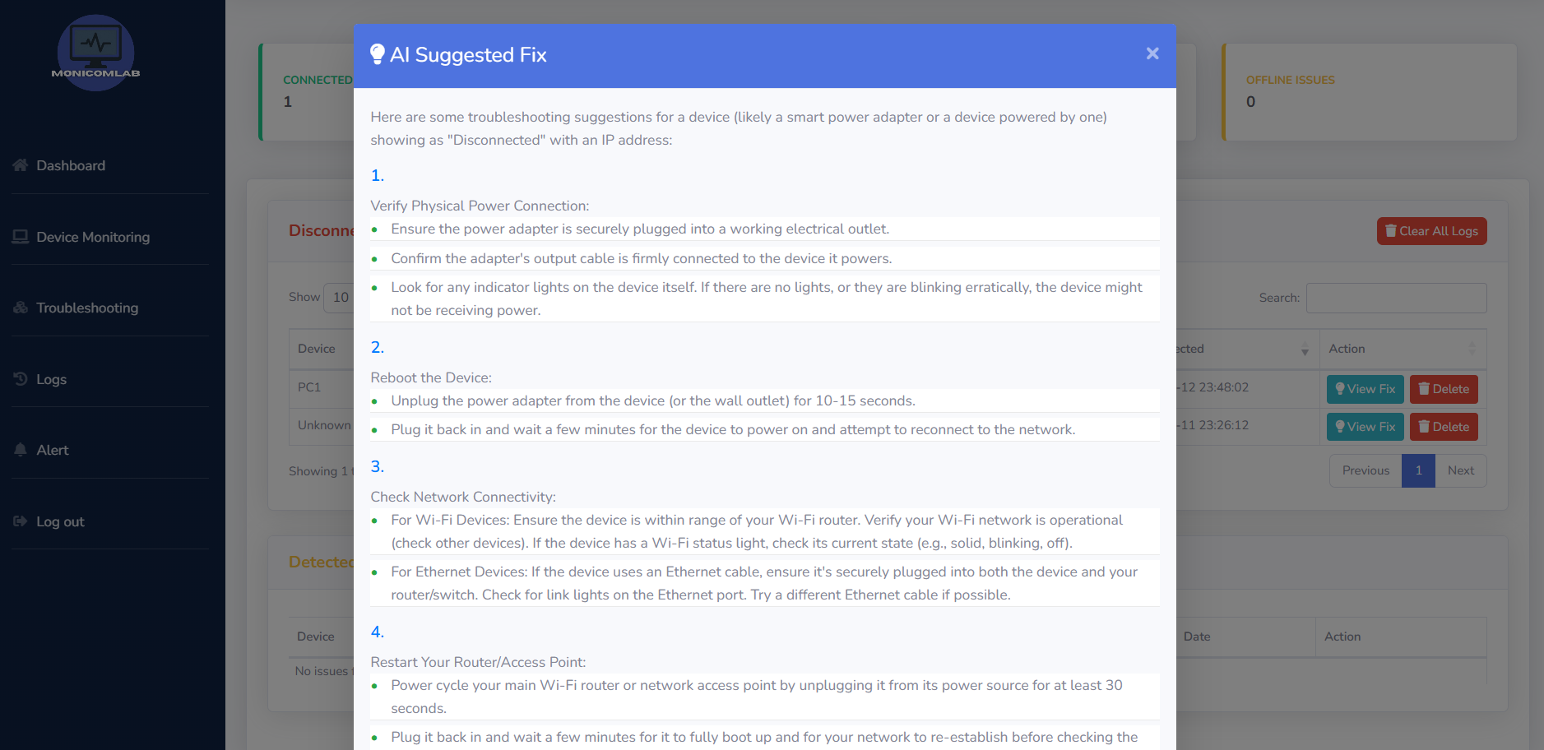 ***Figure 24.*** *Suggested Solution to fix*

***To measure the reliability of the developed system.***

To measure the reliability of the developed system, a reliability test was conducted to determine whether the key features of Device Monitoring and Troubleshooting function consistently across multiple computer units.

Table 7

**Table 7**. Reliability Test for Room 1

|  |  |  |  |
| --- | --- | --- | --- |
| **RELIABILITY** | **NO. OF TEST CASES** | **REMARKS** | |
|  |  | Passed | Failed |
| PC- 01 |  |  |  |
| PC- 02 |  |  |  |
| PC- 03 |  |  |  |
| PC- 04 |  |  |  |
| PC- 05 |  |  |  |
| **TOTAL** |  |  |  |

**Table 8**. Reliability Test for Room 2

|  |  |  |  |
| --- | --- | --- | --- |
| **RELIABILITY** | **NO. OF TEST CASES** | **REMARKS** | |
|  |  | Passed | Failed |
| PC- 01 |  |  |  |
| PC- 02 |  |  |  |
| PC- 03 |  |  |  |
| PC- 04 |  |  |  |
| PC- 05 |  |  |  |
| **TOTAL** |  |  |  |

***Determine the software quality using ISO 25010.***

The following table presents the system evaluation results based on ISO 25010, focusing on key quality attributes such as Functionality, Reliability, Portability, Usability, Performance efficiency and Compatibility. This evaluation provides a clear and consistent way to measure the system overall performance and quality in supporting IT helpdesk operations, particularly its monitoring, troubleshooting and adaptability features. as evaluated by the expert in networking and web-based.

Table 9 shows the results under these categories. Under the Functionality category, the highest-rated item was “The system provides complete functions that cover all specified tasks and user objectives,” with a weighted mean of 4.36, interpreted as Functional. This indicates that the respondents highly valued the system capability to deliver complete and accurate functions according to user needs. In contrast, “The functions of the system provide correct results with the needed degree of precision” received the lowest score of 4.00, interpreted as Slightly Functional, suggesting that while the system effectively performs tasks, minor refinements could improve its accuracy and precision.

However, the Reliability highest-rated indicator was “The system meets performance requirements under normal operation,” with a weighted mean of 4.54, showing that the system performs consistently and reliably under expected conditions. The lowest rating of 4.18 was given to “The system can recover its data directly and re-establish its desired state after a failure,” indicating that while recovery features are reliable, they could be further optimized for better fault tolerance.

Moreover, the Usability several items achieved high scores, with “The system is easy to operate, control and appropriate to use,” “The system interface is visually appealing and satisfying to use,” and “The system can be used by people with varying capabilities” all receiving the highest weighted mean of 4.54, reflecting that users found the system user-friendly, visually engaging, and accessible. Across all quality attributes, the system obtained weighted means ranging from 4.00 to 4.72, demonstrating that it performs well in terms of functionality, reliability, usability, performance efficiency, portability, and maintainability. Overall, the evaluation results confirm that the system meets the ISO 25010 software quality standards, showing strong performance, dependability, and user satisfaction, particularly in supporting IT helpdesk operations.

**Table 9.** Evaluation Result

|  |  |  |
| --- | --- | --- |
| **FUNCTIONALITY** | **WEIGTHED MEAN** | **VERVAL INTERPRETATION** |
| The system provides complete functions that cover all specified tasks and user objectives. | 4.36 | Functional |
| The functions of the system provide correct results with the needed degree of precision. | 4 | Slightly Functional |
| The functions of the system facilitate the accomplishment of specified tasks and objectives. | 4.18 | Functional |
| **RELIABILITY** |  |  |
| The system meets performance requirements under normal operation. | 4.54 | Reliable |
| The system remains operational and accessible whenever required. | 4.45 | Reliable |
| The system continues to operate as intended despite hardware or software failures. | 4.36 | Reliable |
| The system can recover its data directly and re-establish its desired state after a failure. | 4.18 | Reliable |
| **PORTABILITY** |  |  |
| The system can adapt to different or evolving hardware and software environments. | 4.27 | Portable |
| The system runs efficiently on various laboratory computers regardless of their specifications. | 4.27 | Portable |
| The system can replace another similar software product in the same environment. | 4.36 | Portable |
| **USABILITY** |  |  |
| Users can easily recognize whether the system is appropriate for their needs. | 4.45 | Usable |
| The system is easy to operate, control, and appropriate to use. | 4.54 | Usable |
| The system protects users against making errors. | 4.45 | Usable |
| The system interface is visually appealing and satisfying to use. | 4.54 | Usable |
| The system can be used by people with varying capabilities. | 4.54 | Usable |
| **PERFORMANCE EFFICIENCY** |  |  |
| The system responds quickly and meets processing time requirements. | 4.45 | Efficient |
| The system uses resources efficiently during operation | 4.27 | Efficient |
| The system handles maximum load and usage without errors. | 4.18 | Efficient |
| **MAINTAINABILITY** |  |  |
| The system performs efficiently while sharing a common environment with other products. | 4.72 | Maintainable |
| The system can be reused in other environment or as part of other solutions. | 4.45 | Maintainable |
| The system allows easy assessment of deficiencies and modifications. | 4.45 | Maintainable |
| The system can be modified without introducing defects or degrading quality. | 4.27 | Maintainable |
| The system can exchange information and interoperate with other products or systems. | 4.54 | Maintainable |

**CHAPTER V**

# SUMMARY, CONCLUSIONS AND RECOMMENDATIONS

## The summary of the study was discussed in this chapter, along with the conclusion of the researchers based on the result and findings of the study. Additionally, this chapter also offered recommendations for the future researchers that could help to enhance the research study.

## Summary

The researchers of the study entitled “MONICOMLAB: Computer Laboratory Real-Time Monitoring and Troubleshooting System for IT Helpdesk”. found that IT staff in school computer laboratories often experienced delays in detecting issues and resolving device problems. Reporting caused downtime and disrupted services. To address these issues, the researchers developed MONICOMLAB, a system designed to monitor computer laboratory devices in real time, track user activities and connected devices such hardware, send alert notifications and provide troubleshooting suggestions to improve helpdesk efficiency.

Furthermore, this study used an Experimental and Developmental method of research for the development of the MONICOMLAB system. The system was built using Visual Studio Code with PHP, HTML, CSS, JavaScript, and MySQL as its database. Surveys and interviews with IT staff were conducted to gather information on common issues and to evaluate the system performance, functionality and benefits. These inputs guided the creation of features such as the admin dashboard, alert notifications, and automated troubleshooting modules.

Based on the outcomes and results, MONICOMLAB significantly helped IT staff monitor and troubleshoot devices more effectively. The system reduced response time, minimized disruptions, and improved the overall performance of IT Helpdesk operations by providing real-time status, accurate logs and timely alerts. Feedback from users showed that the system was easy to use and enhanced efficiency in managing and resolving issues within the computer laboratory.

**Conclusions**

Based on the research objectives, the following statements were made, MONICOMLAB: Computer Laboratory Real-Time Monitoring and Troubleshooting System for IT Helpdesk.

The research was successfully developed and designed and the proponents successfully integrated the necessary tools for real-time monitoring and troubleshooting of computer laboratory devices. In addition, the IT staff of the College of Computer Studies were able to use the MONICOMLAB system during the testing and deployment phase up until now. Through the installed modules by PC to Server of the system, the IT staff were able to check connected devices and their status and user activities, logs directly from the system interface, allowing them to manage and troubleshoot issues more efficiently.

Additionally, the utilization of real-time alerts, automated troubleshooting suggestions and activity logging was successful based on its parameters. Other features such as device health monitoring, alert notifications and admin role management were also effectively implemented and controlled. the use of visual tools such as graphs, logs and troubleshooting guides was successfully applied using the MONICOMLAB system.

Lastly, the proponents evaluated the technological acceptance of the users and system performance of the MONICOMLAB system based on the results of perceived usefulness (PU), which confirmed that the system is helpful. Also, the results of perceived ease of use (PEU) and usability attribute (AU) confirmed that there is a positive impact of using MONICOMLAB and also the functionality of the system reliability, portability, usability, compatibility and maintainability of system automation in effectively monitoring and troubleshooting IT Helpdesk tasks in the computer laboratory.

**Recommendation**

The study and the developed MONICOMLAB system are provided and the intended goal of real-time monitoring and troubleshooting for the computer laboratory was successfully initiated. However, further innovation and recommendations are still included. Based on the feedback from IT staff and administrators, adding an offline data logging feature would be beneficial so that device and network status can still be recorded even when the internet connection is down. Once the connection is restored, the stored data can automatically sync to the online system for continuous monitoring.

In addition, the system could integrate an online notification feature, such as email alerts, to immediately inform IT staff or technician for critical device or issues even if they are not currently logged into the system. This would improve responsiveness and ensure that issues are addressed promptly.

Moreover, due to time constraints and the wide scope of the study, some features that may enhance both offline and online monitoring were not included. Therefore, the proponent recommends considering future enhancements such as remote access through mobile applications, role-based dashboards for different user types and automated troubleshooting suggestions for common device or other issues.

# REFERENCES

Abbas, W., Lászka, Á., Vorobeychik, Y., & Koutsoukos, X. (2018). Scheduling resource-bounded monitoring devices for event detection and isolation in networks 5(1), 65-78. <https://doi.org/10.1109/tnse.2017.2734048>

Adekunle, A. A., Abolore, B. L., Mutiu, G., & Olalekan, A. M. (2024). Design and Implementation of a Web-Based Laboratory Management System for Efficient Resource Tracking. 13(2), 19–24. https://doi.org/10.70112/ajes-2024.13.2.4248

Alamsyah, L., Munandar, F., Sensuse, D. I., Lusa, S., Safitri, N., & Elisabeth, D. (2025). Knowledge Management Strategies for Optimizing Help Desk Operations. 14(1). DOI: https://doi.org/10.33022/ijcs.v14i1.4648

Ali, L., Alnajjar, F., Parambil, M. M. A., Younes, M. I., Abdelhalim, Z. I., & Aljassmi, H. (2022). real-time smart monitoring system for increasing lab safety awareness in educational institutions. 22(22), 8820. https://doi.org/10.3390/s22228820

Alhilali, A. (2023). Design and implement a real-time network traffic management system using snmp protocol. 5(9 (125)), 35-44. https://doi.org/10.15587/1729-4061.2023.286528

Alkenani, J. and Nassar, K. (2022). Network monitoring measurements for quality of service. 18(2), 33-42. <https://doi.org/10.37917/ijeee.18.2.5>

Anuar, A. M., Mohamad, R., Markom, A. M., & II, R. C. (2024). Real-time forest fire detection, monitoring, and alert system. 33(2), 942-950 DOI: 10.11591/ijeecs. v33.i2.

Azmi Bin Mustafa Sulaiman, M., Adib Khairuddin, M., Rizal Mohd Isa, M., Nazri Ismail, M., Afizi Mohd Shukran, M., & Abu Bakar Sajak, A. (2021). Siem network behaviour monitoring framework using deep learning approach for campus network infrastructure. 9-21. <https://doi.org/10.32985/ijeces.12.si.2>

Aldea, C. L., Bocu, R., & Solca, R. N. (2023). Real-time monitoring and management of hardware and software resources in heterogeneous computer networks through an integrated system architecture. 15(6), 1134. https://doi.org/10.3390/sym15061134

Batitis, C. A., Alcaide, E. S., Arguillon, M. V., Roldan, J. M., & Agustin, L. F. (2019). Sms notification implementing internet of things for barangay labas, city of santa rosa, laguna 10(1) doi :10.26483/ijarcs. v10i1.6356

Bahaa Razia, Bahaa Awwad, Najma Taqi (2023). The relationship between artificial intelligence (AI) and its aspects in higher education. 37 (3): 21–23. https://doi.org/10.1108/DLO-04-2022-0074

Belvis, D. J. T., Hipolito, A. L. G., Ico, M. U., Prudenciado, J. P. O., & Peren, J. R. (2024). Streamlining ICT Network Resources, Processes and Operations through a Centralized. 6(1), 86-99.

Cinque, M., De Simone, L., Mazzocca, N. et al. Evaluating virtualization for fog monitoring of real-time applications in mixed-criticality systems. 59, 534–567 (2023). <https://doi.org/10.1007/s11241-023-09410-4>

Ceronmani Sharmila, V., Vishnu, E., King Udayaraj, M.R., Sharan Venkatesh, V. (2024). Advanced Cyber Security Helpdesk Using Machine Learning Techniques. 796. https://doi.org/10.1007/978-981-99-6906-7_32

D. Mistry**,** P. Modi, K. Deokule, A. Patel, H. Patki and O. Abuzaghleh, (2016). Network traffic measurement and analysis 1-7, https://doi: 10.1109/LISAT.2016.7494141.

Diana, L., Dini, P., & Paolini, D. (2025). Overview on Intrusion Detection Systems for Computers Networking Security. 14(3), 87. <https://doi.org/10.3390/computers14030087>

Domingo, Salvacion M., et al. (2021). Real-time Remote Monitoring and Security System for a Local Area Network Environment. 1-22, doi:[10.53378/346472](https://doi.org/10.53378/346472).

W. Domski, (2022). Remote Laboratory Offered as Hardware as-a-Service Infrastructure, Electronics, 11, 10, doi: 10.3390/electronics11101568.

Ebron, J. G., Rivero, G. T., & Ang, J. V. R. (2024). Integrated Internet of Things and AI for Real-Time Water Quality Monitoring in Laguna Lake. 113, 163-168. <https://doi.org/10.3303/CET24113028>

Fadilah, M. and Handrianto, Y. (2023). Analysis of employee satisfaction with helpdesk websites using service quality in construction companies.1(1), 12-25. https://doi.org/10.58777/its.v1i1.91

Garcia, M.R.T., Culaba, A.B. (2021). Significance of the Internet of Things to the Covid-19 Pandemic in the Philippines. In Innovations in Bio-Inspired Computing and Applications. <https://doi.org/10.1007/978-3-030-73603-3_26>

D. M. Gravano, U. Chakraborty, I. Pesce, and M. Thomson (2021). Solutions for Shared Resource Lab Remote Quality Control and Instrument Troubleshooting during a Pandemic. doi: 10.1002/cyto.a.24266.

Haxhibeqiri, J., Isolani, P., Márquez-Barja, J., Moerman, I., & Hoebeke, J. (2021). In-band network monitoring technique to support sdn-based wireless networks. 18(1), 627-641. <https://doi.org/10.1109/tnsm.2020.3044415>

Jara, C. A., Candelas, F. A., Torres, F., Dormido, S., Esquembre, F., & Reinoso, O. (2009). Real-time collaboration of virtual laboratories through the Internet. 52(1), 126-140.https://doi.org/10.1016/j.compedu.2008.07.007

Kämppi, J. and Saharinen, K. (2024). Key actions to enable automation for mobile network security operations. 23(1), 224-232. <https://doi.org/10.34190/eccws.23.1.2232>

Kadham, N.R., Krishna, P.G. & Ravi, K.S. IoT-Based Remote Monitoring as a Distance (Online) Laboratory for Applied Learning. SN COMPUT. SCI. 6, 114 (2025). https://doi.org/10.1007/s42979-024-03649-9

Khan, R. and Khan, S. (2018). Design and implementation of an automated network monitoring and reporting back system. 9, 24-34. <https://doi.org/10.1016/j.jii.2017.11.001>

Kurnaedi, D., Oktora, E., Dharmawan, E., Nasrullah, I., & Drajat, M. (2022). Web-based IT helpdesk ticketing system at pt. dayacipta kemasindo. 5(2), 121-127. <https://doi.org/10.32877/bt.v5i2.617>

K. Mhmoud Alzubi, W. Salah Alaloul, A. B. Malkawi, M. Al Salaheen, A. Hannan Qureshi, and M. Ali Musarat (2023). Automated monitoring technologies and construction productivity enhancement: Building projects case. doi: 10.1016/j.asej.2022.102042.

Liu, S., Wright, A. P., Patterson, B. L., Wanderer, J. P., Turer, R. W., Nelson, S. D., ... & Wright, A. (2023). Using AI-generated suggestions from ChatGPT to optimize clinical decision support. 30(7), 1237-1245. https://doi.org/10.1093/jamia/ocad072

Loyola, M. C. B., Bueno, J. B., & Leon, R. (2019). Internet-based electric meter with theft detection, theft notification and consumption monitoring for residential power lines using wireless network technology. 8(5), 238-246.

Masongsong, R. & Damian, M.A. (2016). Helpdesk Management System. Proceedings of the World Congress on Engineering and Computer Science 2016 Vol I WCECS 2016.

Nuevas, L. K., Velarde, J. L. C., Javellana, J. B. A., & Torlao, J. R. E. (2024). Real-Time Incident Reporting and Emergency Response: A Mobile GPS App for Abuyog, Leyte, Philippines. 37-43. doi: 10.1109/ICVEE63912.2024.10823942.

Nuruzzaman, M., & Rana, S. (2025). IoT-Enabled Condition Monitoring in Power Distribution Systems: A Review of Scada-Based Automation, Real-Time Data Analytics, and Cyber-Physical Security Challenges, 1(01), 25-43. DOI: https://doi.org/10.63125/pyd1x841

Ogogo, W. (2021). Real-time monitoring of network devices: its effectiveness in enhancing network security. 3(1), 1-6. <https://doi.org/10.37284/eajit.3.1.153>

Oliveros, A. G. G. (2022). Design and Development an Interactive On-the-Job Training Monitoring and Help Desk System with SMS for College of Information and Communication Technology. 10(7), 72-89.DOI: 10.4236/jcc.2022.107005

Omede, E. U., Edje, A. E., Akazue, M. I., Utomwen, H., & Ojugo, A. A. (2024). Imanobas: an improved multi-mode alert notification iot-based anti-burglar defense system. 1(3), 273-283. <https://doi.org/10.62411/jcta.9541>

Rabia Noor Enam, Huma Hasan Rizvi, Muzammil Ahmad Khan et al (2024). Internet of Things-based Intelligent Environmental Monitoring and Alert System, <https://doi.org/10.21203/rs.3.rs-5280407/v1>

Rapada, R., Llorca, A. A., Perez, M. A. M., & Raymundo, J. C. (2021). Langkiwa river water detection system implementing internet of everything. 12(4). Doi: 10.26483/ijarcs.v12i4.6751

Rey, W. P. (2023). MidwestCloud: A centralized SDN-based Network Management Design, Integration, and Deployment for an Academic Institution in Marinduque Islands, Philippines. 36-41, https://doi: 10.1109/INCC58754.2023.00011

Rozaki**,** E. (2019). Design and implementation for automated network troubleshooting using data mining. <https://doi.org/10.5281/zenodo.3542465>

Safrianti, E., Sari, L., & Sari, N. (2021). Real-time network device monitoring system with simple network management protocol (snmp) model., 122-127. <https://doi.org/10.1109/icracos53680.2021.9701973>

Sallay, H. and Bourouis, S. (2015). Intrusion detection alert management for high‐speed networks: current researches and applications., 8(18), 4362-4372. <https://doi.org/10.1002/sec.1366>

Serrano, E. (2023). Creating the ABC Philippines’ IT helpdesk playbook: A live guide for configuring applications and workstations, and troubleshooting software and hardware errors. https://animorepository.dlsu.edu.ph/etdm_manorg/169

Santhi, V., Nandikaa, G., & Samendhra, G. (2025, March). Smart Lab Management: Real-Time Occupancy Monitoring and Analysis using Edge Computing and Deep Learning. (pp. 1-6). doi: 10.1109/WiSPNET64060.2025.11005196.

Somarapalli, V. and Vesepogu, N. (2024). Automated software process discovery and real-time monitoring. 08(01), 1-10. <https://doi.org/10.55041/ijsrem28263>

Shaffi, Shamnad Mohamed and Sidhick, Jezeena Nikarthil (2025) Real-time incident reporting and intelligence framework: Data architecture strategies for secure and compliant decision support. 26 (3). pp. 110-118. ISSN 2581-9615

Sharma, K., Anand, D., Sabharwal, M., Tiwari, P. K., Cheikhrouhou, O., & Frikha, T. (2021). A disaster management framework using Internet of Things‐based interconnected devices. 2021(1), <https://doi.org/10.1155/2021/9916440>

Ukon, Y., Yoshida, S., Ohteru, S., & Ikeda, N. (2021). Real-time virtual-network-traffic-monitoring system with fpga accelerator. 19(10), 51-60. https://doi.org/10.53829/ntr202110ra1

Wang, B. and Su, J. (2018). Flexmonitor: a flexible monitoring framework in sdn., 10(12), 713. https://doi.org/10.3390/sym10120713

Yuhong , y., zhuo , S., & Monreal , R. N. (2024). Design of the Network Security Architecture for Smart Campus in the Philippines. 2(1), 26-34. <https://doi.org/10.60087/mrb0hh55>

# APPENDICES

**Technical Background**

1. **Planning & Requirement Analysis Phase**

* **Preliminary Investigation Answered Questionnaires.**

**ISO Evaluation**

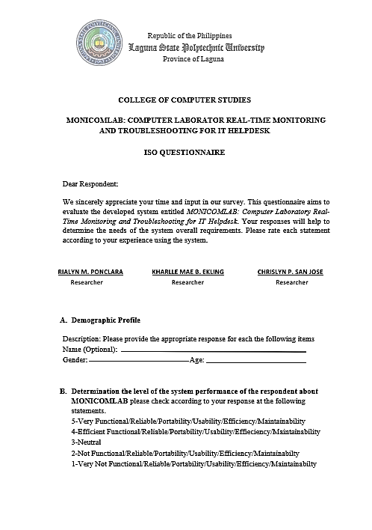

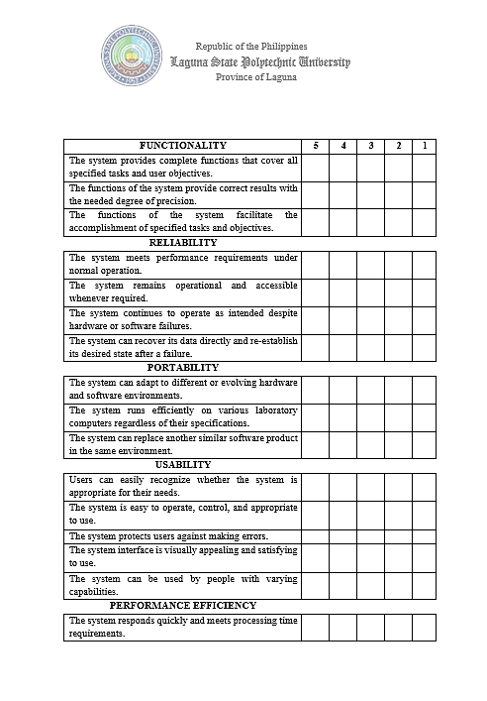

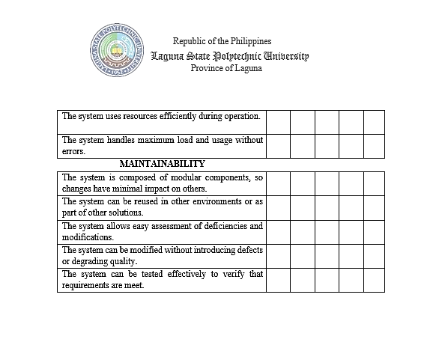

* **Capstone Project Transcribed Recording**

**DR. FRANCIS F. BALAHADIA**

Hindi, kasi ang pinag-uusapan dito is mga computer laboratories, right? CCS, specifically. So ngayon, paano yung naging prototype nyo how you monitor to the different laboratoratories? Each laboratory has its different routers, na connected does computer to provide some internet connection and what other network and activity inside. So ngayon, paano mo sa amin I demonstrate with your system, pag ito’y connected sa computer laboratory. And then, once those particular units are working, and then there will be several issues, how your system comes in. Go. Okay, so you have those computers connected with your system. Sige you may continue How do I set up? 101 may gantong devices, 30 devices. Paano ko set up to link with your system? Then, another computer laboratory, another set of 30 units to link with your system. Paano yun? Gumagana ba ito ngayon? Oo. Paano ako magse-set up? Magse-set up kami ng 206 sa 30 units na ikokonekta mo sa system. Kung ito ay gumagana, sabihin sa akin kung ito ay gumagana. Ah sa xampp. Working naba yun? Kunware set up natin si room 206 of 30 units na I ko-connect nyo sa system. Kung working na, sabi nyo it’s working. Halimbawa, computer laboratory 201. Pagkatapos, magse-set up ka ng 30 units na parang ito yung I monitor mo, not exactly 30 units kunware 2 lang muna ano ayan sige, tapos mag se-set up. Para lng ma simulate lng natin ha, sige po. So, Sino si PC3 dyan? Ito ang IP address. Paano natin ma- monitor yung activity nito You do have some activities here. Ano ang mga mimonitor nito sa PC na iyon? Bukas ka ng mga applications. Makiki view mo nga ang apps. ayan ah view apps. So far, wala pa sige ilagay mo lang dun, don sa activities tignan natin kung pumapasok yung mga sinasabi nyong na momonitor yung activities. It's like the internet. You open Microsoft Word, PowerPoint, there's music. Mag bukas ka ng PDF file, I back mo nga kung makakapag refresh yung PC3 mo. Binuksan mo ba ang Microsoft Word? It can be monitored. Mabagal lang. ang concerned ko ay yung paano na monitor if there will be some issues. May problema dun sa laptop. Kailangan, I fix. how? Sa ngayon, kase parang nakikita ko lang so far is yung mga nag bubukas na apps. So ngayon Paano mo ma momonitor yung mga concerns, issues that need to be troubleshooted? Kase kung na experienced nyo yung mga main concerns natin sa laboratory. Ano yung mga nagiging main concerns natin, ano yung mga nagiging concerns natin pag nagamit tayo ng laboratory. Full storage, bukod done? Full storage na agad nag bubukas palang agad diba yung ibang application nag bubukas palang full storage na agad. Mabagal ano pa? nag re-restart ano pa? meron paba? Hindi maka connect sa internet di maka deretso. Alam nyo pala pero hindi ko nakikita dito sa document, ang nakikita ko lng manual diba? Yung yung dapat I solve e diba, kase so far general yung discuss nyo sa document e, yung sa introduction papuntang project context, hindi yun yung dini- discuss nyong problem. And then, kase ang pinaka-main concern students. Diba student, ang mini- mention nyo dito IT diba? IT. So ngayon kunware nandyan sya so pano sya ngayon ma ti- trigger that there will be some problem with 206, 207? Pano sya mag no- notify jan sa IT diba may office sya kunware 206. My set up tayo jan na 30, okay dun sa area, di naman natin papakita yung area e, kunware di natin papakita kung saang area may problem sa 206, I identify lang natin kunware PC1,7,13, ito yung may mga concern, anong concern, paano nyo ibabato. May ganon po? May ganon po ba tayo currently? Sa future pa? wala pa? ang nakikita palang natin ay na monitor palang natin yung mga usage nung mga computers. So anong ng yayare so far ngayon. Add tayo ng add dito no, pero kunware katulad nan pag nag add ako pano ko malalaman na ito’y sa laboratory 1 diba? Comlab 2, Comlab 3? Kase ang nakalagay lang kase dyan parang add mo lang dumadagdag lang sya ng dumadagdag, sana ay parang by folder diba? Nandon makikita kong lahat diba. Itong sa 206, meron tayong 10 connected, 207 may 10 tayong connected Okay, so on and so forth. You can depend. I might not be able to handle it. But that's what I can see here. Working ba yung troubleshooting nyo? What are those? Sino yung mag sa- submit ng mga, kase diba automatic na mag di-detect ng mga concern without a specific human intervention. Kunware ako dun incharge sa 106. Nakita ko na maraming may problems dun sa mga units na handle, system na ang automatic na mag babato kay IT technician ng gagawin nya or possible na concern na nadetect nung system. Kase katulad nung last na gumamit dito, pinagamit ko mga ayaw mag continue, naka block lang tapos hindi din alam ng mga bata kung kelan mag continue, tapos nung nag continue napaka tagal and then afterward, Buong storage? Maliban diyan? Full storage na pero nagbubukas pa rin. Ito ay mabagal. ano pa ba Minsan, kapag ginamit natin ito, nagre restart ito. ano pa ba Hindi ito makakonekta sa internet. Ayaw nitong direktang kumonect. Minsan, connected pero hindi gumagana. Hindi ko nakita iyon sa document. Nakita ko lang ito nang mano-mano. tama? Iyon ang kailangang I solve. Ito ay sobrang pangkalahatan sa pagpapakilala sa konteksto ng proyekto. Hindi mo pinag uusapan ang problema. At pagkatapos, ang pangunahing alalahanin ay mga mag-aaral. tama? Mga mag-aaral. Nabanggit mo IT. tama? IT. Nandiyan na. Ngayon, paano ma-trigger na magkakaroon ng ilang problema sa 206, 207? Paano? Yan ang hinahanap namin. Paano ito ma-trigger sa IT? Nasa opisina tayo ng IT, di ba? Halimbawa, 206. Mayroon kaming isang set ng 30. Okay. Hindi namin ipapakita ang lugar. Kung hindi namin ipapakita ang problema sa 206, linawin lang namin, halimbawa, ang PC1, 7, 13. Ito ang mga alalahanin. Anong mga alalahanin? Paano ito ma-trigger? Mayroon ba tayo nito sa kasalukuyan? Sa kasalukuyan, ito ay nasa hinaharap. Sa future? Sa 207, hindi pa ito tapos. Ang nakikita namin ay sinusubaybayan pa rin namin ang paggamit ng mga computer. Gaano karaming mga problema ang mayroon? Ano ang nangyayari sa ngayon? Dagdagan pa natin dito. Halimbawa, kung magdadagdag ako, paano ko malalaman kung ito ay nasa Laboratory 1, comLab 2, comLab 3? Isa-isa lang kasi itong dinagdag. Parang folder na nandoon. Nakikita ko lahat. Sa 206, mayroon kaming 10 connected. Sa 207, mayroon kaming 10 na conneted. Okay, so on and so forth. Makakaasa ka. Baka hindi ko na kayanin. Pero yun ang nakikita ko dito. Parang group chat na may pangalan, halimbawa, Lab 1, Room 1, Room 2. Doon natin ito makikita. Oo. Kaya naman sinabi kong gawin mo. Idinagdag lang. Okay. Nagpakahirap ka ba sa pag-troubleshoot? Para sa pag-troubleshoot, ang ginagawa namin ay kung mayroon kaming isang awtomatikong sistema upang i troubleshoot ang isang problema, ang mga pangunahing problema ay kung ano ang maaari naming hawakan. Ano ang mga iyon? Ito ay tulad ng isang internet cross-connection. Para sa mga problema tulad ng memorya, maaari tayong magdagdag ng espasyo. At pagkatapos, para sa pag-troubleshoot, mayroon kaming awtomatikong system na bumubuo ng mga ticket. Kung ang isang ticket ay nabuo, ito ay automatic mapupunta dito. Para sa amin, 60% lang ang sytem namin. Pagkatapos, may opsyong mag submit ng ticket kung hindi ito mabuo ng system. Sino ang mag papasa? Ito ay tulad ng isang automatic system na nakakakita ng mga alalahanin nang walang partikular na interbensyon ng tao. For example, I was in charge in 2006. Nakita ko na maraming problema sa units ko na na-handle. Automatic pupunta ang system sa aming IT technician para gawin ang mga posibleng alalahanin na nakita ng system. tama ba yun? Anong mga alalahanin sa iyong system ang nakitang mga problema? Parang last time na nandito ako, ginamit ko sa unit ko. May mga taong ayaw ituloy dahil nakaharang. Minsan, hindi alam ng mga bata kung kailan magpapatuloy. Nagtagal ito Pagkatapos, hindi sila connected sa internet. Iyan ang mga karaniwang alalahanin na nais nating lutasin dito. Kaya, hindi ko pa nakikita kung paano na trigger ng admin ang mga alalahanin. Automatic ba ito? May notification ba? kailan? Paano natin malalaman kung nalutas na ang mga alalahanin? Nasaan ang mga log? Mangyaring ipakita sa amin. Dito, makikita natin ang lahat ng mga isyu kapag hindi nalutas ang nakabinbing. Kapag alert, wala sa loob. Eto na. Kapag sinabi mong alert, alert na may alalahanin. Kaya, nalutas mo ito. Ngunit walang nakaalerto. Kapag alerto ito, magbibigay ito ng mga mungkahi kung paano lutasin ang problema sa ilang device. Kaya, ano ang pinakamalaking problema? Saan mo nakita ang problema? Ang mungkahi ay naayos na ngunit walang problema. anong problema? saan ang problema? pasensya na po. Nasa alertong mungkahi ito. Nasa alertong mungkahi ito. Sa sinasabi ng alerto, ano ang nakikita ng IT o admin? anong problema? kaninong computer? saan ang kwarto? saan ang kwarto? 206. Ano ang pagkakakilanlan ng PC na iyon? Ano ang alalahanin? May mungkahi. Okay, mabuti iyon. Pero hanggang ngayon hindi ko pa nakikita. Oo, sige. Hindi ka nagsasalita. Kahit na nakikita namin ang sinasabi mo, hindi ka nagre-react. Halimbawa, sa isang computer lab, hindi ako ganoon ka-technical sa networking, sa isang computer lab, mayroon ba tayong ilang mga router na konektado? may switch ba? may hub ba? O ano? Sa tingin ko ito ay konektado lamang sa isang pangunahing. Halimbawa, kung ginagamit ng iyong router ang tatlong router na konektado, tama ba iyon? lima. Kaya isa lang itong router. Isa lang itong router at matutukoy mo ang mga computer na iyon batay sa IP address. buti naman. Ngunit wala pa ring ibang pangunahing alalahanin. Kasi naglagay ka lang ng warning. Paano ang tungkol sa pagkakakilanlan ng kalubhaan? Grabe naman. Mayroong babala ng kalubhaan. Paano mo ito ikategorya? Para sa babala, hindi ito ganoon ka-kritikal. Maliit na isyu lang. Maliit na isyu lang. Ano ang isyu? Sa warning, ano ang isyu? Ito ba ay ang paggamit lamang ng RAM? Dahil iyon ang palaging inaalala namin. Iyan ang palaging inaalala namin. Ngunit kadalasan, hindi ito ang pag-aalala. Kaya sana, matukoy natin ang iba't ibang alalahanin bukod sa paggamit ng CPU. Dahil medyo luma na ang ating mga computer, paano naman ang ating magagandang computer sa 108, 107, o 207? Medyo mataas ang specs nila. Kaya ngayon, ano ang pinaka aalala doon? Halimbawa, nakabitin ito. Maaari ba itong masubaybayan? Kasi sa 207, laging nakasabit. Lalo na kapag ginamit mo ang RapidMiner, nakasabit ito. Kaya maaari itong matukoy? Maaari ba itong matukoy? Dapat mong sabihin ang saklaw at mga limitasyon ng mga bagay na iyon upang maging malinaw tayo sa kung ano ang kailangang saklawin at kung paano ito magpapatuloy. Gusto ko ang ideya. Iyan ang tamang gawin. Pagsubaybay, pagsasabit, pagtukoy ng mga alalahanin, mga isyu, kung paano lutasin ang mga ito, kung paano ikategorya ang mga ito. So at least, dapat may report sa IT. Dapat mayroong isang ulat para sa isang buwan. Dapat mayroong talaan ng mga ulat. Halimbawa, sa 207, may mga alalahanin. Ito ang mga naaksyunan. Para may monitor tayo. yun lang. Iyan ang aking mga alalahanin. meron pa ba? wala na? Okay. Hindi ko na pinagdaanan ang mga dokumento dahil nakatutok ako sa mga sistema. Ayan na para sa pagpapakilala. Hindi ako dumaan sa konteksto ng proyekto dahil ito ay isang malaking bahagi. Iyon ang dahilan kung bakit dapat mong tukuyin ang iyong mga alalahanin.

**MERVIN JOMMEL T. DE JESUS**

Good morning po, ito po ay comments and suggestion po or may question din. So, pa check po muna ng dashboard so that’s good po ano na meron kayong dashboard, in that dashboard ano ba yung pini perform natin dyan. Yan yang CPU usage, ah laptop, Main Server. How about yung parang summary, lahat ng naka connect nandyan sa MONICOMLAB nyo, Sa device monitoring. Kaso lahat yan isa-isa nyo yan, imean yung sa dashboard we can put some ano don summary nung ano, some analytics din. So yun ahh real time ano po kase meron kayong word na real time monitoring and troubleshooting for IT helpdesk pero kanina I think kailangan nyo pang bumalik ng page tas I click ulit yung PC para pumasok yung mga data nyo. Siguro what can I suggest is refresh at the same time yung ano para real time na mang yayare, so meron namn yun ano nakikita nyo yun kung pano ginagawa. So connected devices okay naman, sa connected devices siguro we can add the mac address not only the ip address unless otherwise we have another function pa dun sa ip address, static ba natin yung mga Pc para mas madali yung mangyayaring monitoring ang troubleshooting for our devices. And then I agree po na I categories like for example, laboratory room 1, 101,202,203 tas nandon kahit siguro naka ano lang kase lahat na ediba. Diba hindi natin alam kung san pupunta si technician kung halimbawa mag ka roon ng error ano po, and then siguro we can also add that yung PC halimbawa ay ginagamit ko I can report ano po kase to more on ano lang to e admin side tama. Pero yun nga yung concern kanina halimbawa may error akung na detect, specific ay dun sa internet pano malalaman natin na connected sa internet yung PC, ano po how kase naka local tayo e definetly ma ano yan connected sayo kapag naka network pero ang concern is kapag wala ng internet ano ng mangyayare kase more on focus tayo sa network administration so yun yung concern, pano pag na disconnect sa internet detected din sya. Halimbawa yung pc okaya nawalan ng internet yung pc, siguro makita natin na maging usecase din yun sa mga susunod like for example kase diba naka router kayo ngayon definetly online ka kase connected ka jan e, pero kapag ano yung router ba natin may internet sya. So yun pag inalis natin yung sim card kung naka sim card ba yang gamit nyo na router nayan na disconnect sa internet so kita natin, kase naka local kayo e edi definetly makaka connect kayo sa system and then dahil yun nga magiging limitation nyo pano kapag na disconnect sa network kase we are using web base system kase yun nga yung concern, So how to deal with does kase yun nga ay agree yung common pc problems halimbawa yun yung mga walang internet lahat- lahat paano mangyayare, ano po yung common pc problems natin diba, mag kakaroon tayo ng kase diba nabanggit din ni dean kanina yung mga problems na na mention nyo kailangan automatic ganto ganyan mano- mano system pero kung common pc problems ano ano bayun siguro I suggest look for common pc problem not only yun eto yung eto yung nararamdaman natin dito pero RRL can do. Halimbawa yung CPU yan meron na tayo yung RAM yung peripirals halimbawa hindi naka connect yung mouse hindi naka connect yung keyboard. Ang problema natin ay real time monitoring ang troubleshooting ano yung focus natin. Bkt, pag nabigyan nyoko ng isang magandang dahilan supported by literature. Yung mga pc natin may device manager it can detect if connected o hindi yung mga fireperals software yun diba, pero yun tignan nyo yun as a suggestion we need to ano live with your title ano po computer laboratory, real time monitoring and troubleshooting isa yun sa common problem hindi nagana yung mouse sira ang keyboard e dapat dyan kung realtime yan pag nag bukasan lahat ng ating laboratory room kita natin, oh sa room 202 pc 3 sira yung mouse oh punt ana kaagad s technician hindi na kailangan I report ni user e kung focus natin e yung software only anong kahalagahan non halimbawa dyan ka sa part nayan, ma detect natin na guma gamit ng dota Ng kung anong games ano po somewhat like that. Kase ang iniisip ko maging useful to para sa atin, I suggest mag conduct ng interview sa ating technician. Si sir Edwin yung naging guide jan.

**GLAIZESS P. SALISI**

On the introduction, sa panimula, mayroong isang mahabang talata na walang sipi. self-claim ba yan? O may author na nakakuha nito? Kami ay isang 5-taong panitikan. Napansin ko na maraming reference sa iyong in-text citation. Kung maraming may-akda, maaari mong banggitin ang et al. Kung mayroong dalawang may-akda, maaari mo silang banggitin. Sobra na kasi. Laging may author. Teka, may idadagdag ako. Kung ang mga author ay mahaba, maaari mong banggitin ang buong mga may-akda sa unang pagtatangka. Ngunit kung ikaw ay maikli, ito ay et al. Sa konteksto ng proyekto, nagsagawa ka ng isang panayam batay sa kanyang sinabi. At ang mga issue na natukoy niya ay nagmula sa interview. At pagkatapos, ang spacing. Ang bawat paragraph ay dapat magkaroon ng space. Pero pinapasok mo lang. Hindi ito dapat magkaroon ng puwang sa talata na may dalawang puwang. Dapat kang magdagdag ng espasyo bago at bago ka maglagay ng talata. Sa layunin, magkakaroon ng indent. Sa ilalim nito, magkakaroon ng isa pang indent. Isasama ko ito sa iyong layunin dahil nandito na tayo. On your objective, maybe we can't include Ito lang ba ang susuriin mo? Mag aral muna tayo. Kapaki-pakinabang at kadalian ng paggamit. Hindi yung lima. O yung lima. Sa hinlalaki. Yung dalawa lang. Bakit dalawa lang? Kasi... Bakit dalawa lang? Dapat lahat. Iyon ang ilalim ng hinlalaki. Ibang challenge yan. User-friendly. Ang system ay user-friendly. Madali lang... Naiintindihan namin. Pero normally, yung lima. naguguluhan ako. Yan ang thumb model. yun lang. Ito ay standardized. Tapos, ilagay mo dito. May hinlalaki ka. Ngunit pagdating sa iyong instrumento sa pagkolekta ng data, naglalagay ka ng isang talatanungan sa pagsusuri kung saan mo inilalagay ang thumb at ISO. Gumagamit ka ba ng ISO? Ilagay mo diyan. Nagamit mo ba o hindi? Doon namin nilagay. Ilagay ito sa object page kung gagamit ka ng ISO. Dahil isinama mo ito sa talakayan, kaya malinaw. Sa conceptual na balangkas, sundin ang format ng caption kung saan ito naka-indent. Isang user lang yan. Admin lang. Mag-ingat sa malaki at maliit na titik sa talata. Dapat itong uppercase o upperspace. Tapos, may periods. Inalis ko ang isa, ngunit maaari mong suriin ito. Sa Kabanata 2 o RRL, mayroong limang taong panitikan. Mangyaring magsama ng transition statement sa iyong talakayan bawat seksyon. Ang bawat seksyon ay dapat magkaroon ng isang pangwakas na pangungusap sa kung paano tinugunan ng iyong system ang mga puwang na tinatalakay sa aming unang seksyon. Sa kaugnay na sistema, napansin kong walang mesa. Walang mesa. Walang paliwanag sa talahanayan. Sa Hulipadok, tapos na. Ang talahanayang ito ay dapat may ibinigay na format. Pakisuri kung mayroong tamang format ng talahanayan at pamagat ng talahanayan. Normally, ganyan lahat ng table mo. Kung magpapakita tayo ng figure, kailangan nating magkaroon ng talakayan bago iharap ang figure. Maaari ka ring magsama ng intro tungkol sa kung ano ang iyong tatalakayin. Maaari mo ring ipakita ang pigura at pagkatapos ay isa pang talakayan. Sa dulo ng talata, dapat mong bigyang-katwiran ang pagkakaiba ng iyong system at ng kaugnay na sistema. Sa disenyo ng pananaliksik, isakonteksto ito sa iyong pag-aaral at isama ang isang talahanayan sa aming populasyon at disenyo ng sampling. Sa text citation, i-double check. Gumamit ng mga transitional device upang mailagay mo ang may-akda nang hindi ito ikinokonekta sa nakaraang pahayag. That's all. Congratulations.

* **Story Board.**

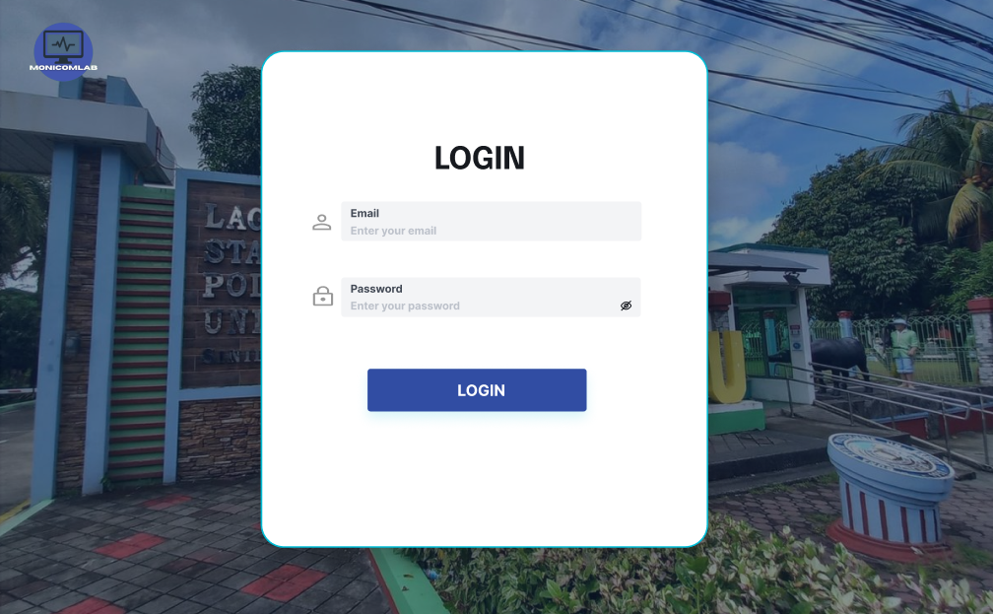

Login Page -The purpose of this login is too able to login admin account

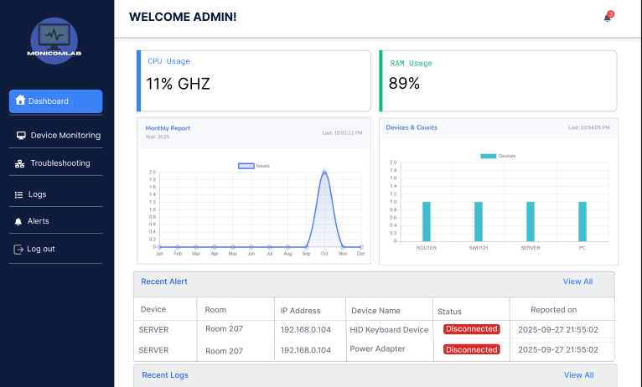

Dashboard - The purpose of this dashboard is can be monitored or view cpu usage, ram usage, data analytics, notification, recent alerts and recent logs.

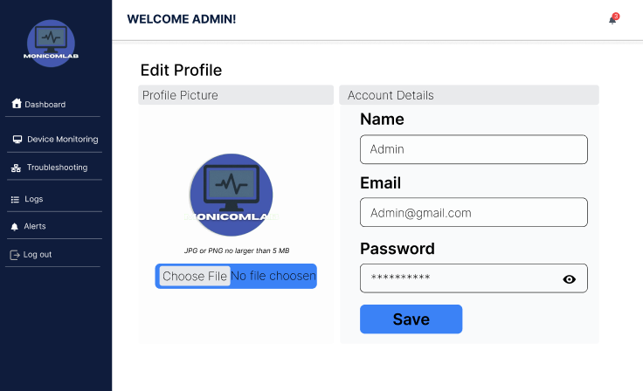

Admin can change picture logo or name, email and password

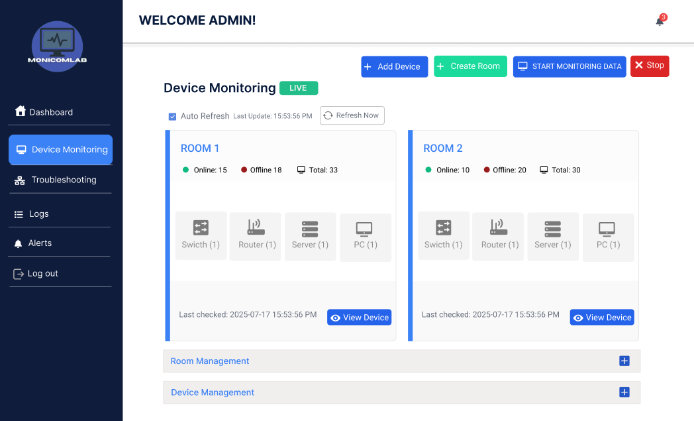

Device Monitoring – admin can monitor all connected devices

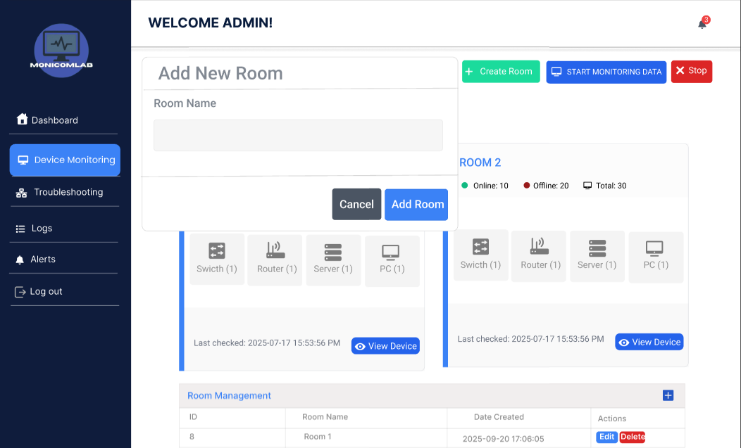

Create Room

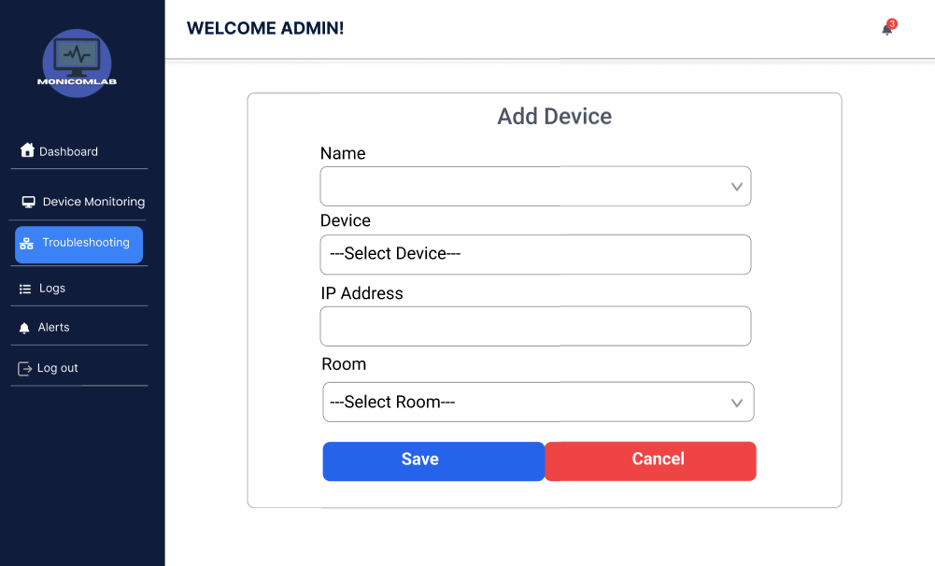

Add Device

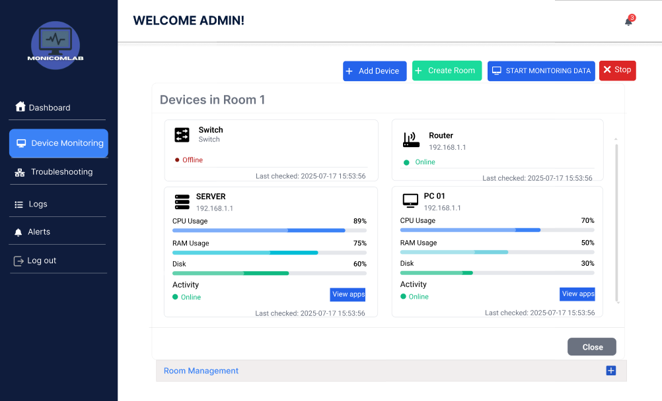

Admin can view all connected devices.

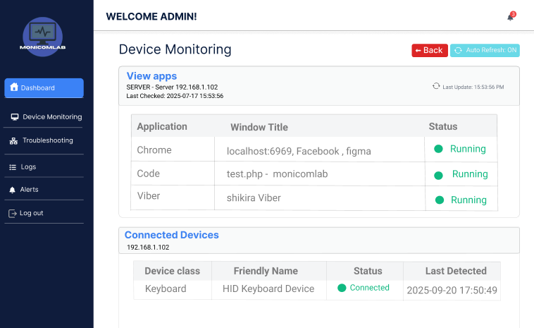

Admin can view user activies and connected devices.

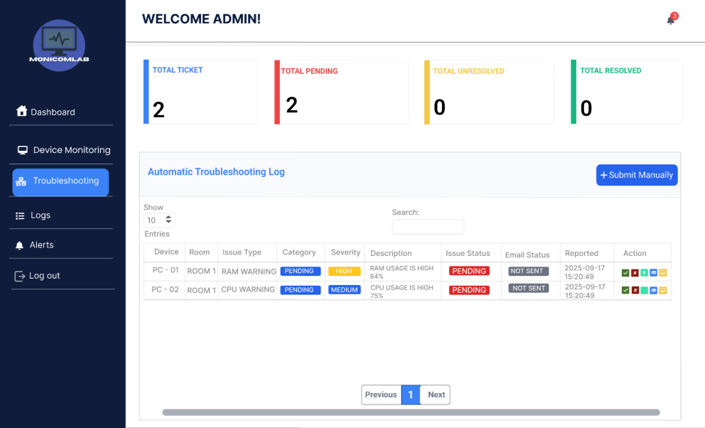

Troubleshooting – All detected issue automatically creates ticket and display here.

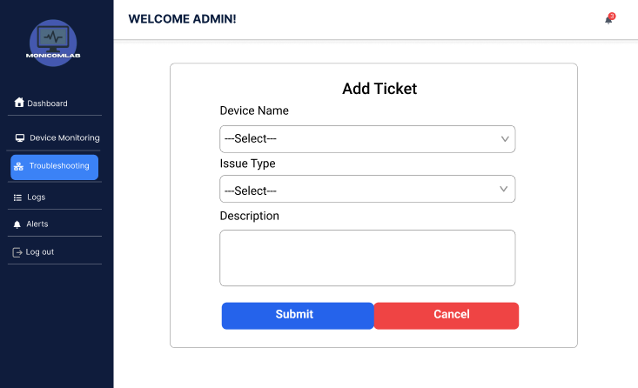

Admin can create ticket manually ounce the system cannot generate automatic the issue

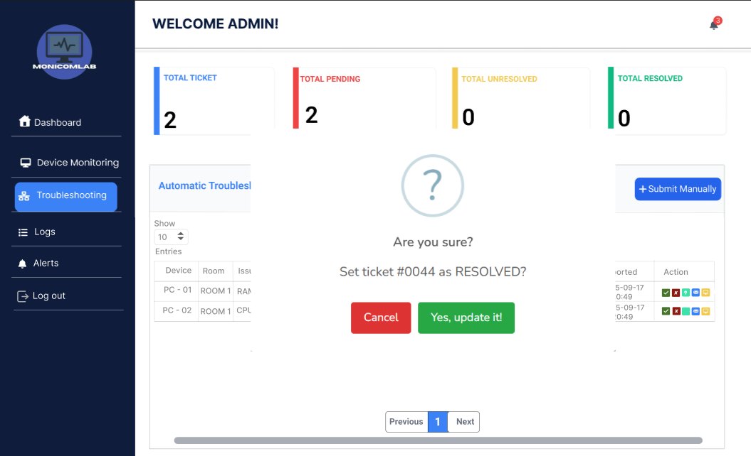

Admin can resolve the issue when the technician resolved it.

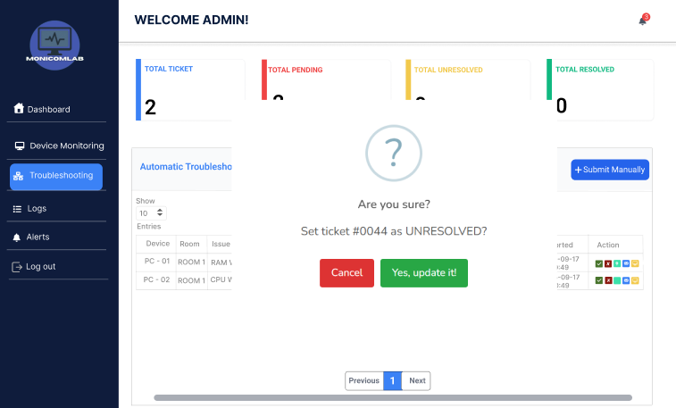

Admin can unresolved the issues.

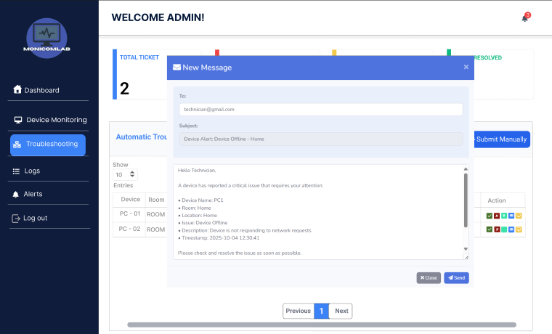

Then system automatic create email that admin can send it to technician to inform the issue location.

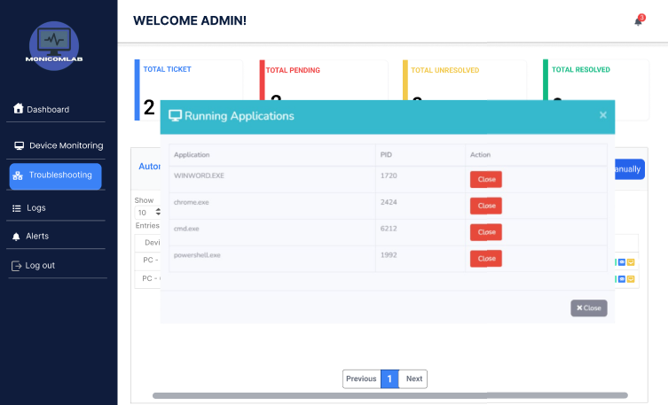

Remote fix admin can control it to close running application for the issue of RAM, CPU. DISK.

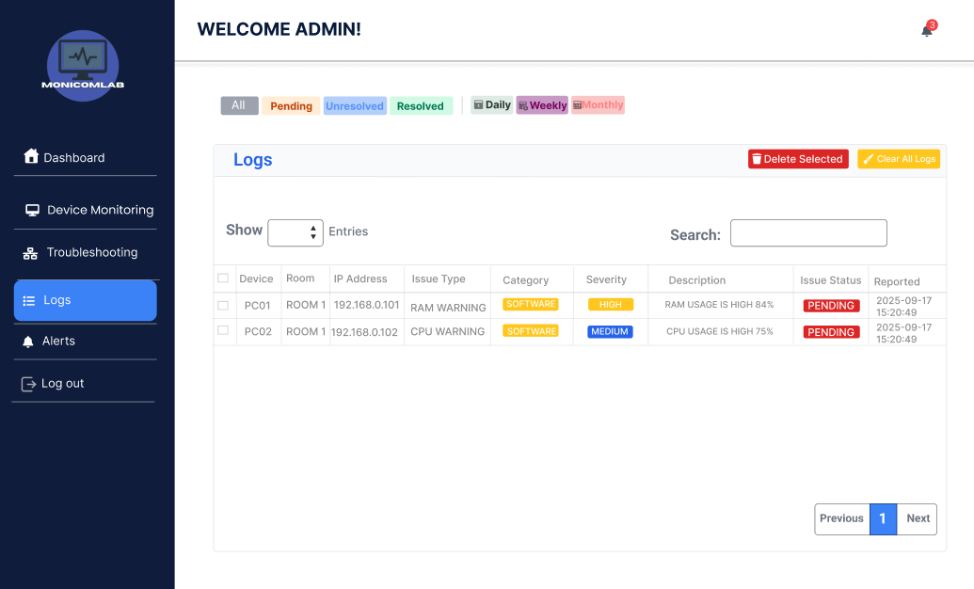

Log – all issues will display here

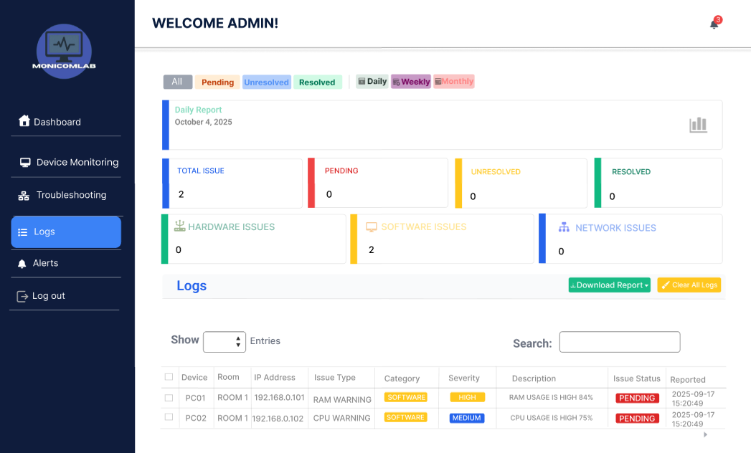

Admin also can download report daily, weekly and monthly.

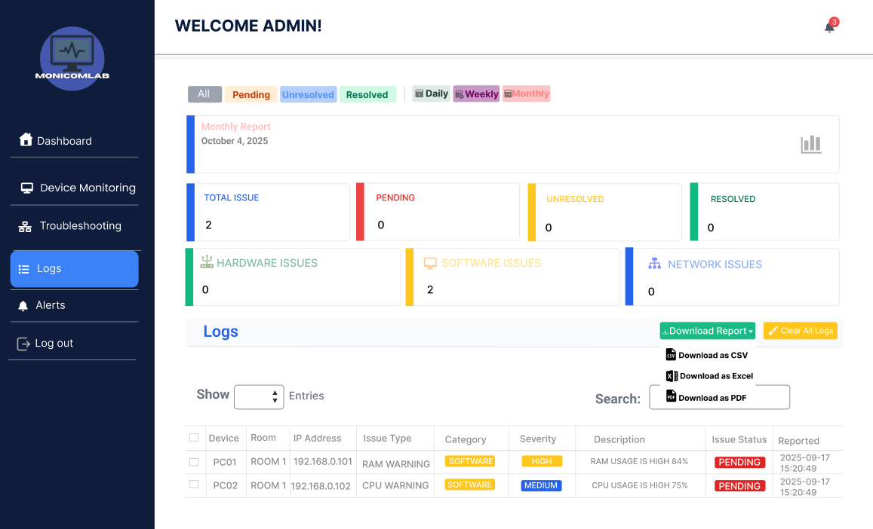

Admin choice to download such CSV, Excel, PDF.

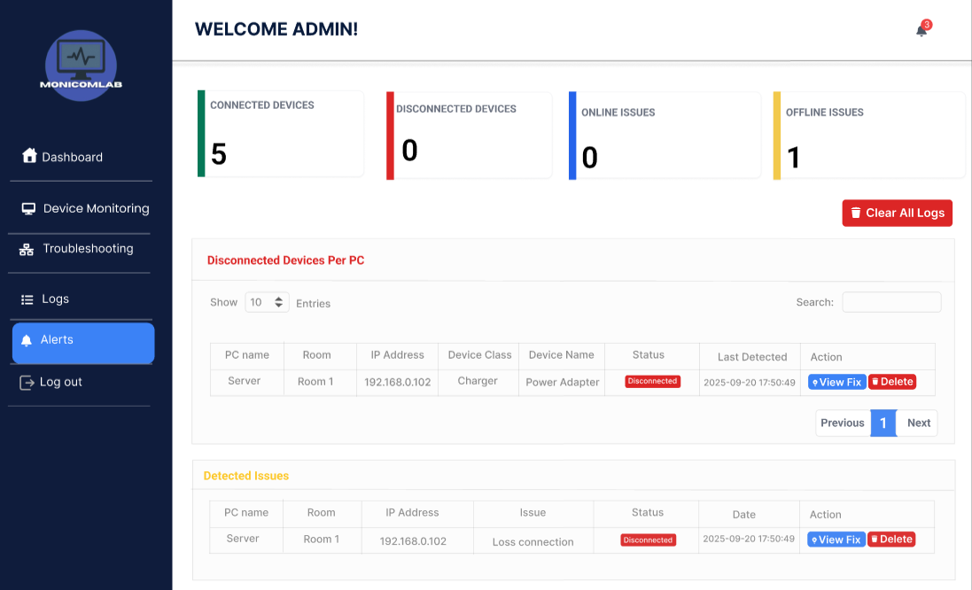

Alert – The purpose is to display all disconnected devices such as hardware and detected issue such as connection or disconnected.

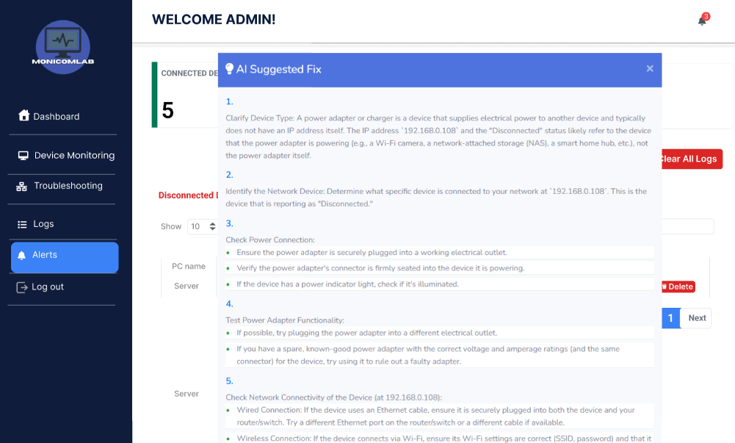

View fix admin can view the suggestion to issues detected.

* **Current Flow Chart / Process Flow.**
* **Software**

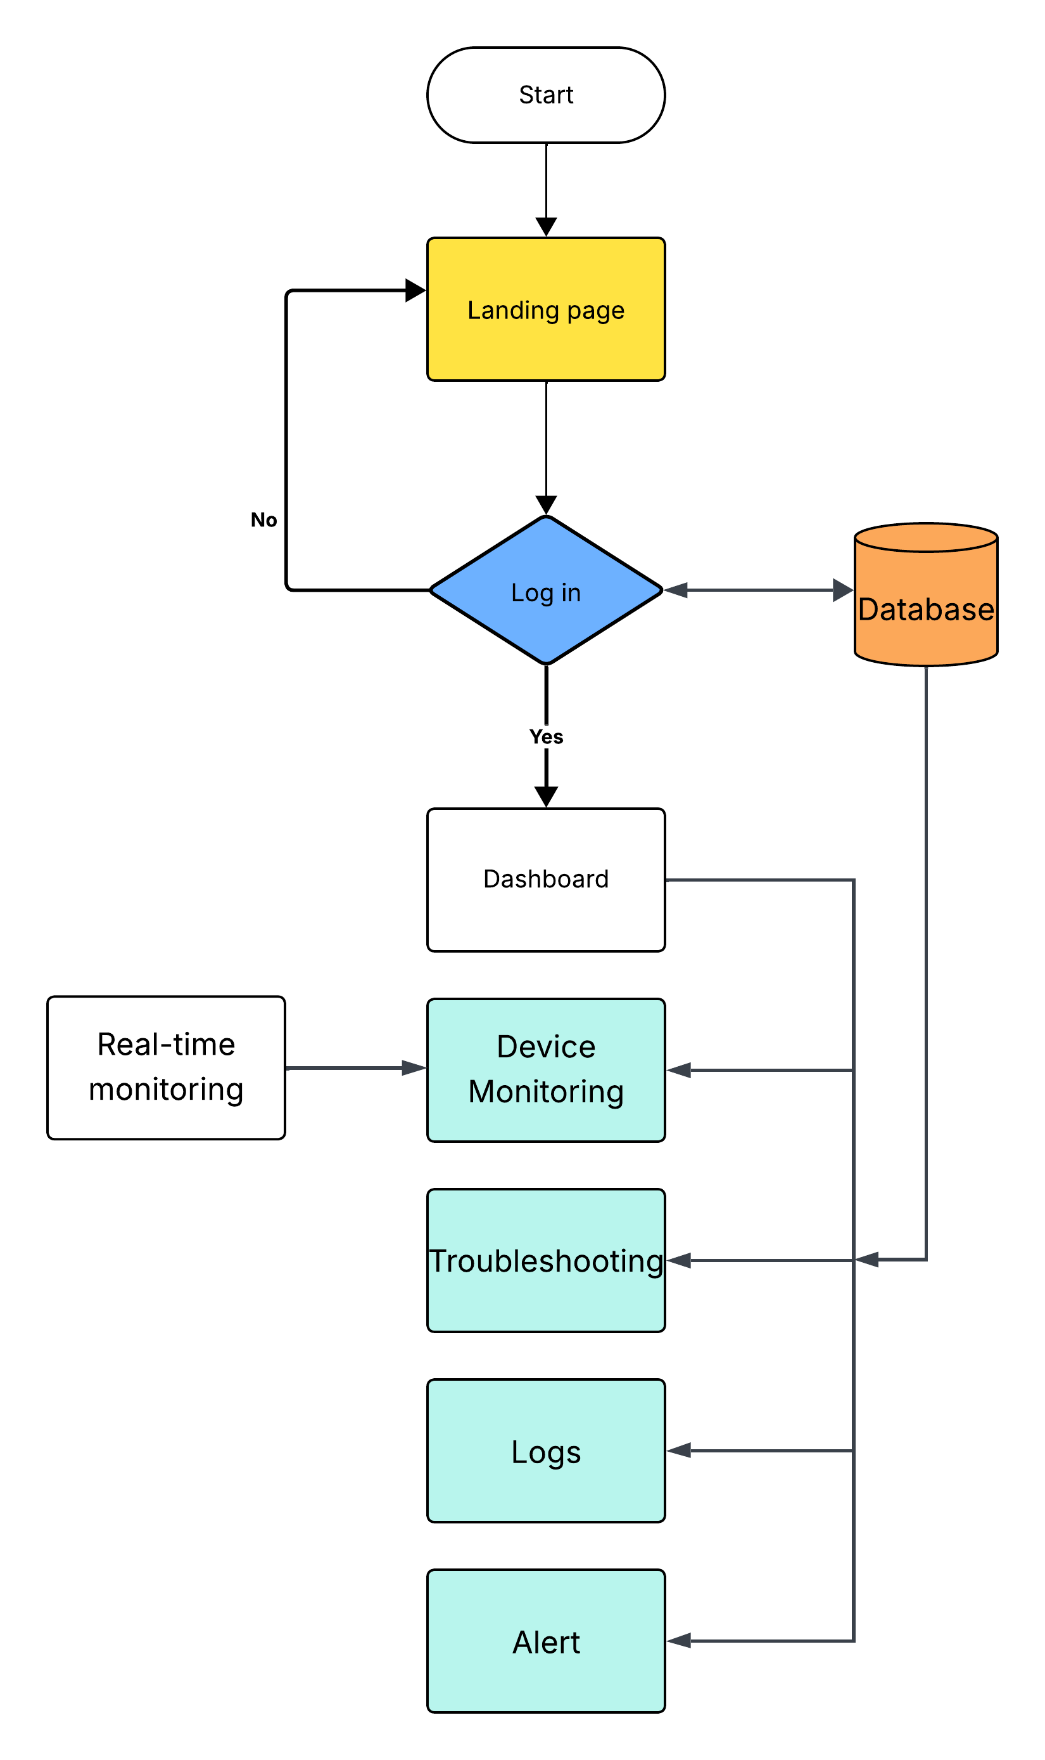

* **Proposed Flow Chart / Process Flow.**

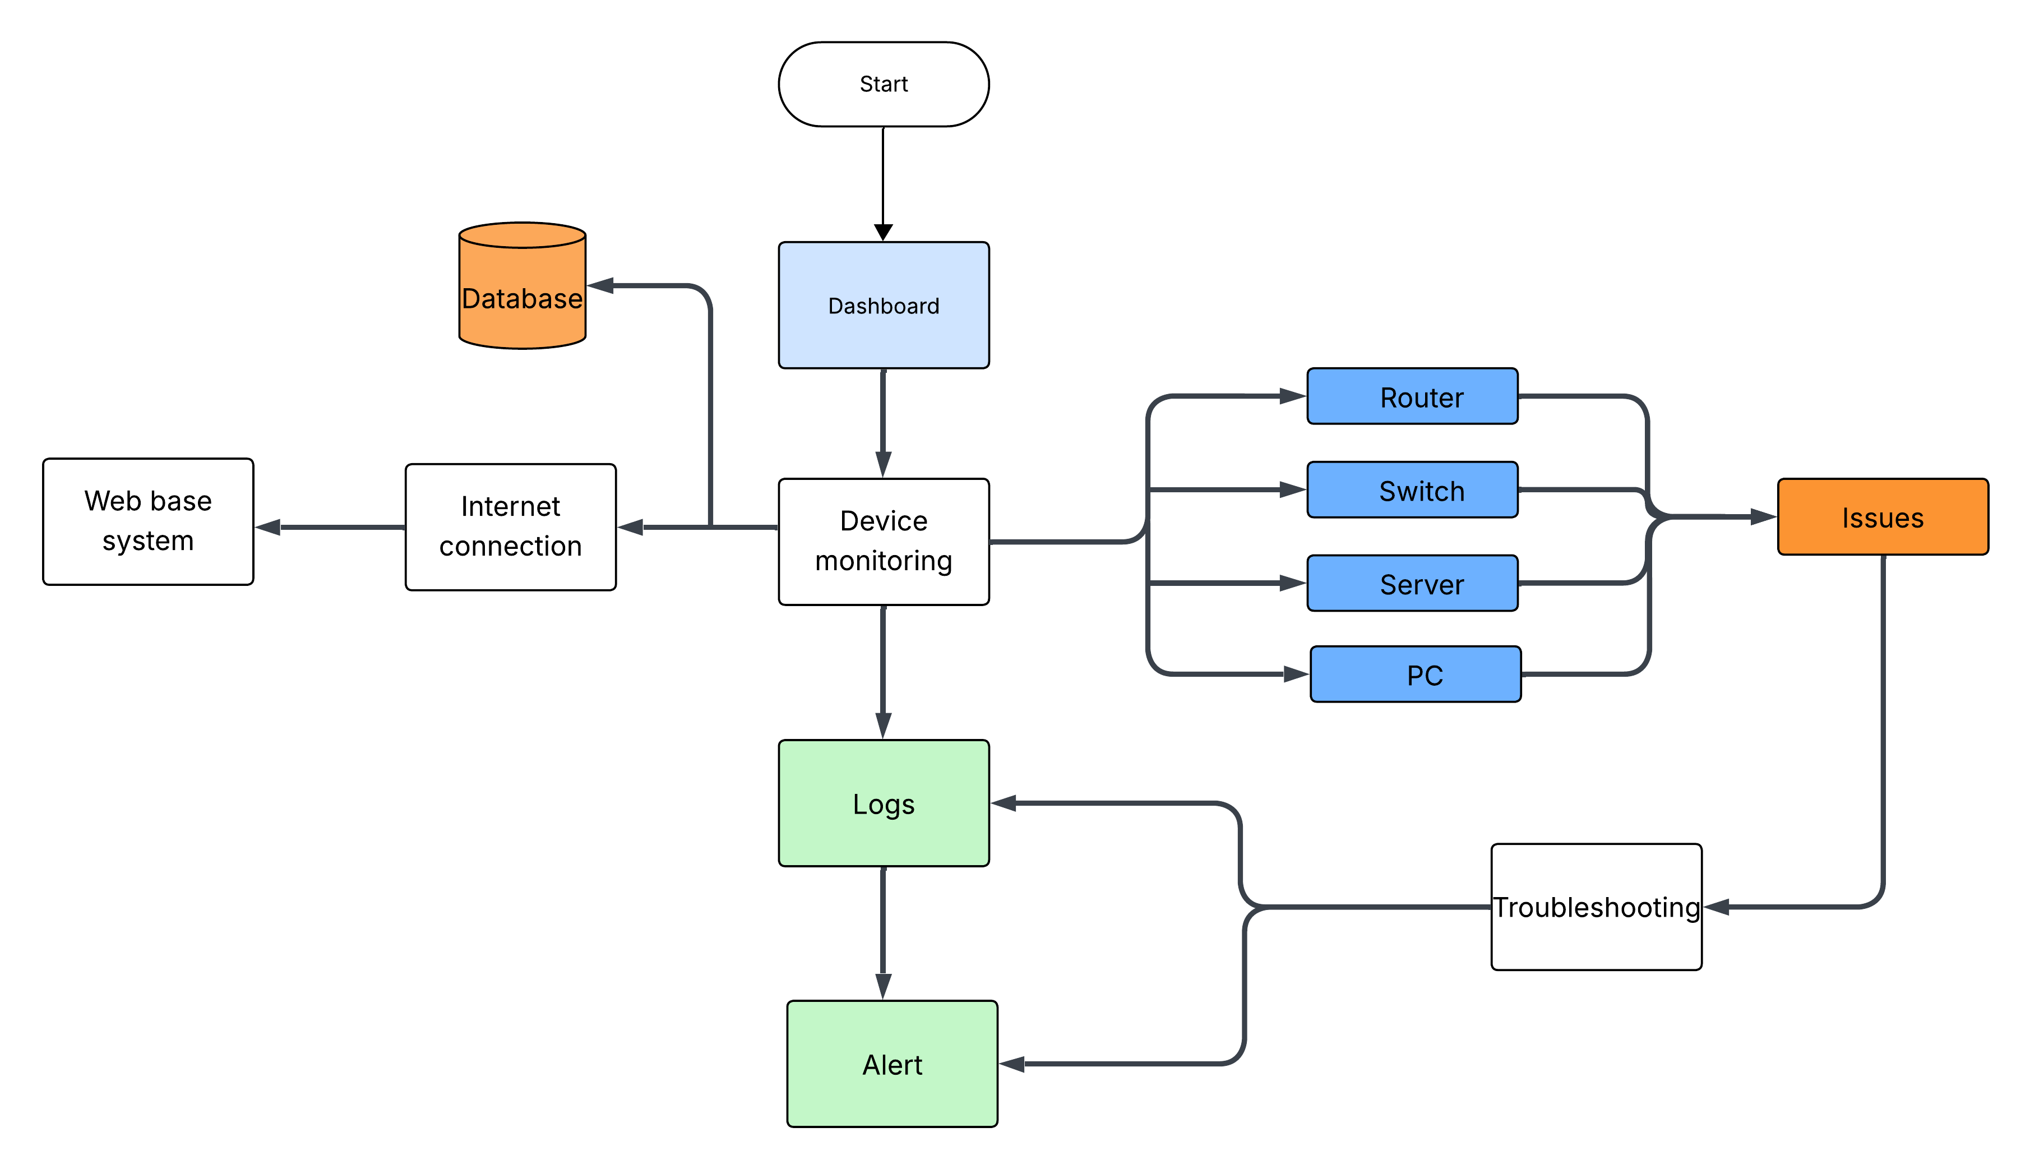

* **Proposed Use Case Diagram**

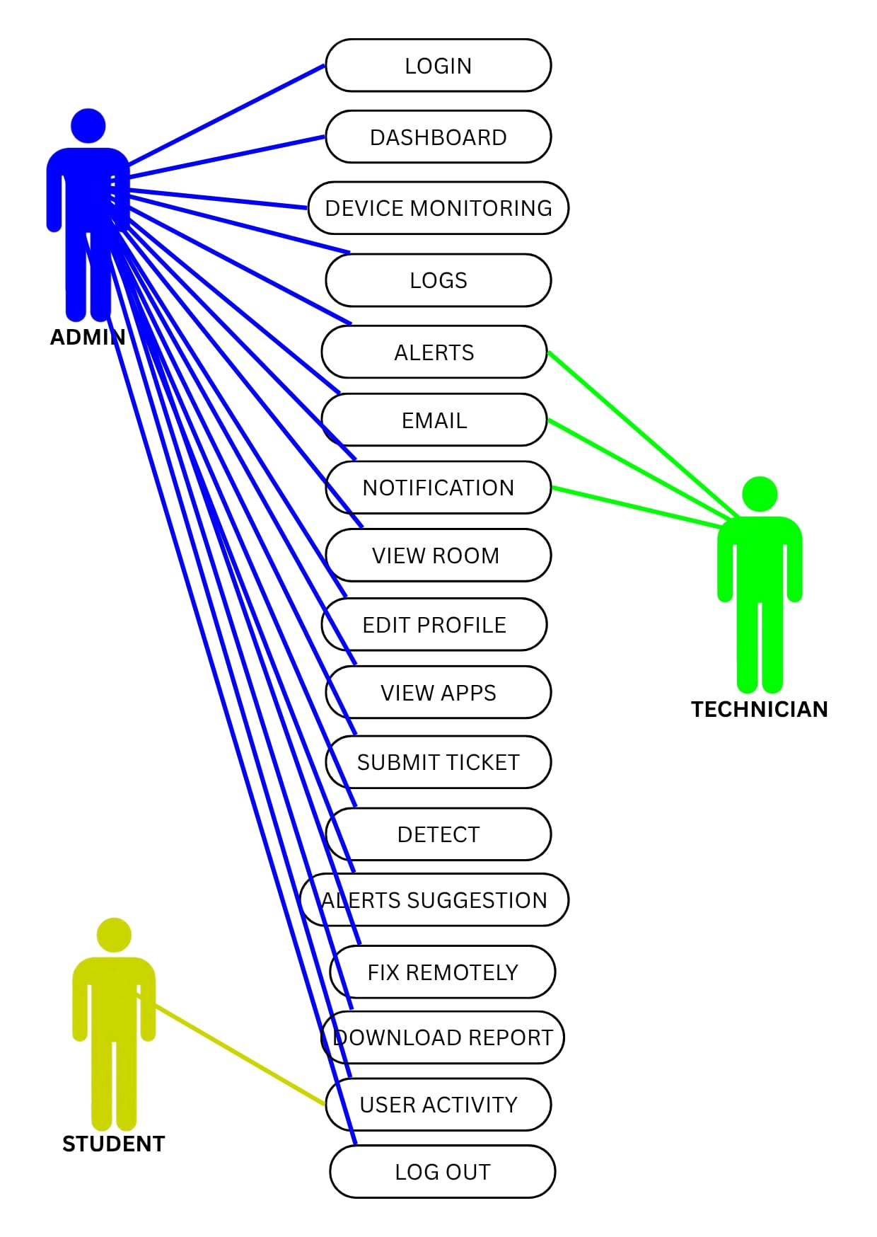

1. **Specification & Design Phase**

* **System Architecture / Module Specification**

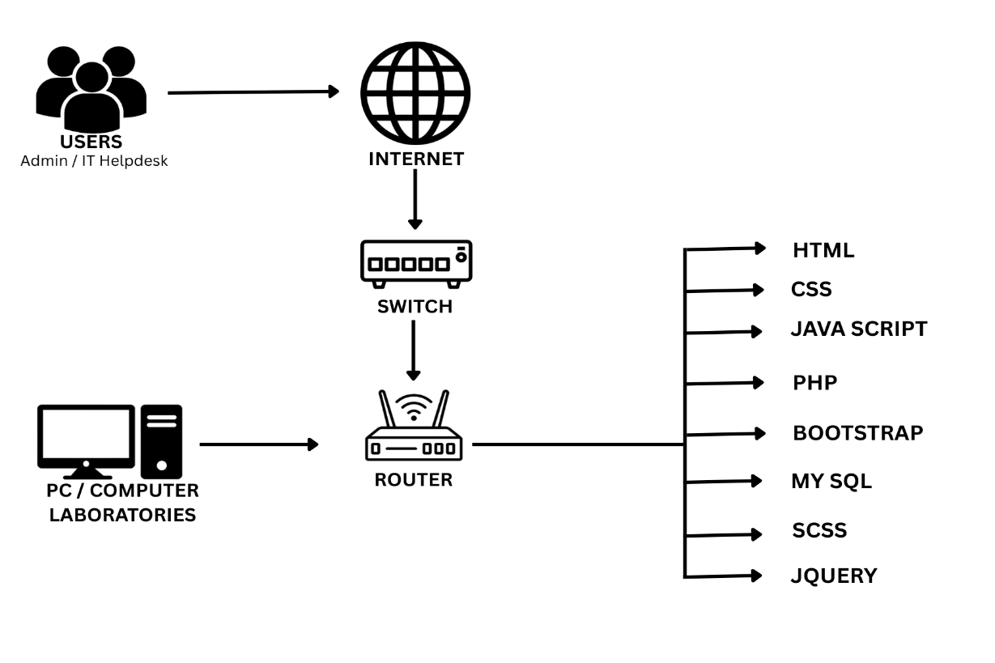

* **System Context Diagram**

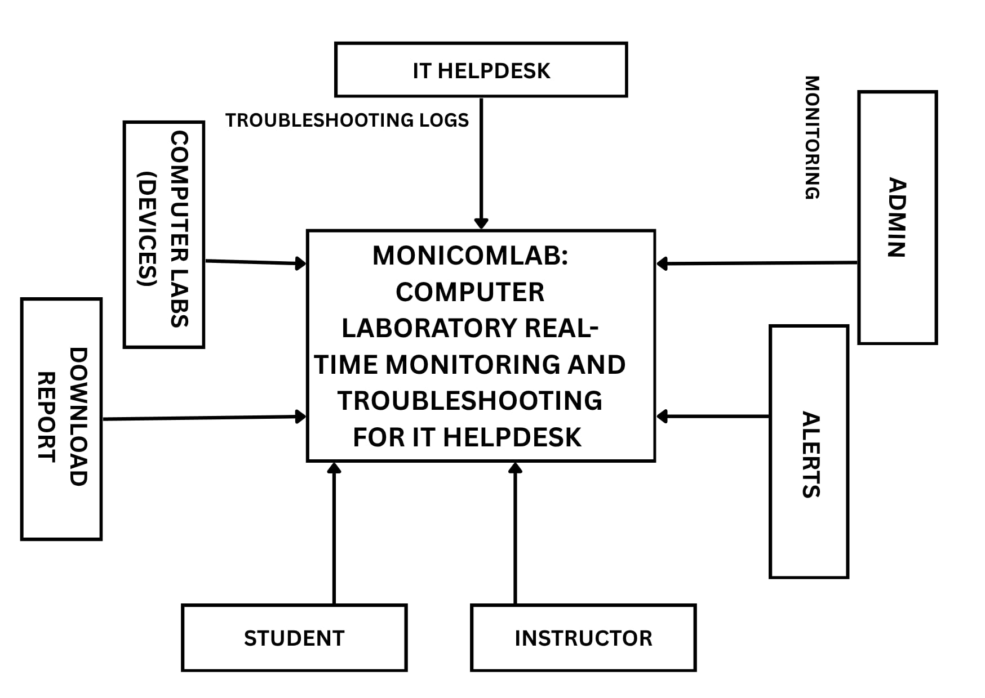

* **Data Flow Diagram**

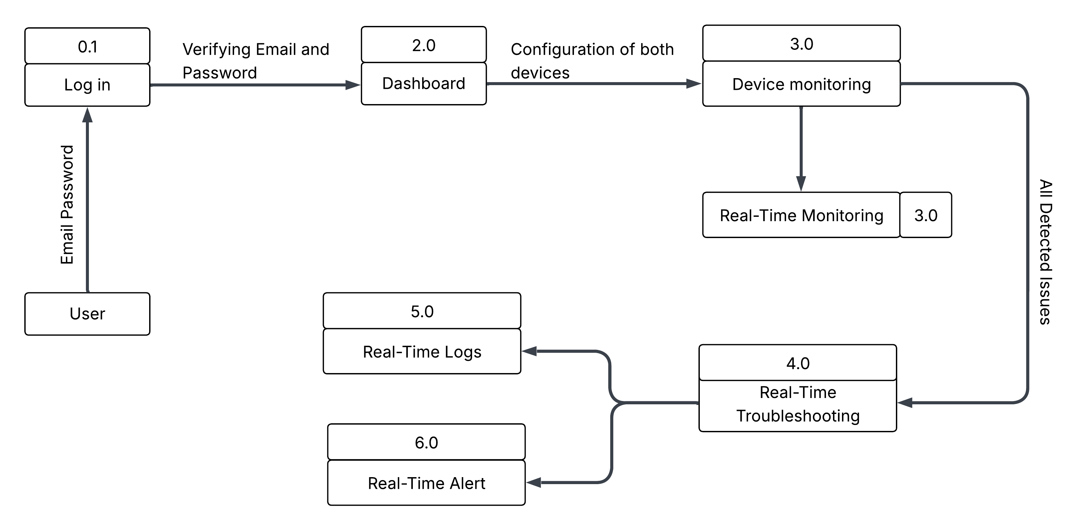

* **Data Dictionary**

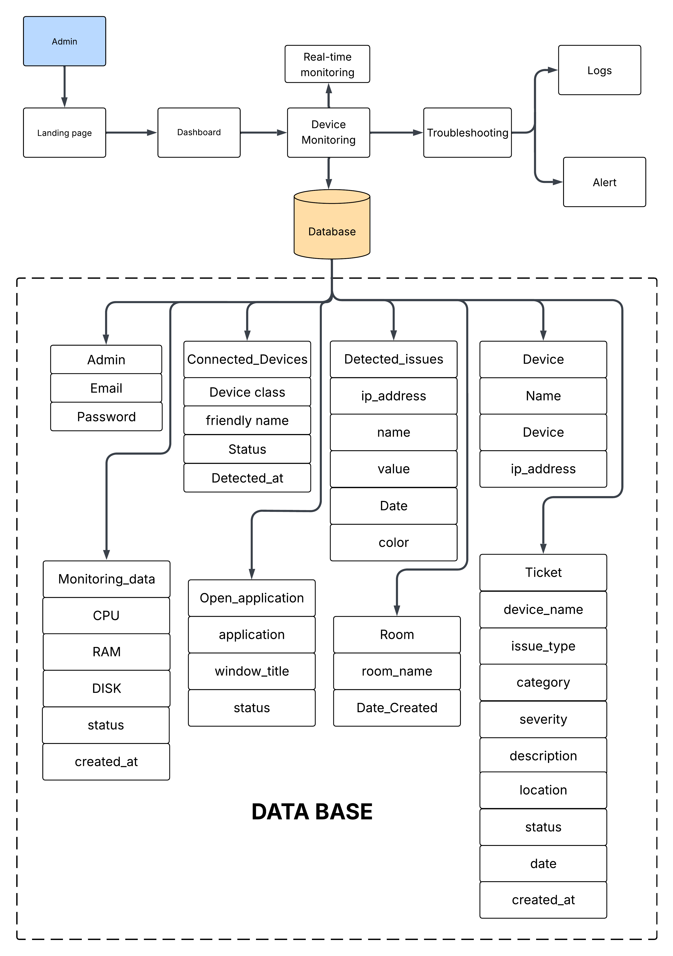

* **Hierarchical Input Process Output Model**

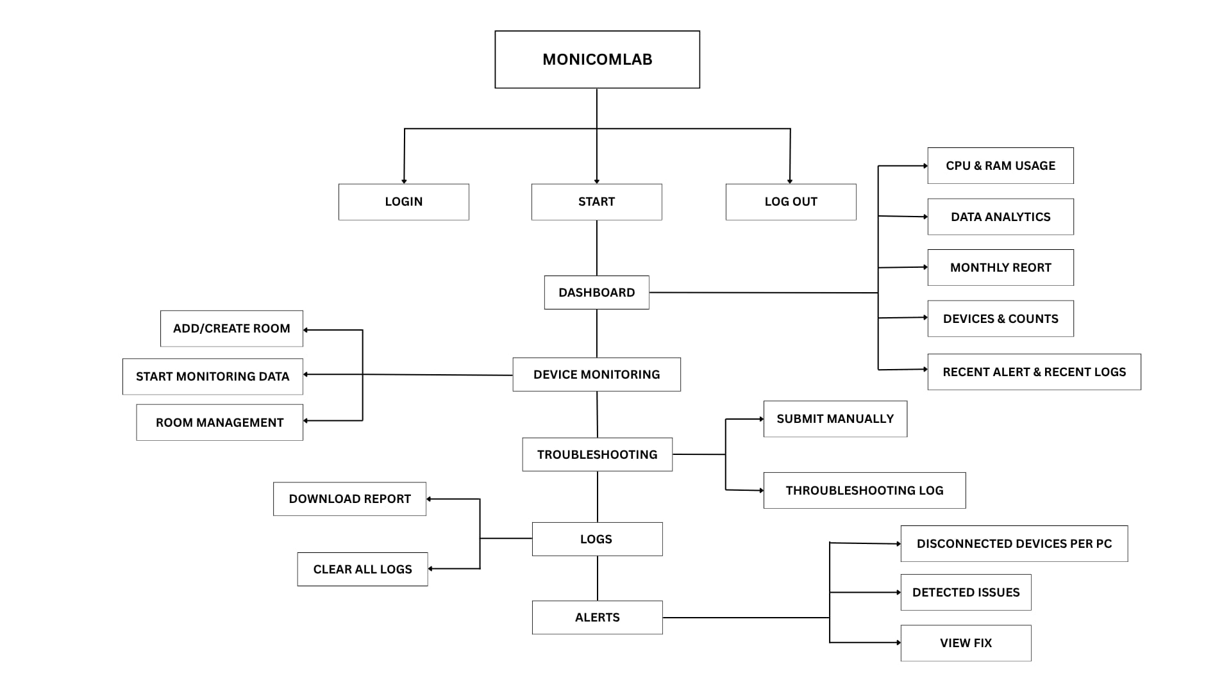

1. **Project Schedule**

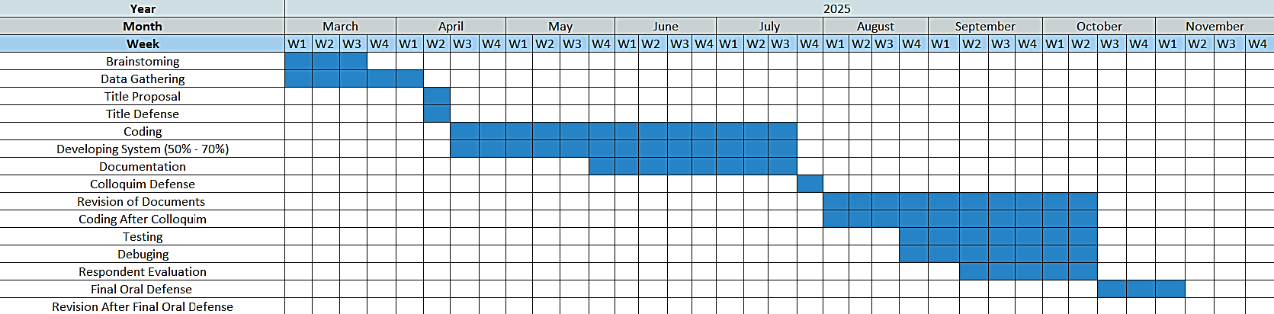

**D. Hardware and Software Resources**

following pictures are the resources that need in developing the system from its software requirements and hardware particularly in document and requirement to proceed on developing the system.

Hardware requirements of the system

|  |  |
| --- | --- |
| **HARDWARE** | **EXISTING** |
| Router | ✓ |
| Laptop | ✓ |
| Switch | ✓ |
| Server | ✓ |
| Desktop Computer | ✓ |

Developers will need following software to prepare for the development and design of the proposed system:

Software requirement of the system

|  |  |
| --- | --- |
| **SOFTWARE** | **EXISTING** |
| PHP | ✓ |
| CSS | ✓ |
| Xampp | ✓ |
| UI Transition | ✓ |
| HTML | ✓ |
| Visual Studio Code | ✓ |
| Java Script | ✓ |

**Input/Output/Reports Screen Shots**

The MONICOMLAB users will be have a given account if that user has a MONICOMLAB hardware. User must input the given email and password in the textbox.

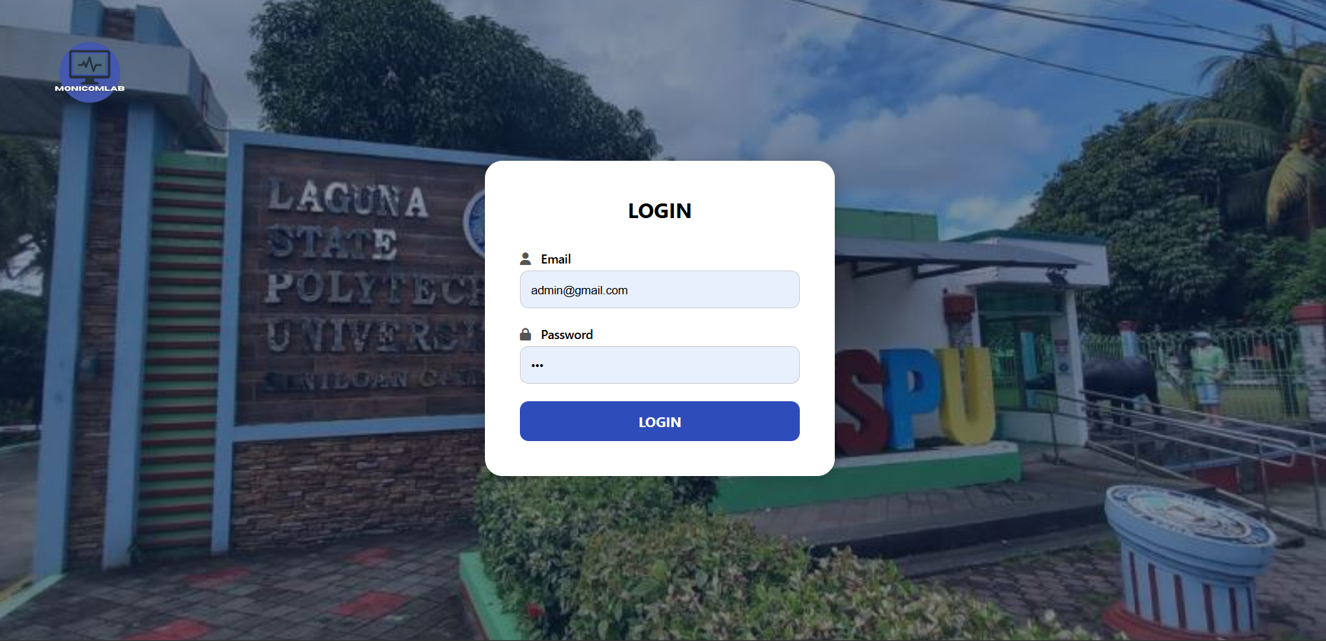

After the user login it will show a message alert “Login successful” and redirect into the dashboard

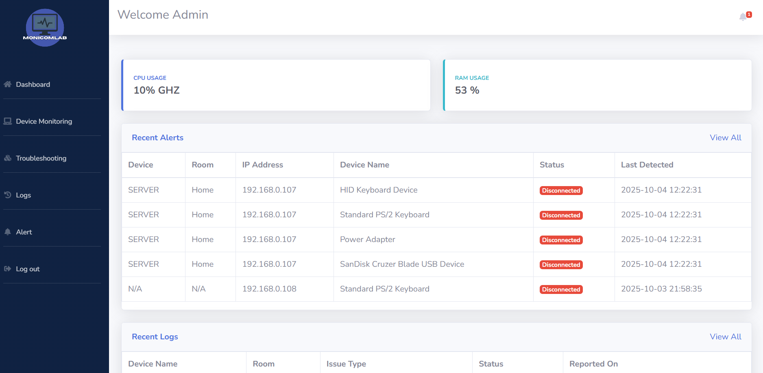

The “Dashboard” views the real-time monitoring of CPU usage and RAM usage. If the user wants to view the notification icon user will see the disconnected devices and the picture icon of MONICOMLAB to change picture.

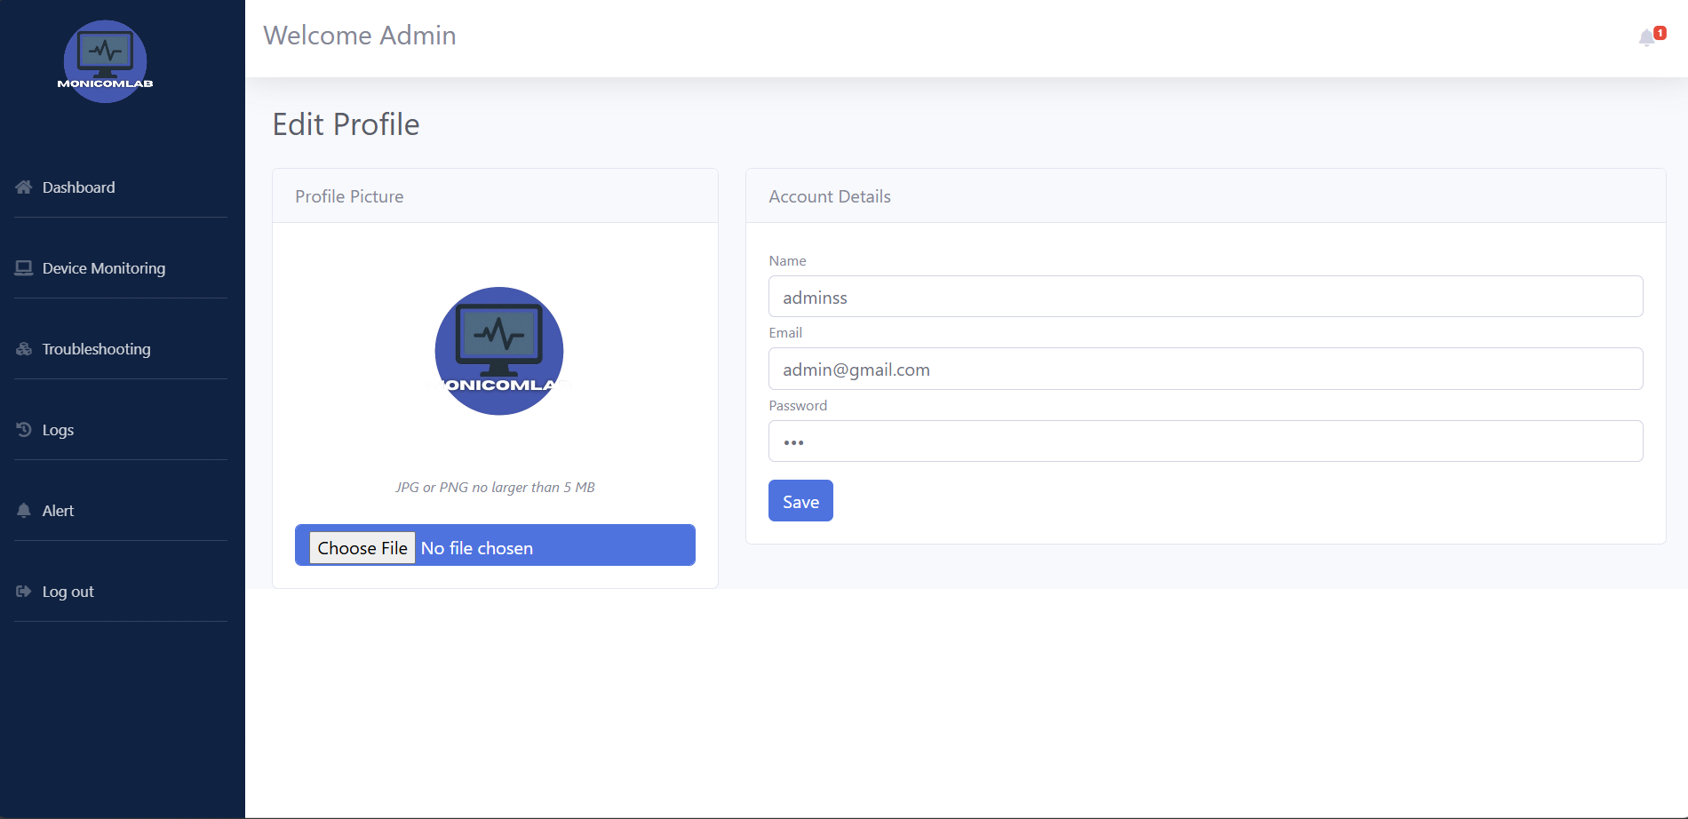

User can change any picture or update email, nameor password.

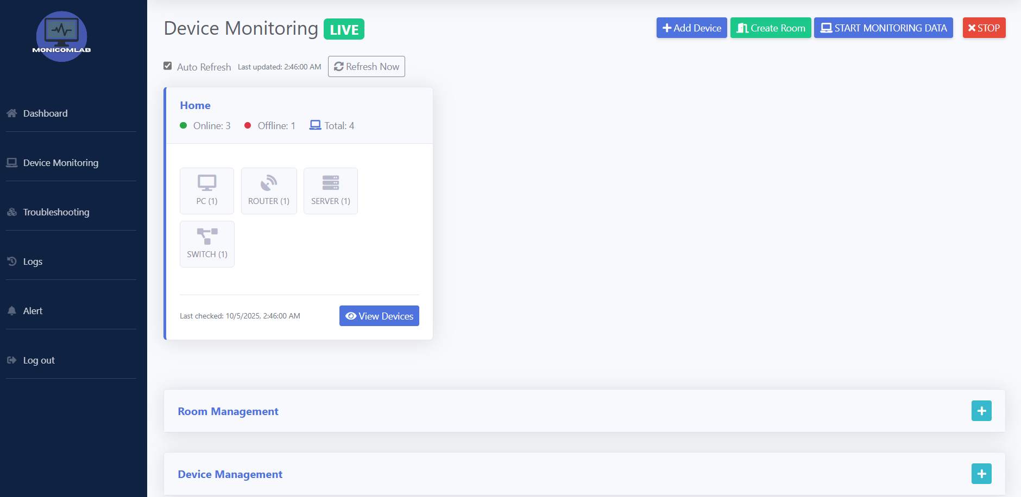

If user click this will view all devices and also user activities and connected device.

If user click this, it will start monitoring data of all devices.

The user also create room first before add devices.

If the user wants to add other devices click this. 

The “Device Monitoring” purpose is to view all connected devices such as switch, router, server, pc and room management, device management to delete, edit connected devices.

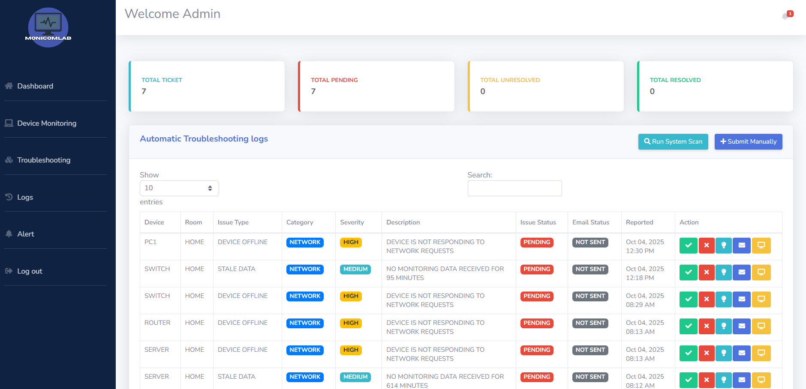

User can submit ticket manually

If user click this it will automatically scan the issues.

The troubleshooting purpose is to view all type of issue such as hardware, software or network and total of ticket, total pending, unresolved and resolved also we have button in action check whether it resolve, x if unresolved and suggested to fix, email to inform it to technician and also remote fix to close all running application.

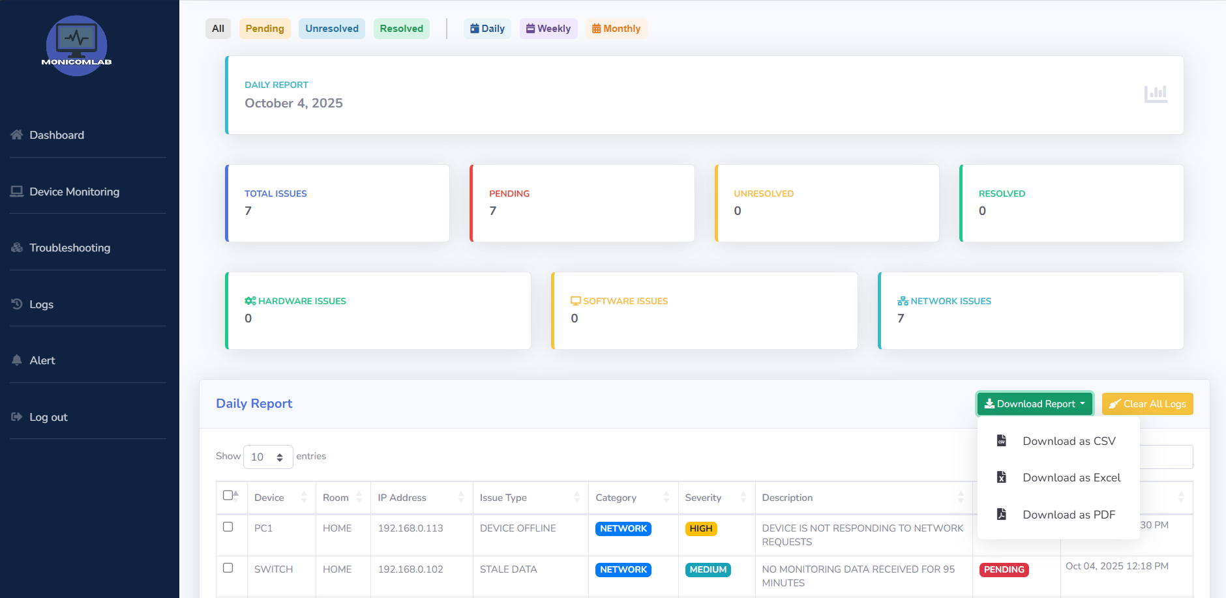

If the user wants to download this report click this

The “logs “to view all issues the user can download report base on daily, weekly, and monthly by CSV, Excel or PDF, also we have cleared all logs if the user wants to delete all type of issues.

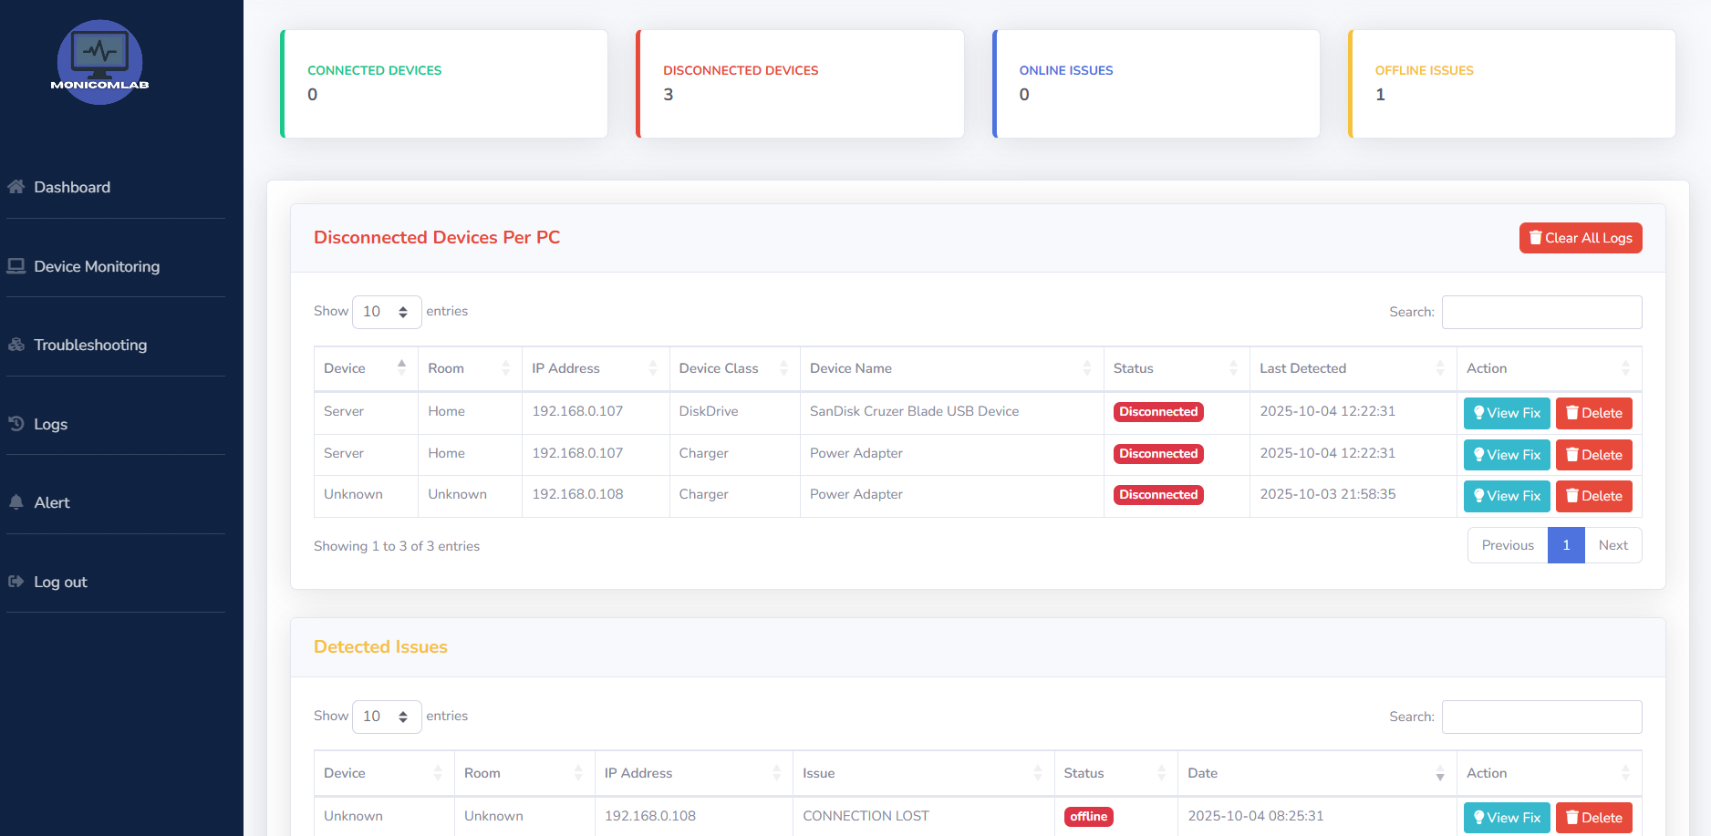

The “Alert” to view all disconnected devices per PC and detected issue online and also, we have view fix button for suggestion how to fix it the problem.

**Testing & Evaluation Instruments**

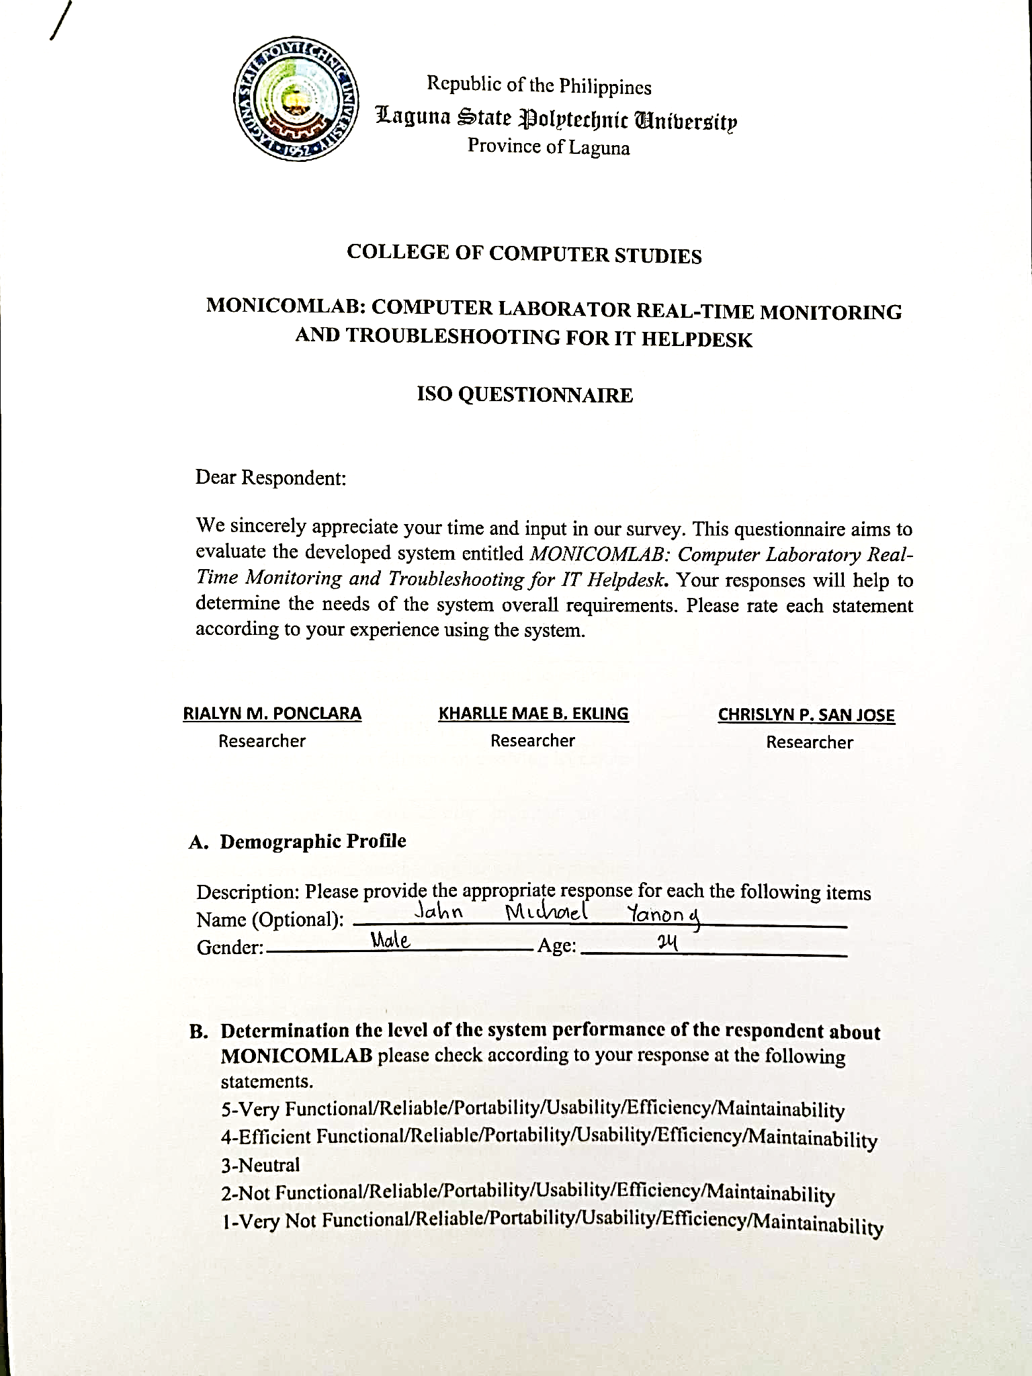

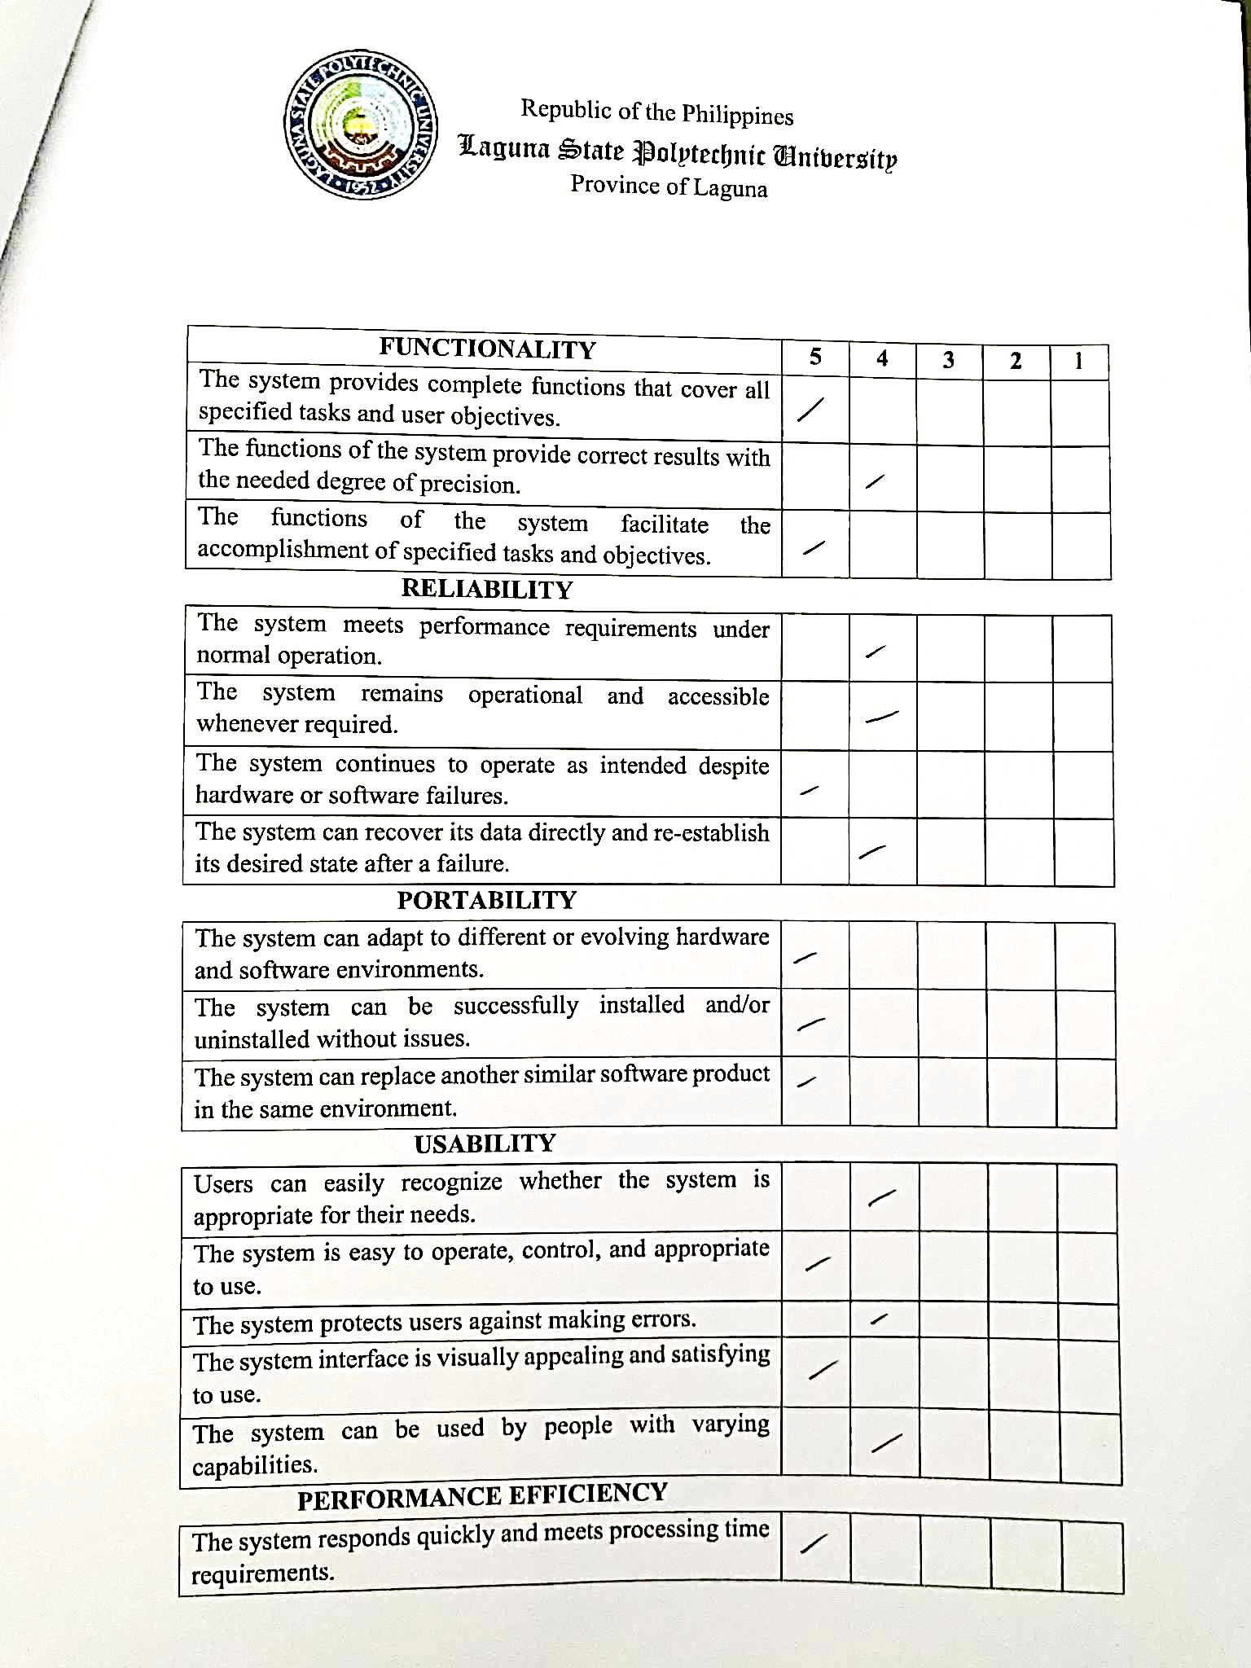

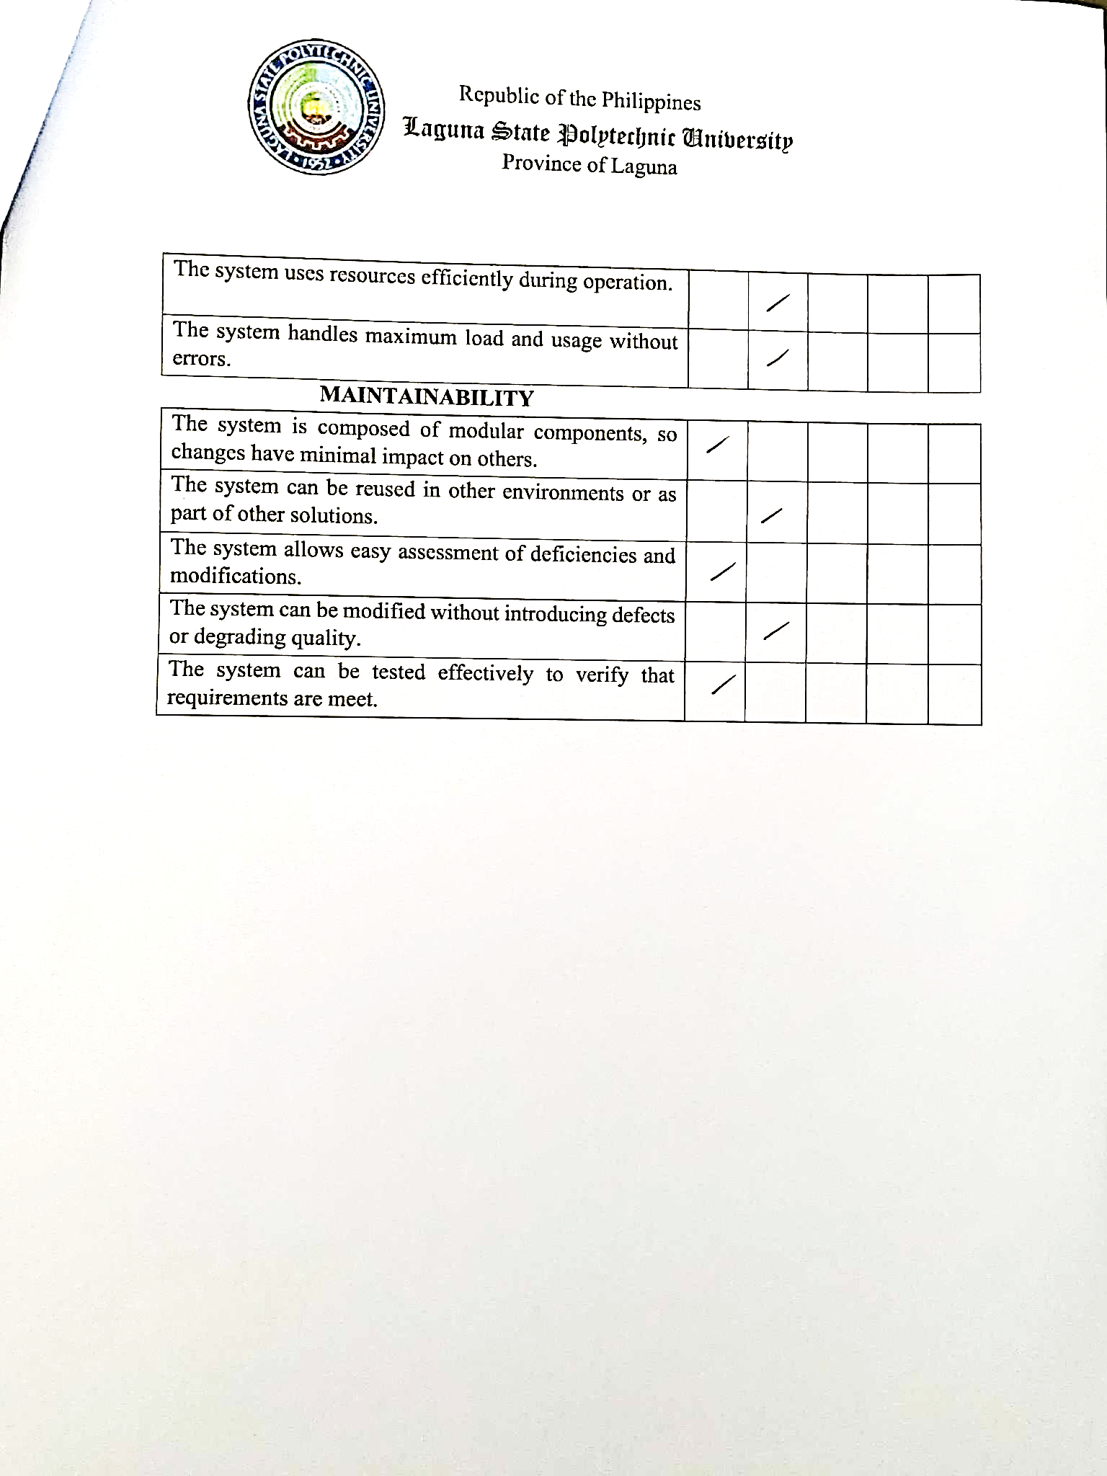



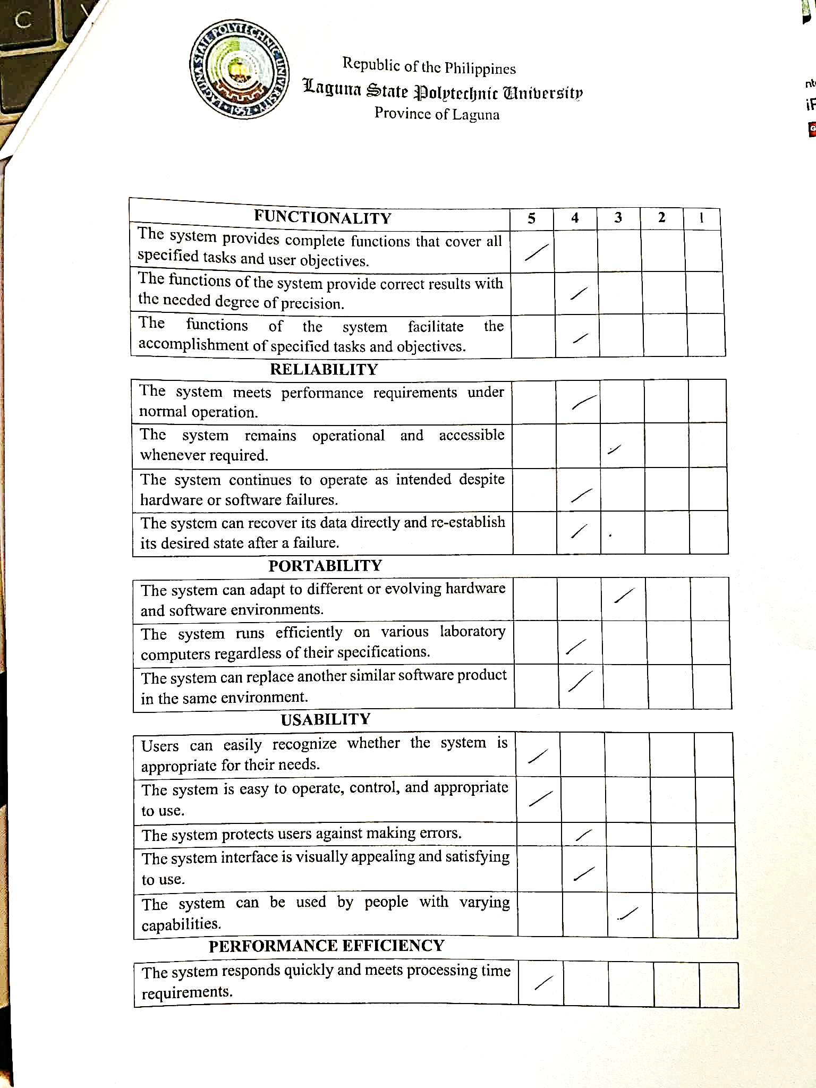

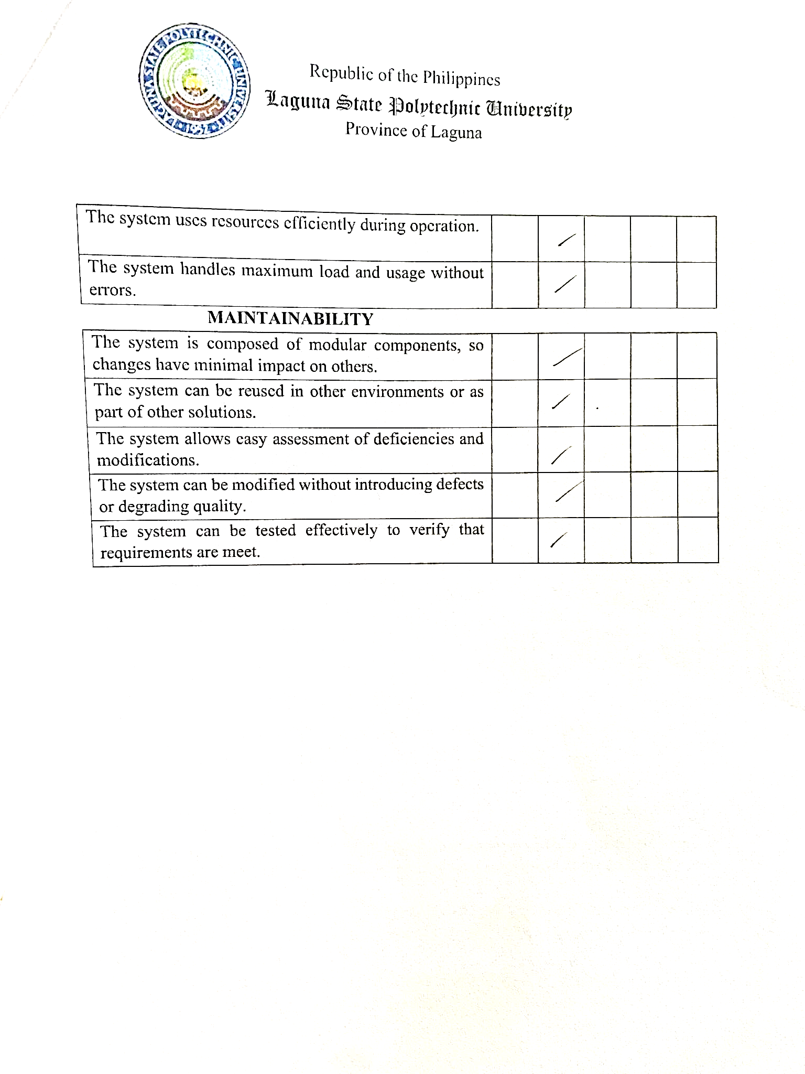

**Implementation Plan**

Capstone Project Implementation Plan for MONICOMLAB

|  |  |
| --- | --- |
| **STAGES** | **PROCESS ACTION** |
| **Phase 1** | * Brainstorming * Planning * Research for feasible area of conduct. * Location of the client * Gather Data * Designing and Finalization * Developing the system process and story outline |
| **Phase 2** | * Testing the Web-based system |
| **Phase 3** | * 1 Week for the respondents to evaluate the system |
| **Phase 4** | * Practical demonstration and potential system modification in collaboration with the researchers. |

**User’s Manual**

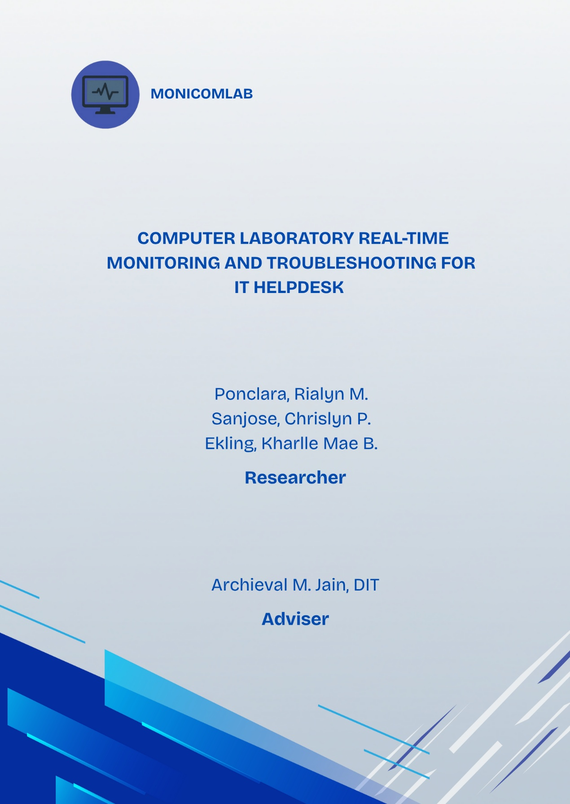

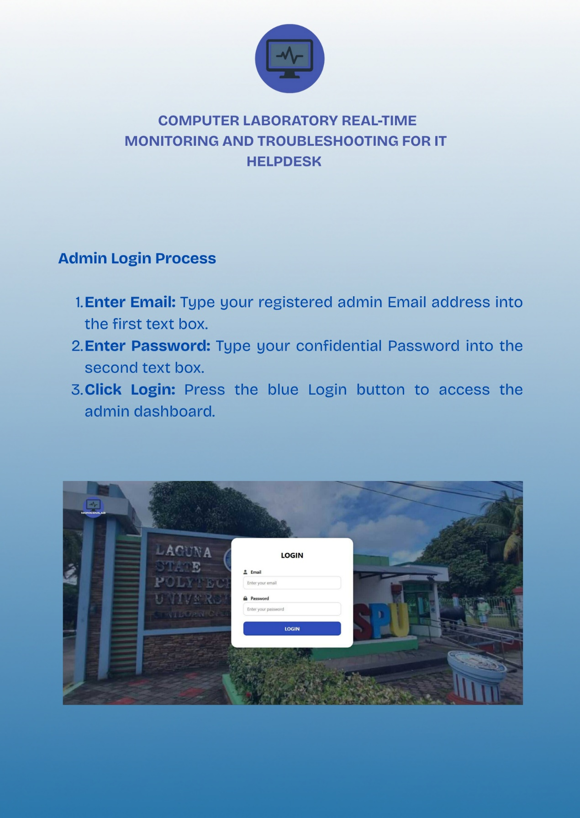

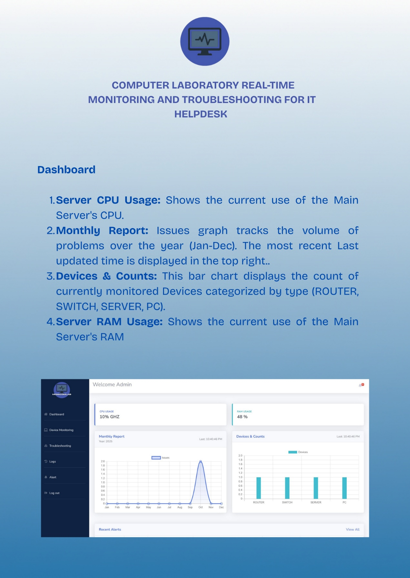

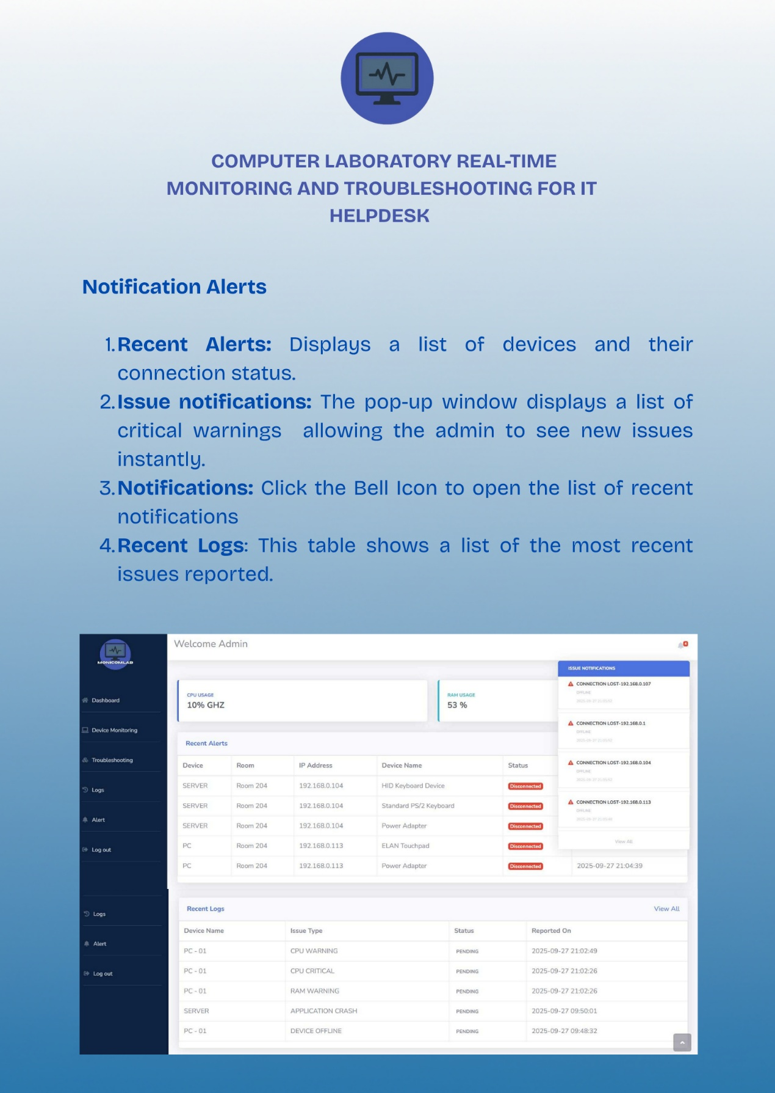

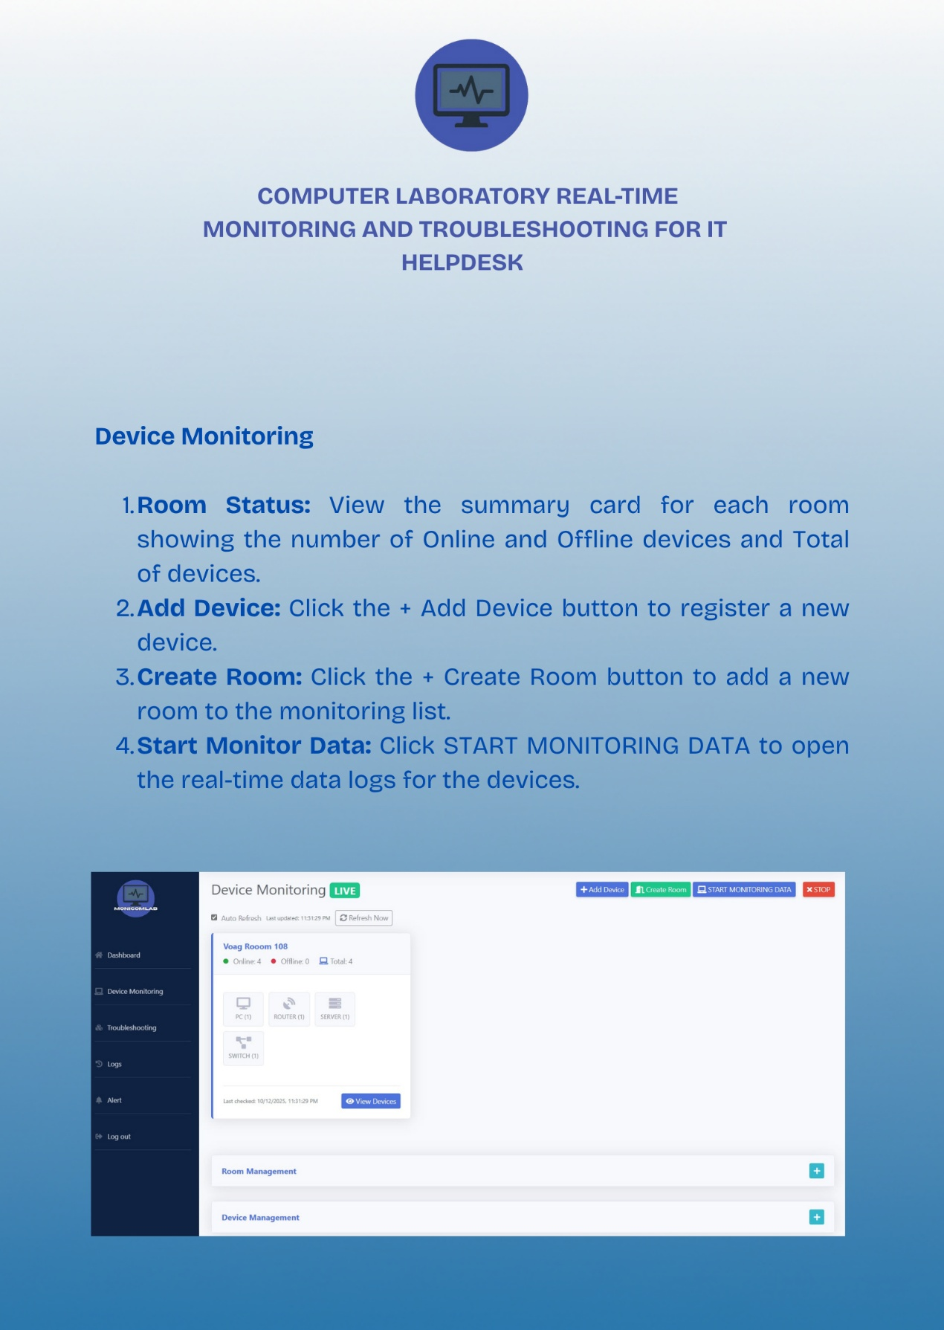

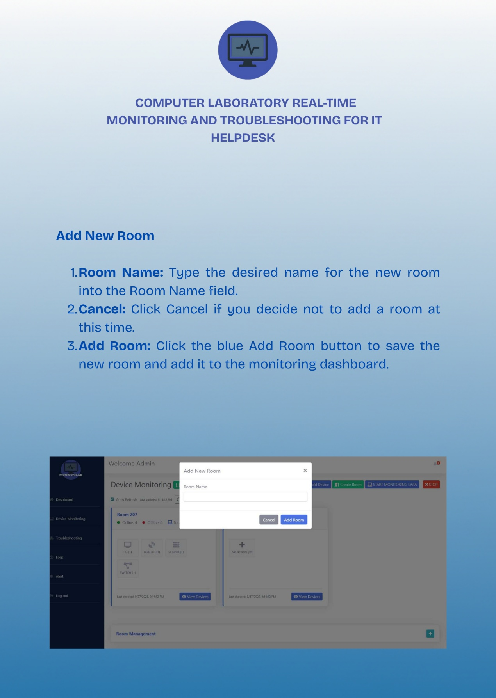

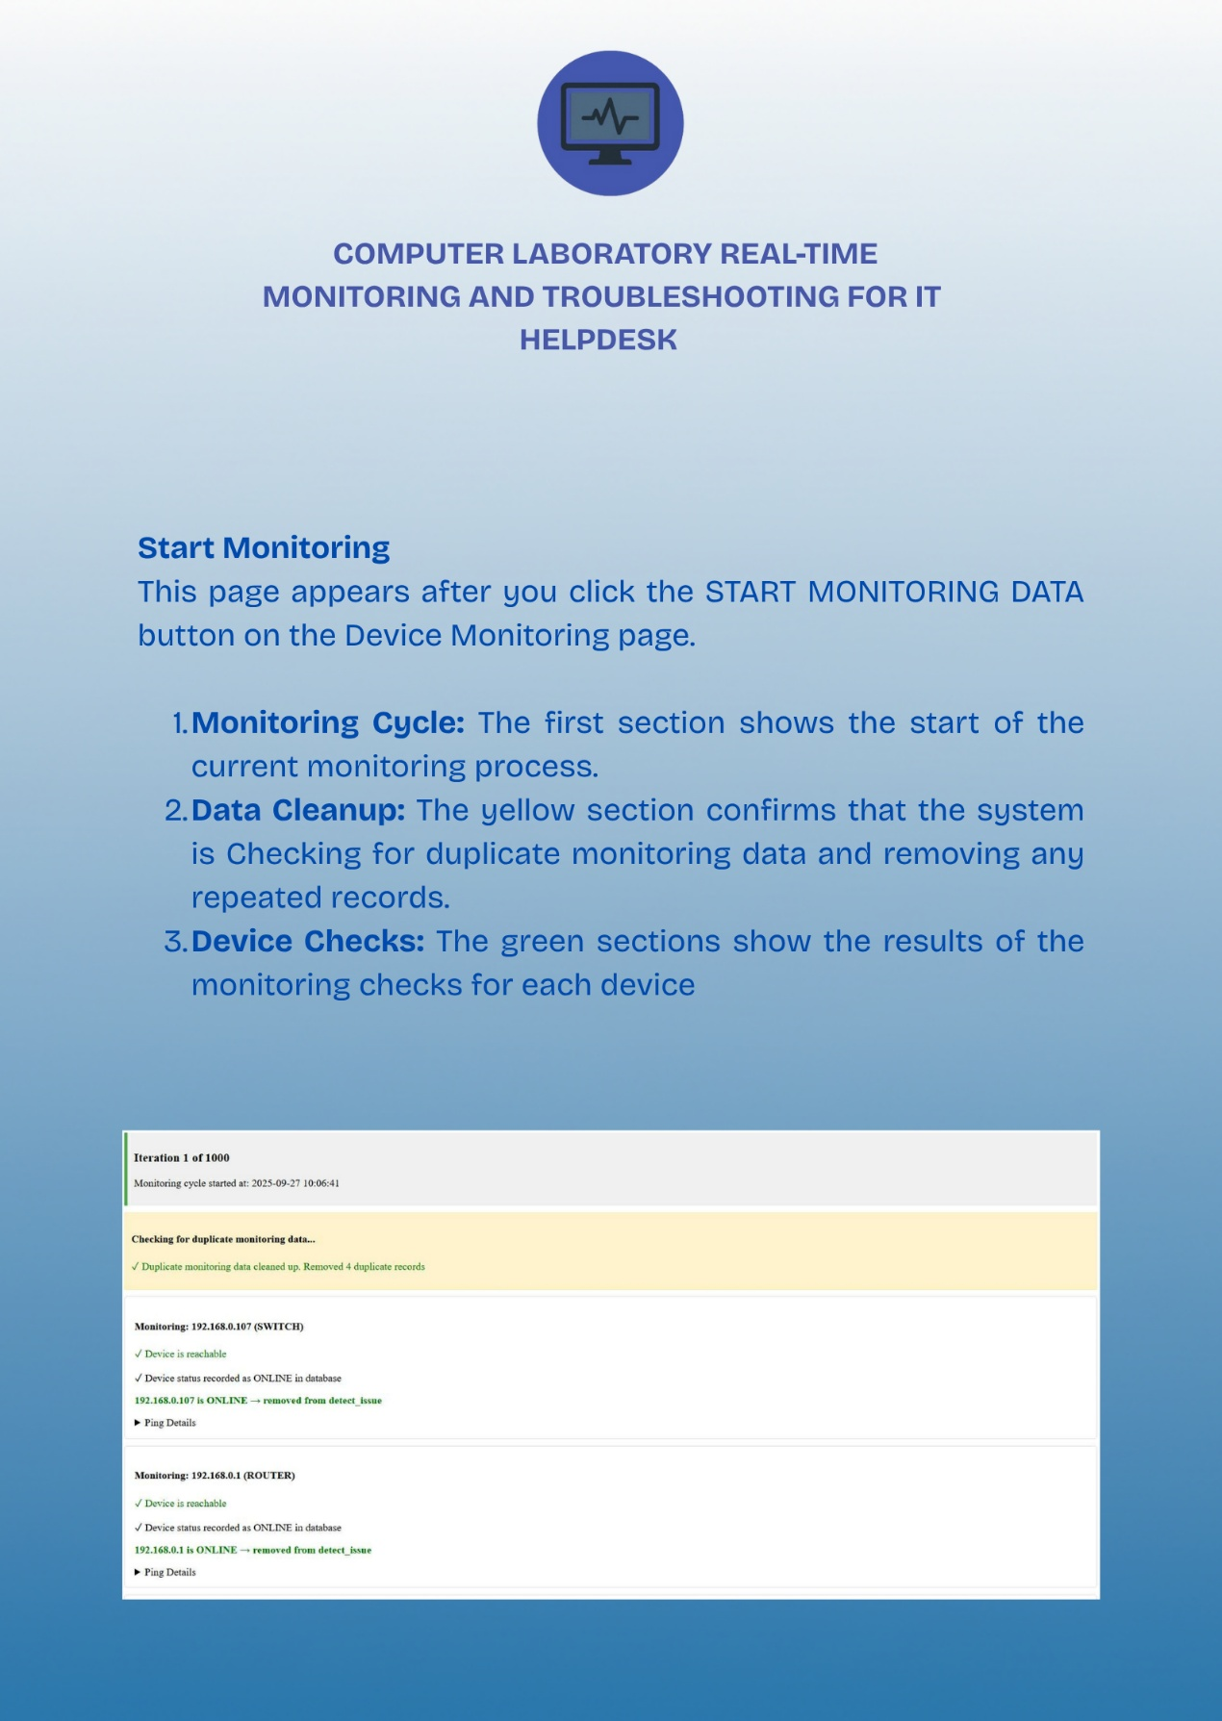

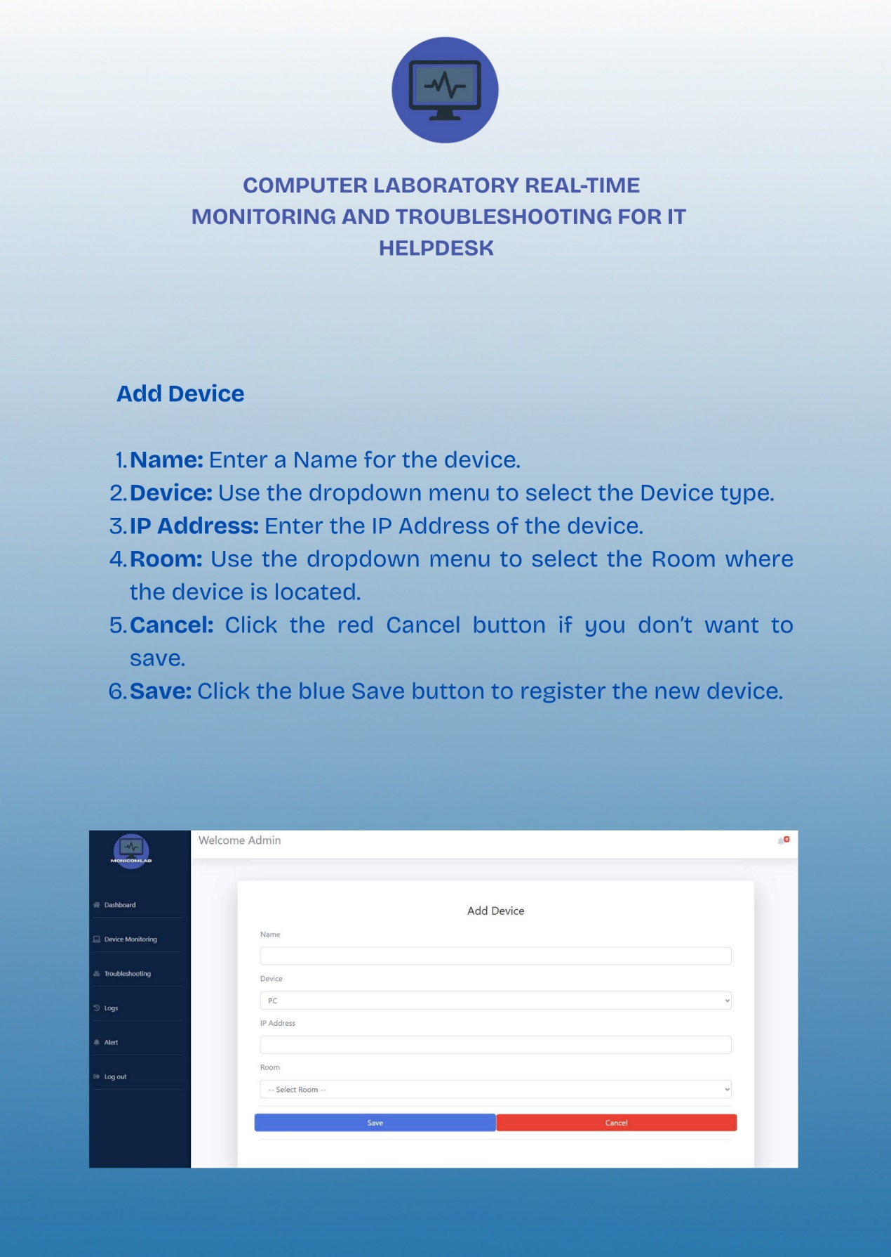

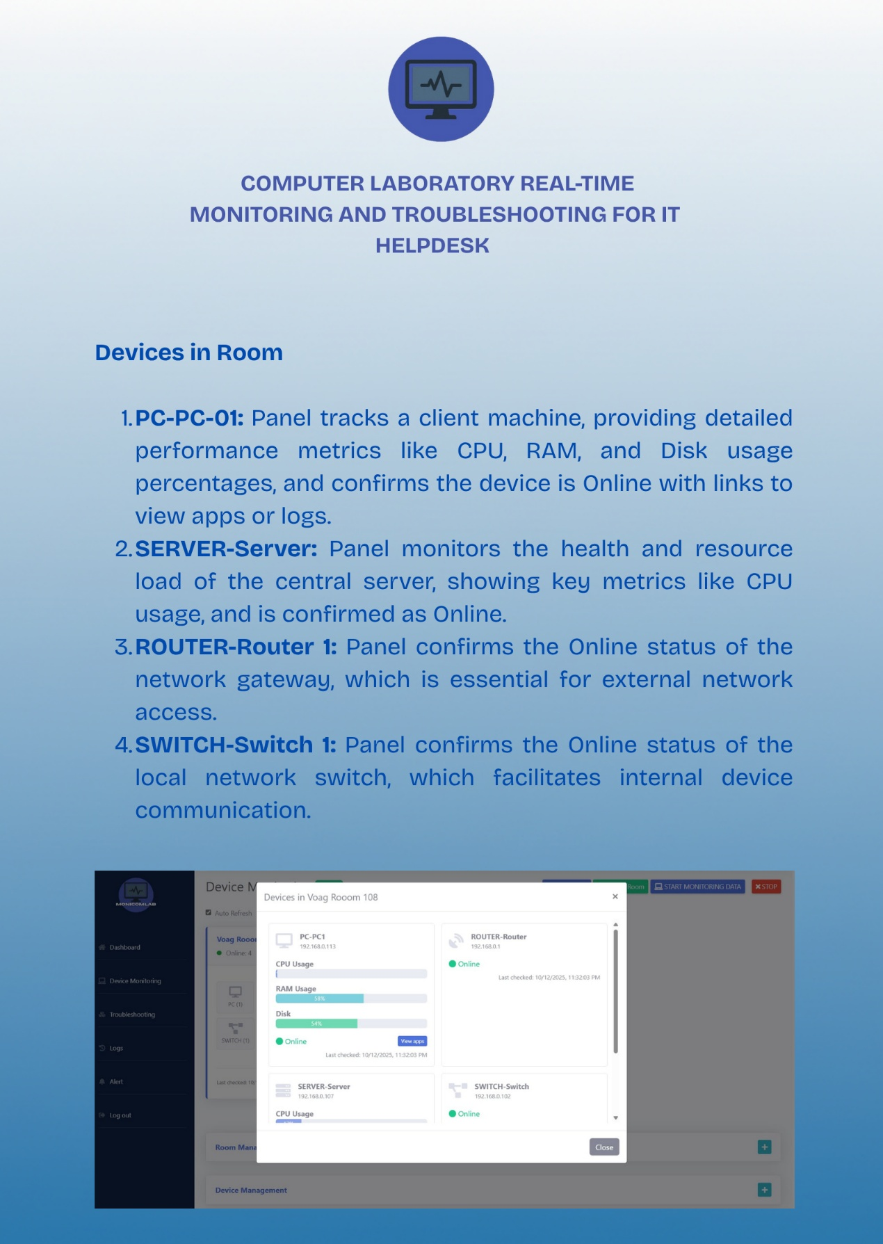

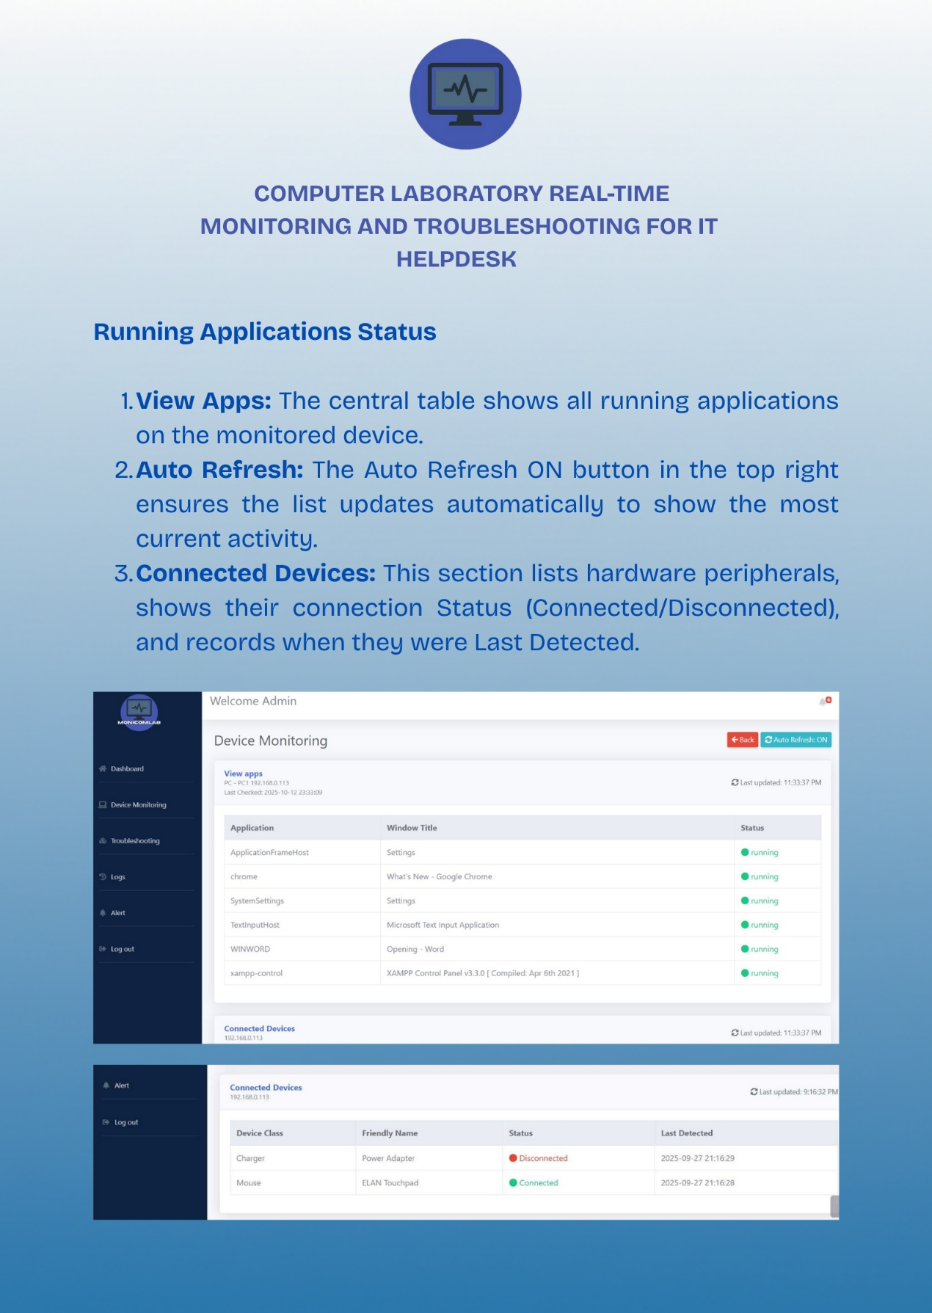

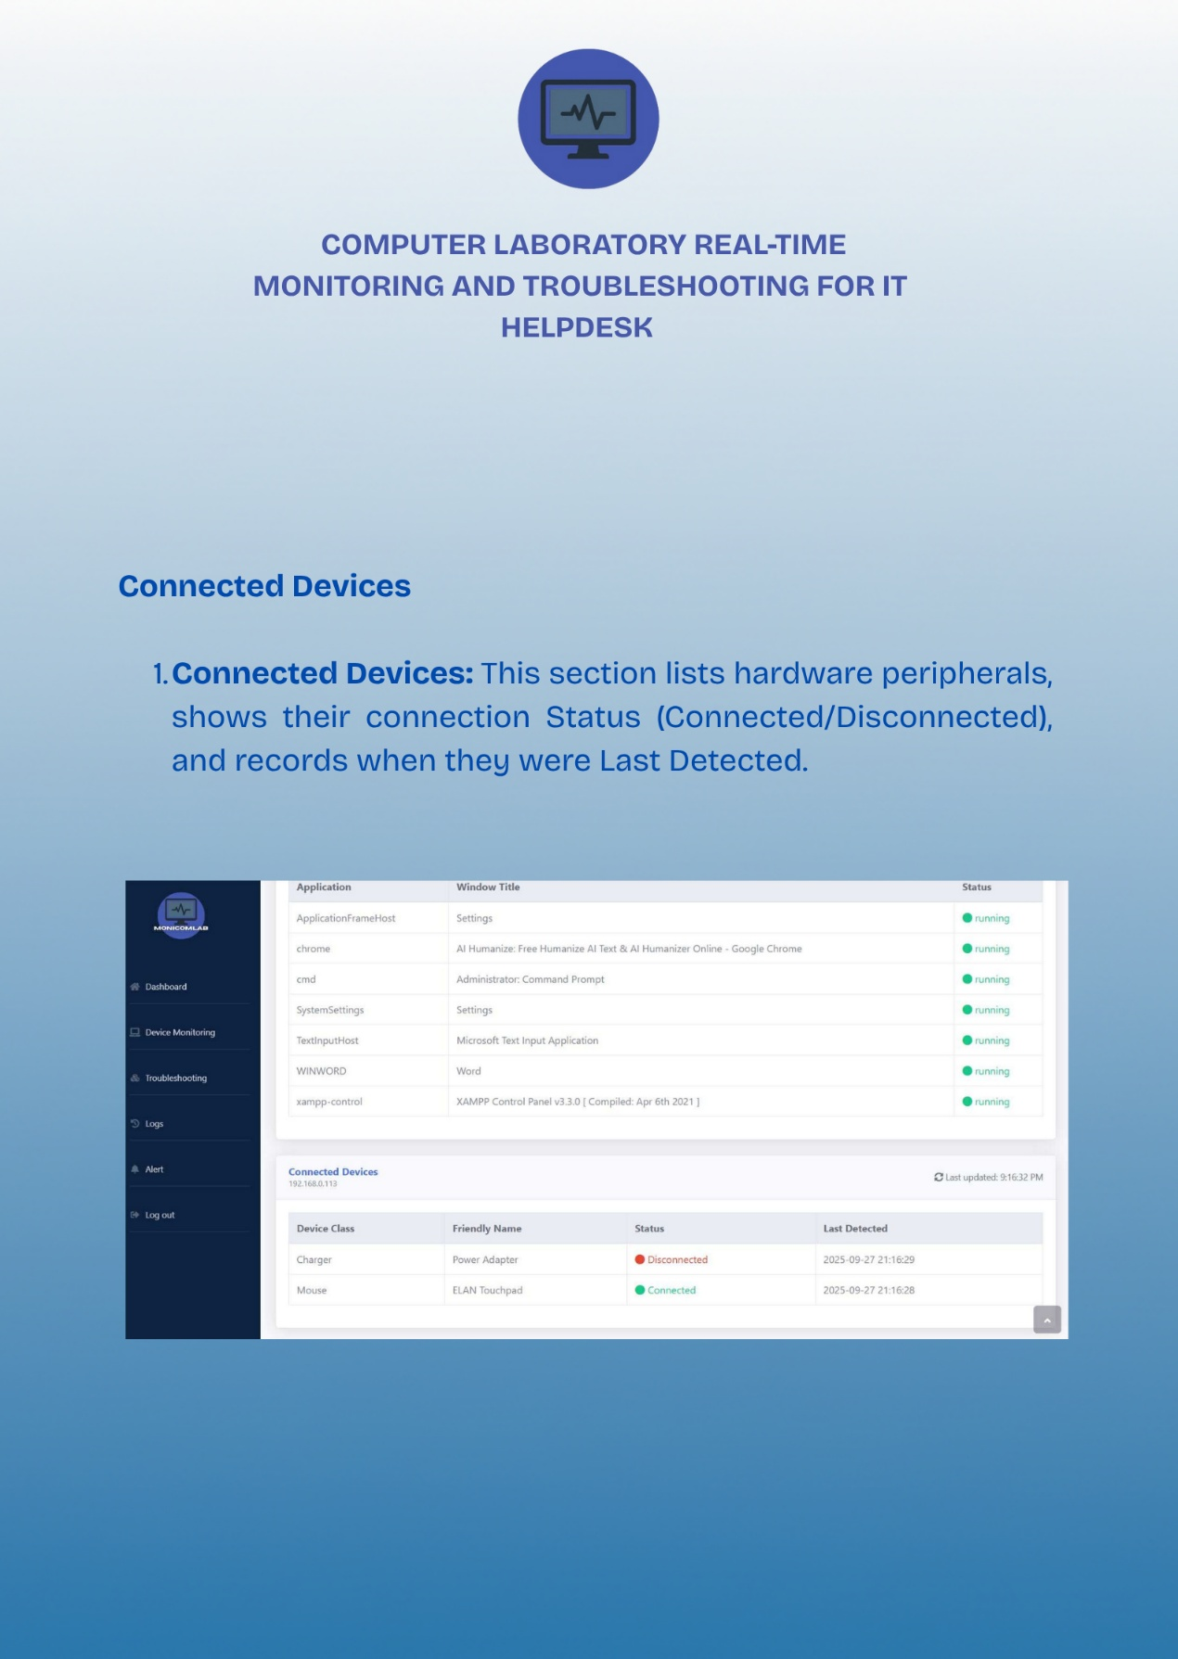

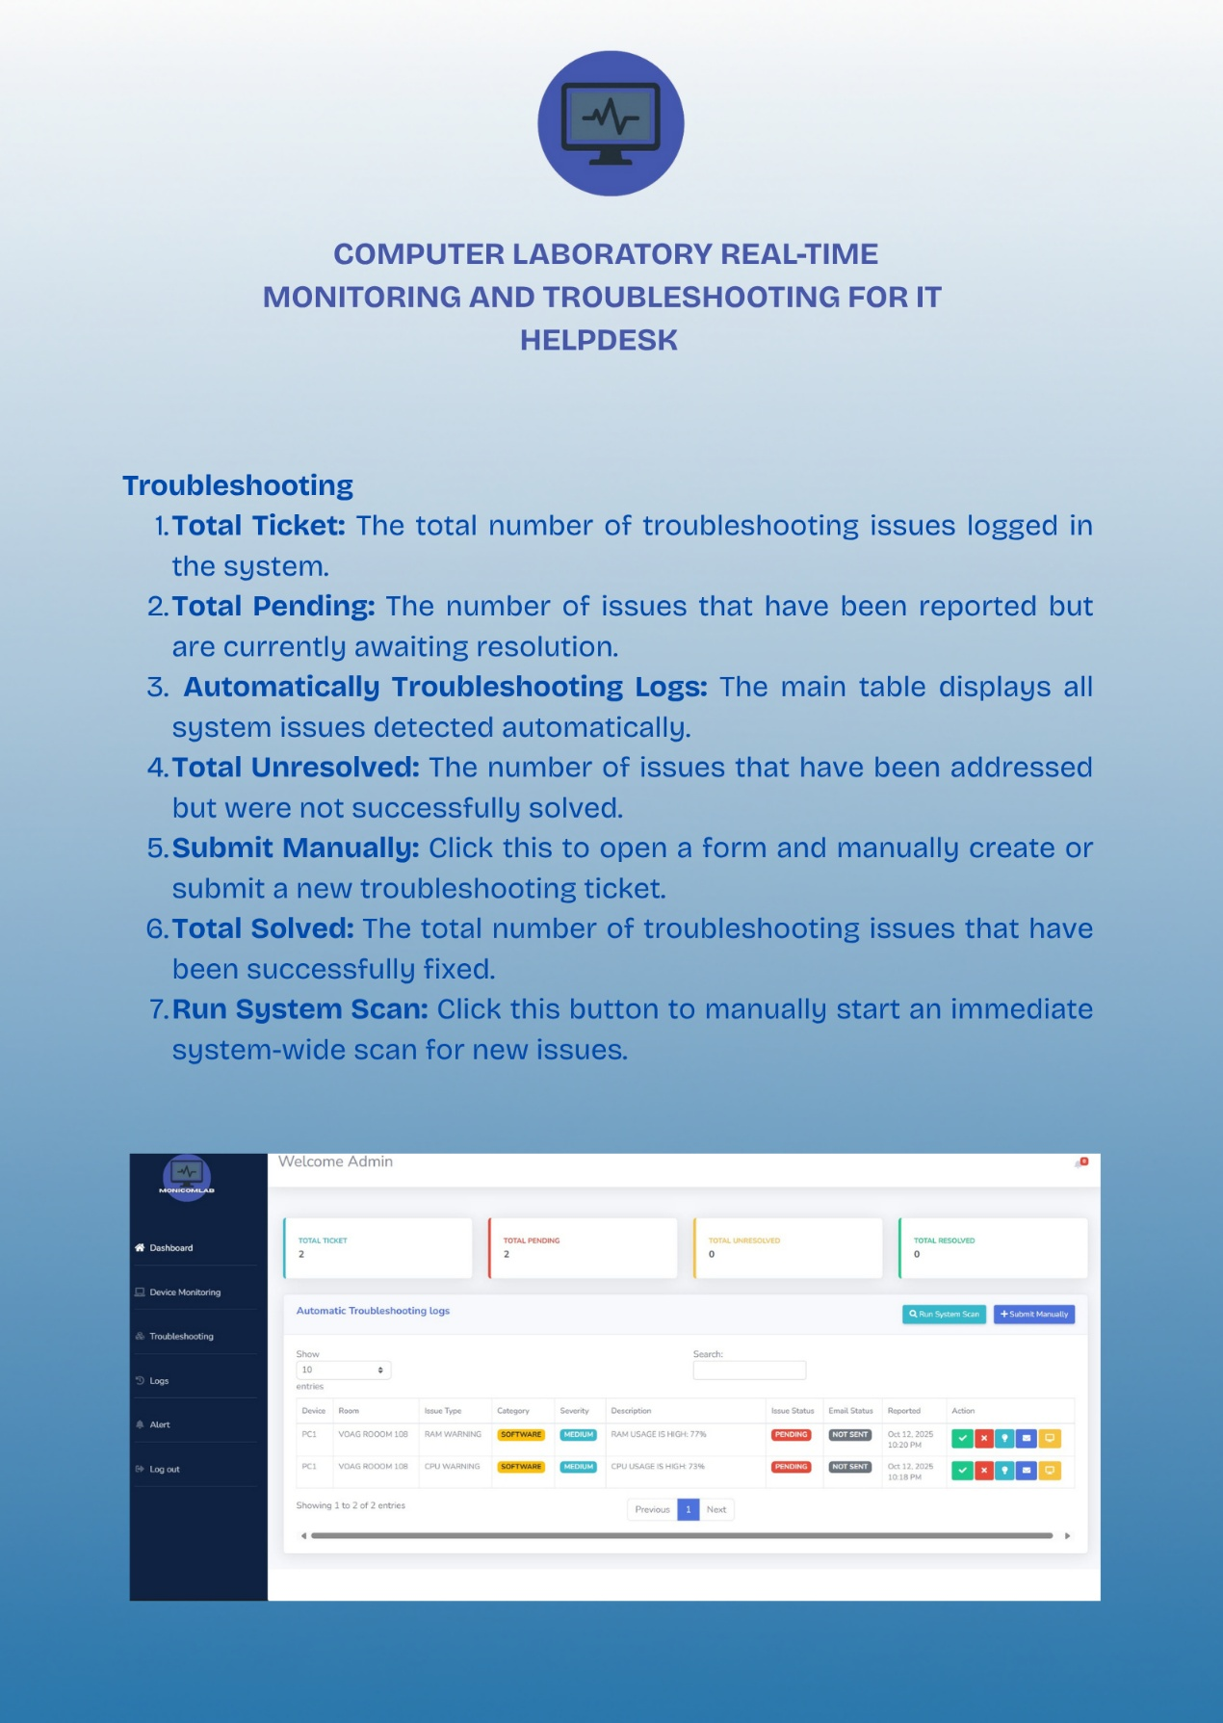

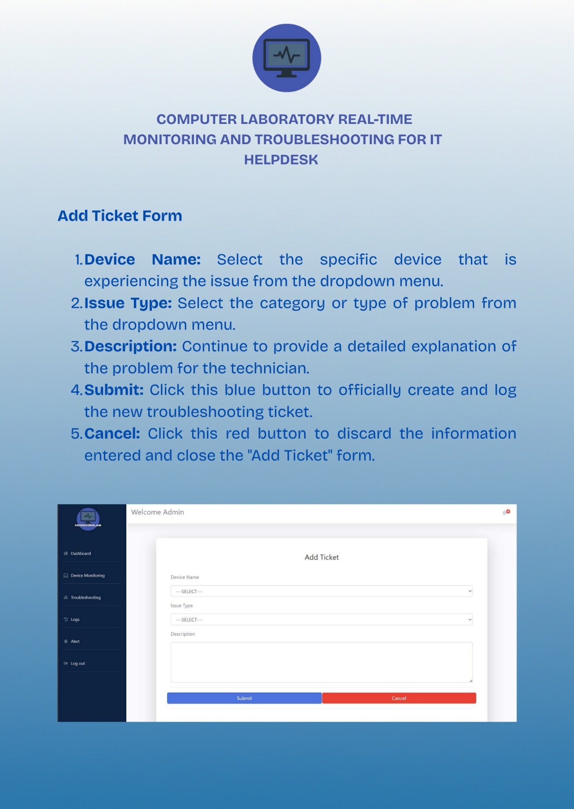

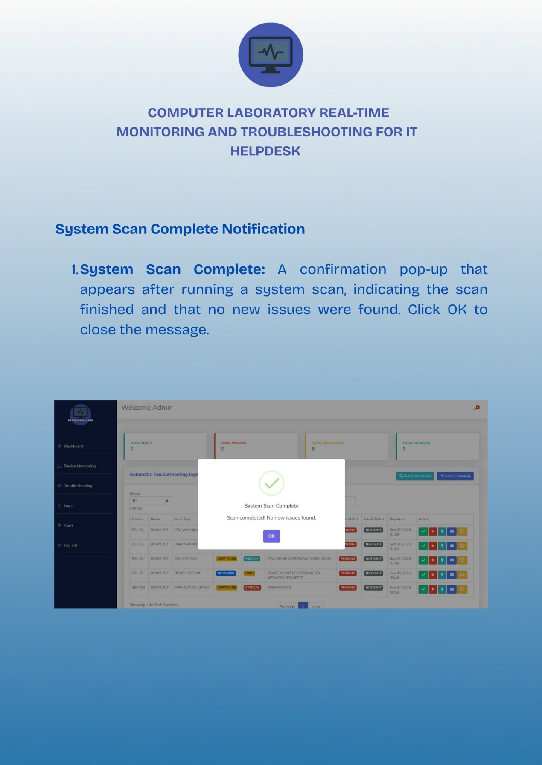

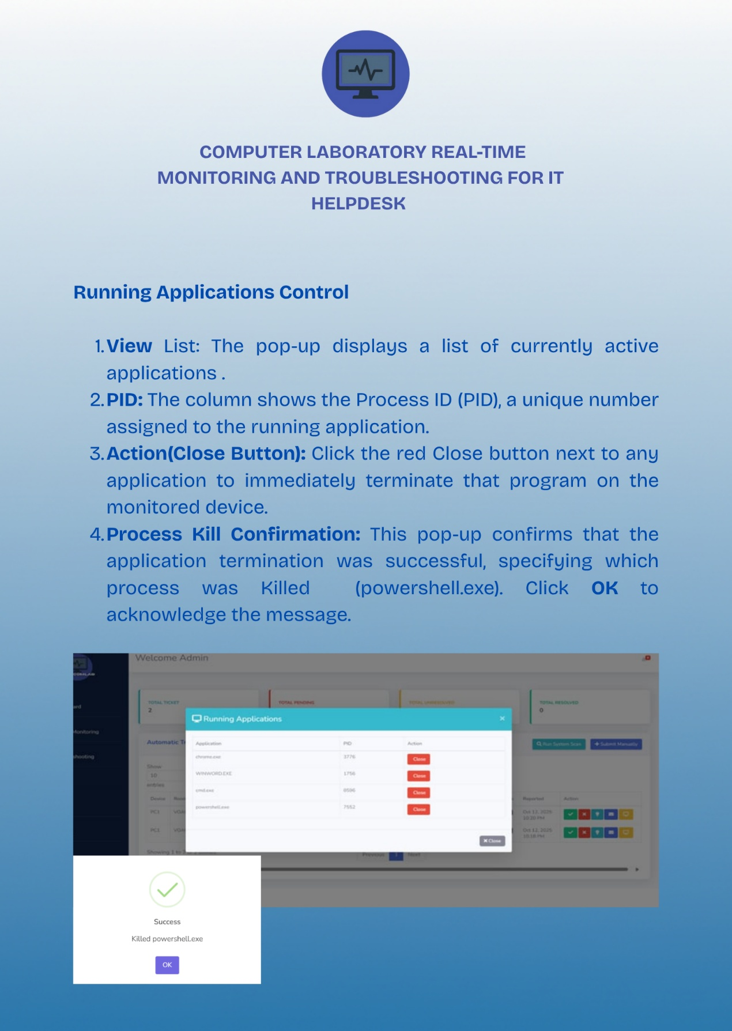

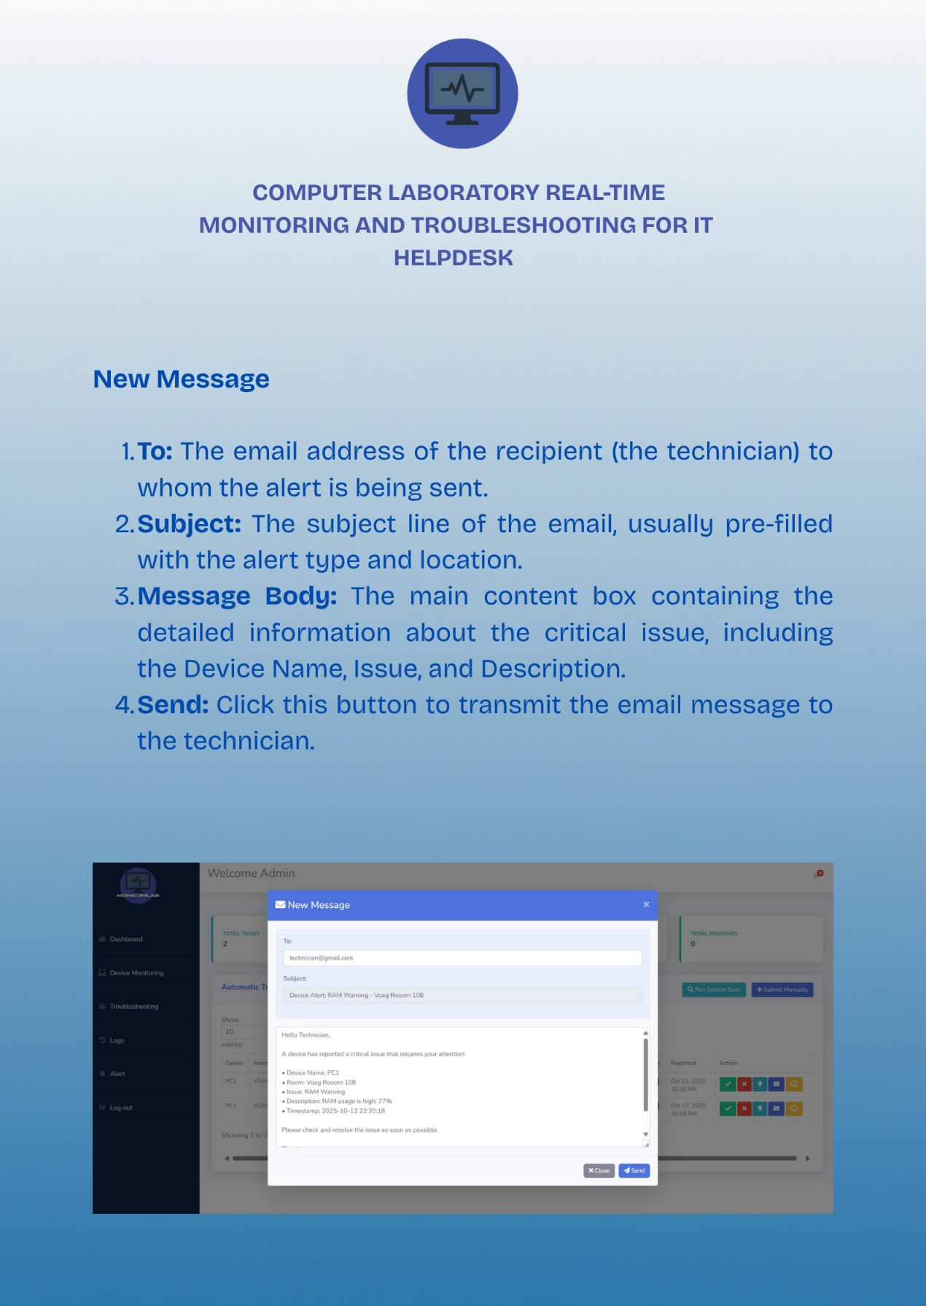

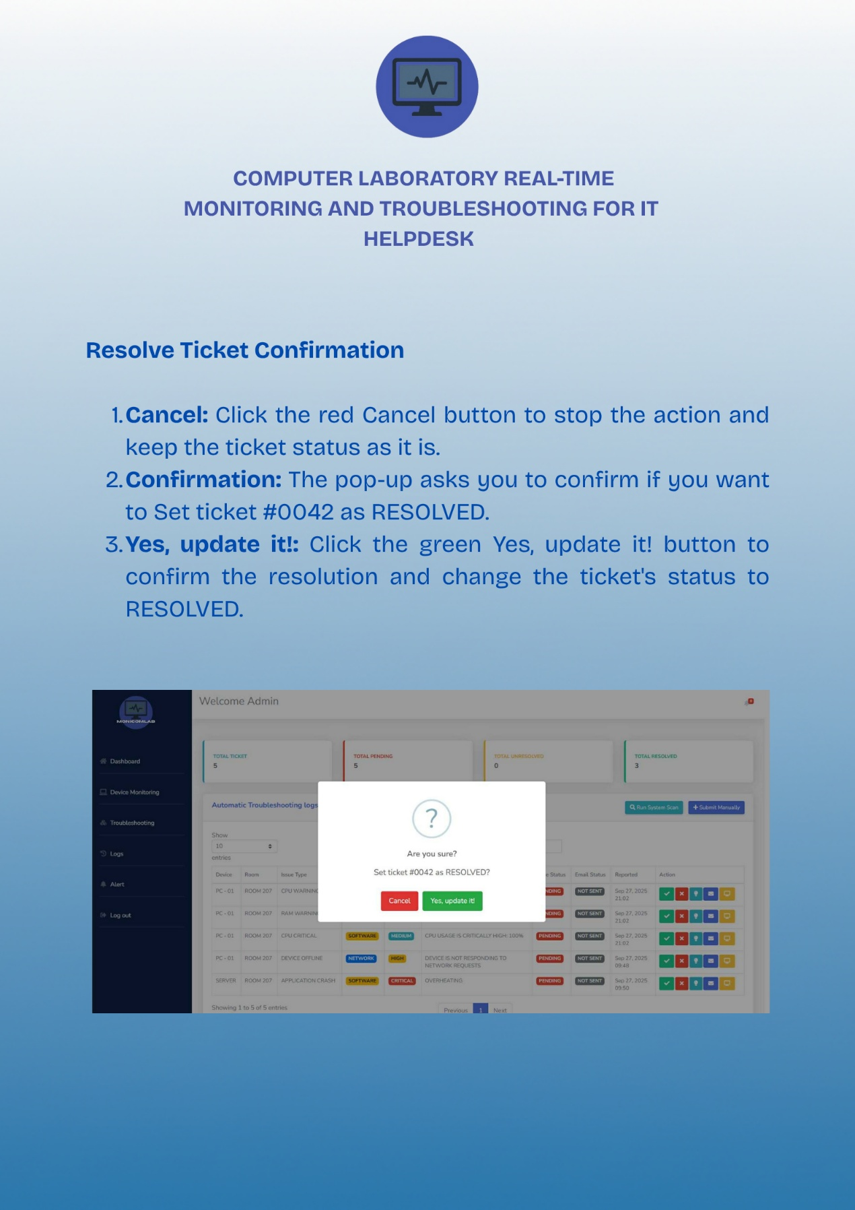

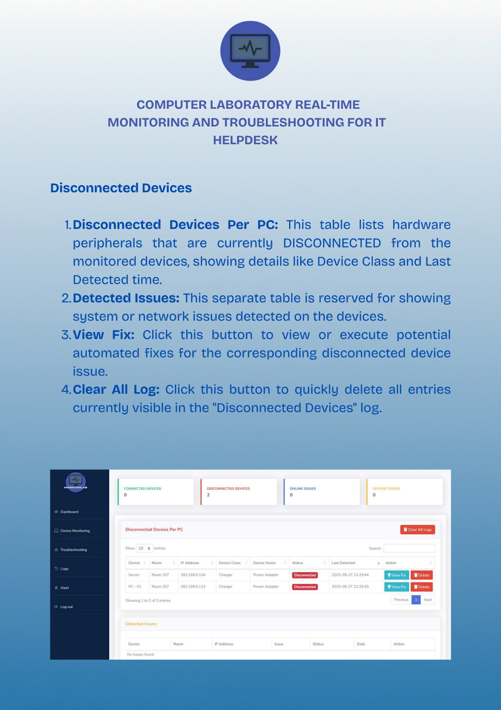

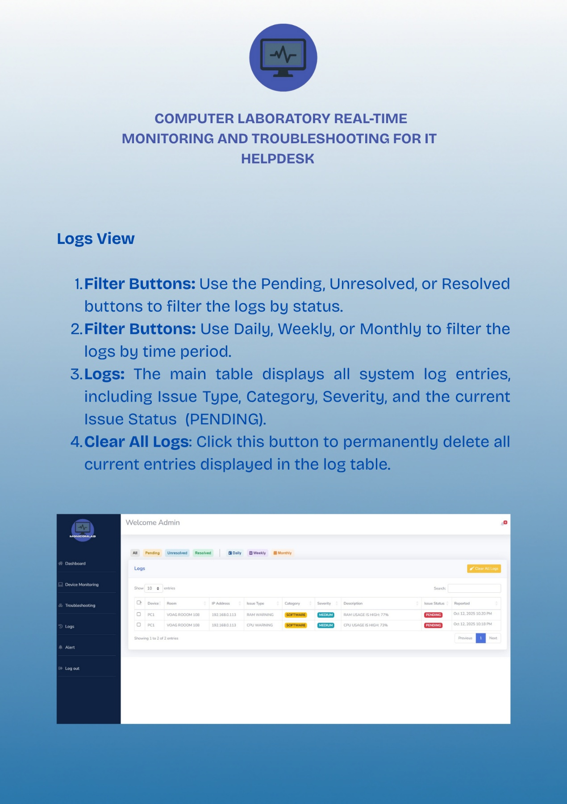

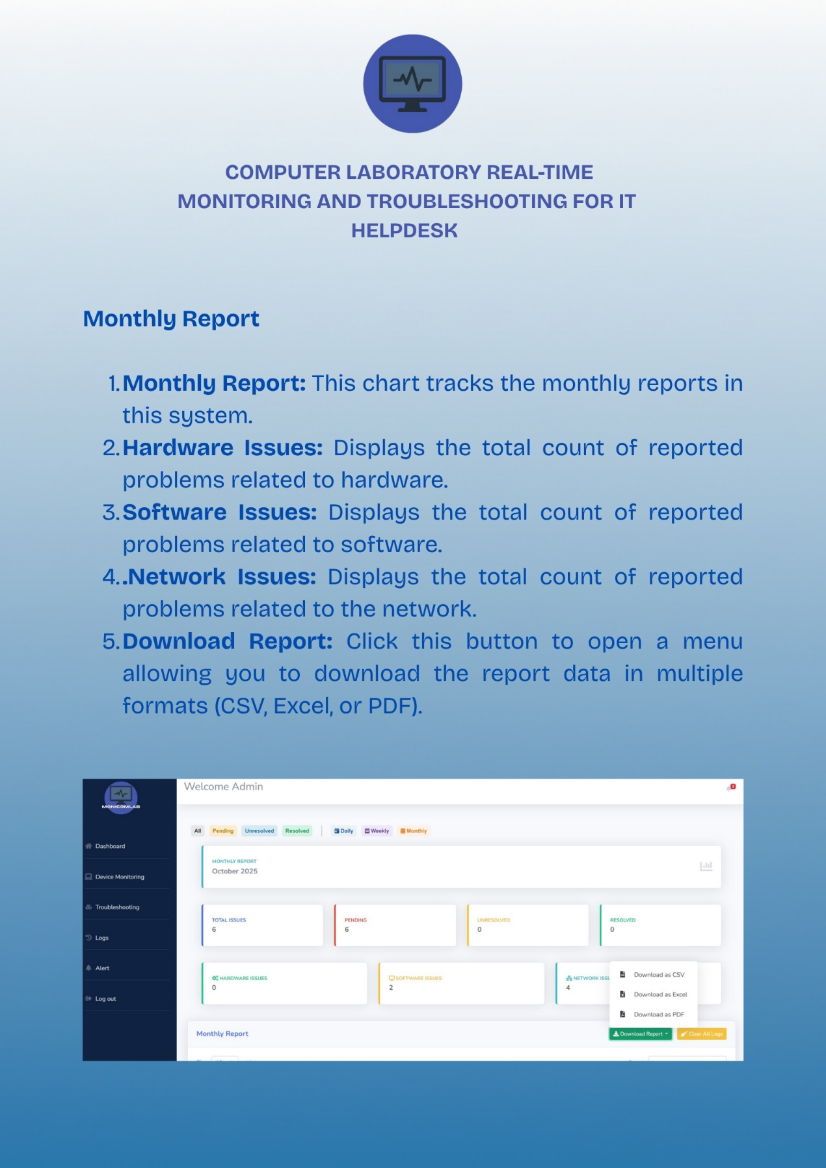

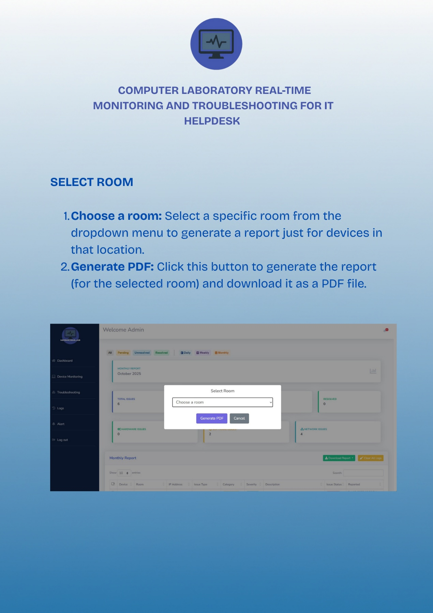

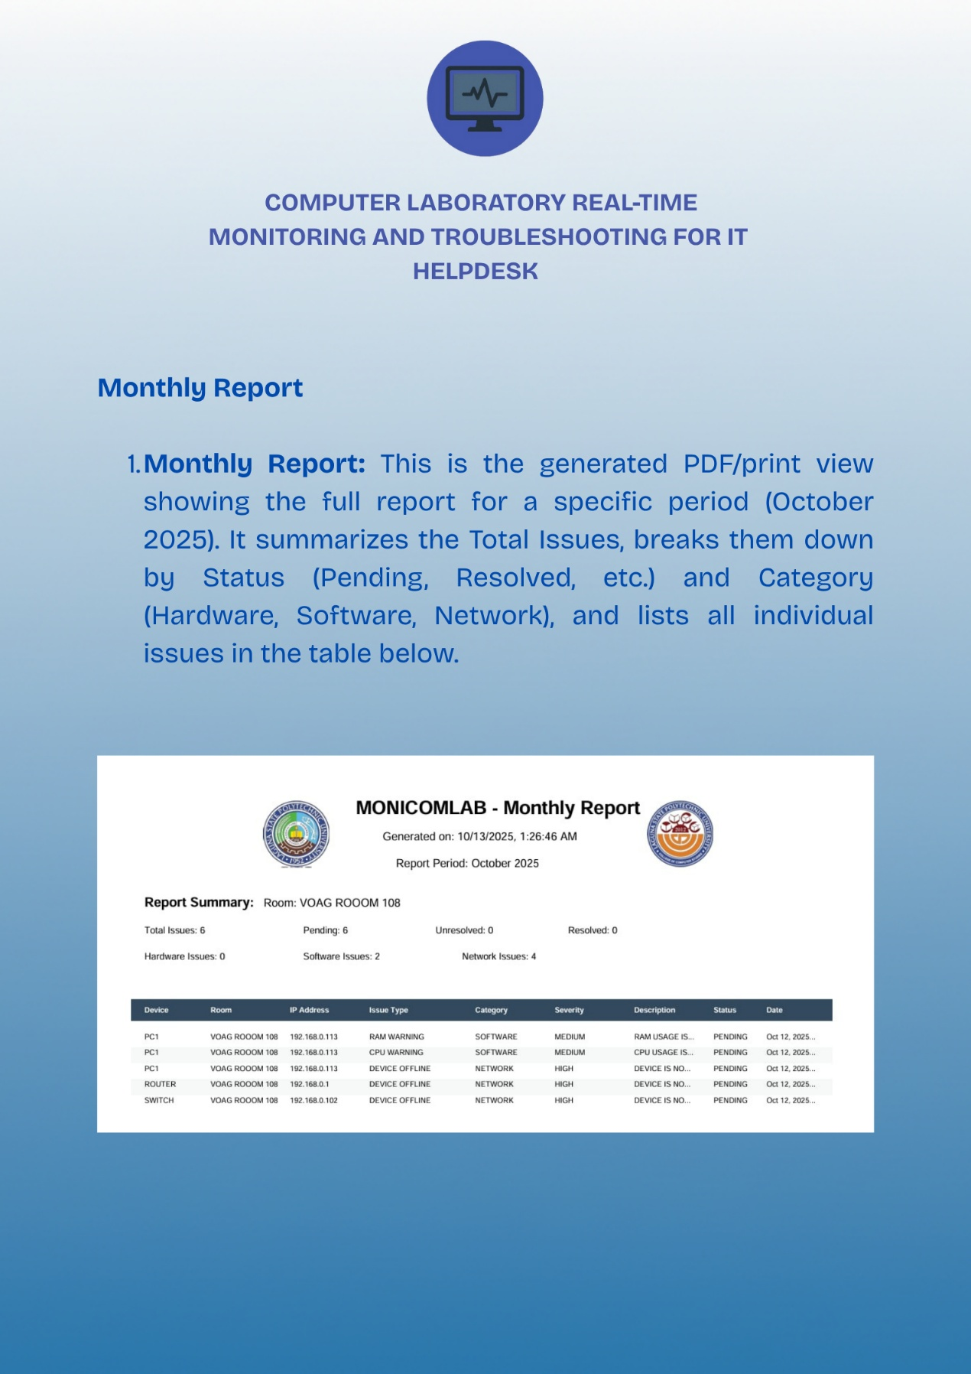

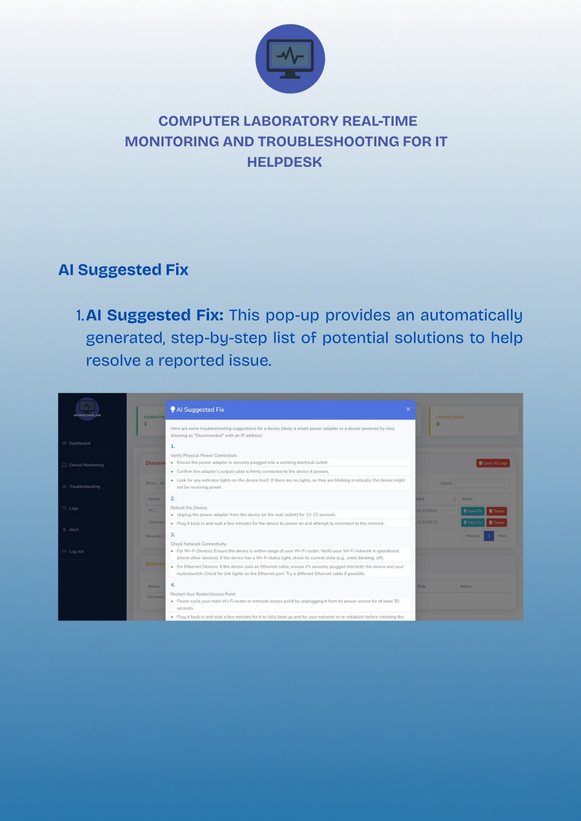

**APPENDICES**

**Communication Letters & Forms**

1. **Request Letter**

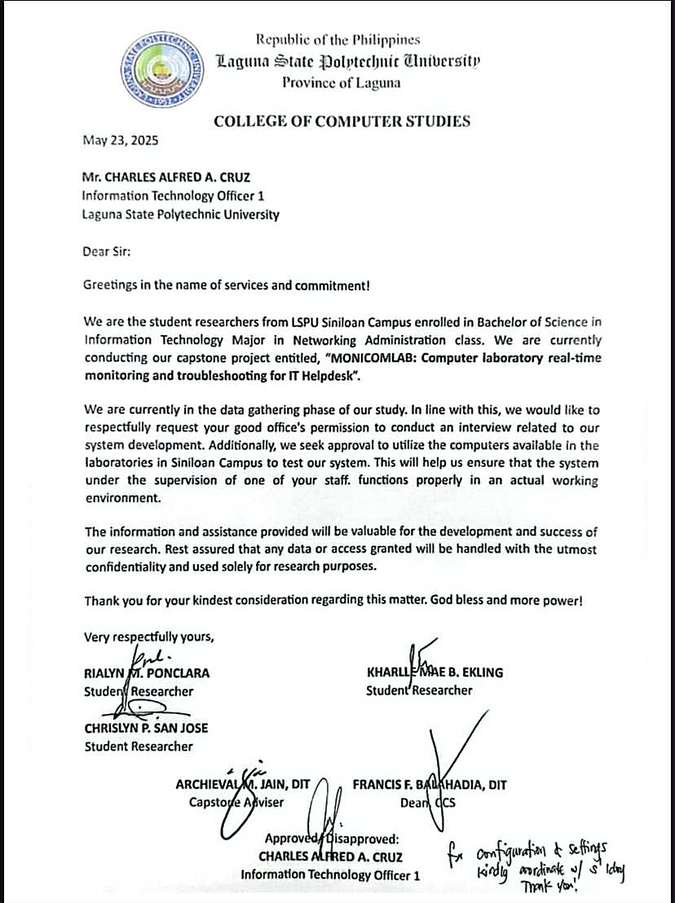

1. **Pre-proposal Approval**



1. **Proposal Approval**

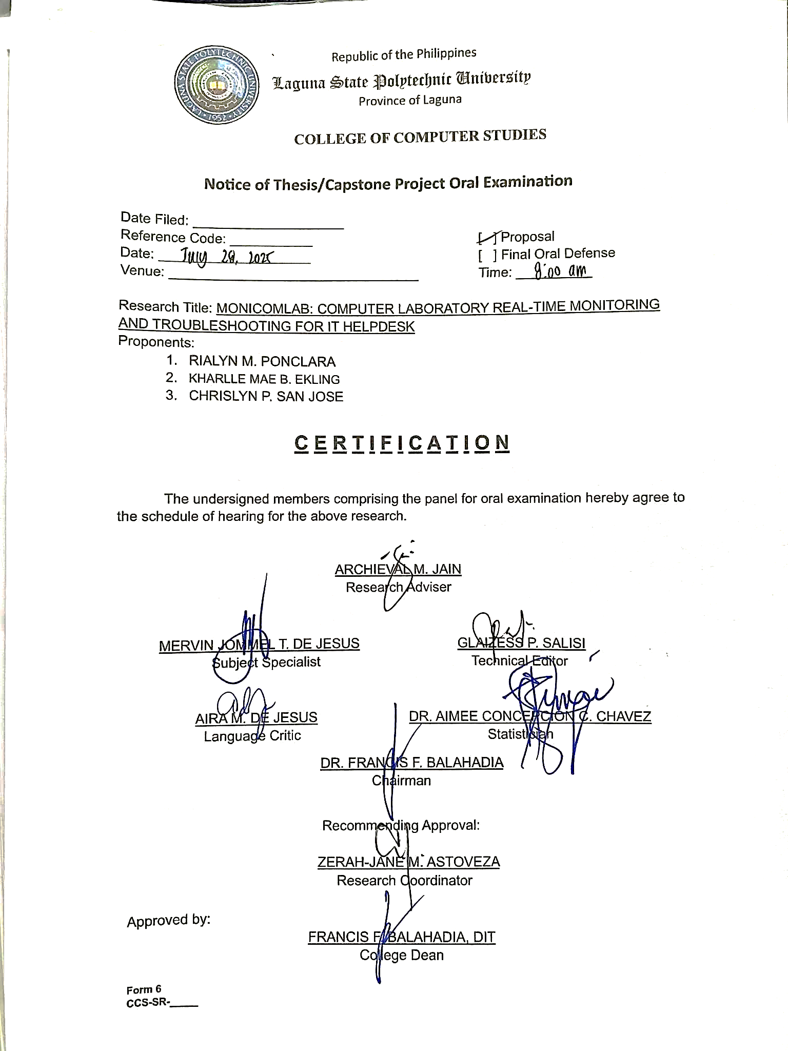

**Recommendation for Final Oral Defense**

**APPENDICES**

**5 Pager IMRAD Format**

**MONICOMLAB: Computer Laboratory Real-Time Monitoring and Troubleshooting for IT Hepldesk**

|  |  |
| --- | --- |
| **Ponclara, Rialyn M.**  College of Computer Studies Laguna State Polytechnic University Siniloan, Laguna rialyn.ponclara@lspu.edu.ph | **Sanjose, Chrislyn P.**  College of Computer Studies Laguna State Polytechnic University Siniloan, Laguna chrislyn.sanjose@lspu.edu.ph |
| **Ekling, Kharlle Mae B.**  College of Computer Studies Laguna State Polytechnic University Siniloan, Laguna  kharllemae.ekling@lspu.edu.ph | **ARCHIEVAL M. JAIN,**  College of Computer Studies Laguna State Polytechnic University Siniloan, Laguna |

**ABSTRACT**

MONICOMLAB: A Computer Laboratory Real-Time Monitoring and Troubleshooting System for IT Helpdesk was developed to improve the management of computer laboratory devices and ensure efficient IT support. The system integrates monitoring and troubleshooting features to automatically detect issues in PCs, servers, routers, and switches. Once problems such as software, hardware errors, or network interruptions are identified, they are recorded in the log’s module, generating tickets with details such as device name, issue type, severity and status. This enables IT staff to efficiently track incidents, prioritize urgent cases and resolve them in a timely manner. The system also provides troubleshooting suggestions for common issues, assisting technicians in faster resolution and reducing downtime. A centralized dashboard displays real-time device status and logs, allowing administrators to maintain awareness of laboratory conditions. This promotes accountability and ensures that reported problems are properly documented and addressed. The study employed an experimental-developmental approach, with testing conducted at the Laguna State Polytechnic University College of Computer Studies. Results showed that the system improved issue detection, minimized manual monitoring and enhanced helpdesk response and productivity.

**INTRODUCTION**

Issues have emerged in computer networking, especially when it comes to handling real-time processes and maintaining network security. Many systems still rely on manual checks and outdated methods, which often lead to delays in detecting errors and make it harder to maintain stable performance (Somarapalli et al., 2024). As networks grow and data traffic continues to rise, these weaknesses become even more obvious, leading to slower performance, unsolved problems and lower efficiency. The rise in cyberattacks shows that current tools are not enough to detect new and more advanced threats. There is a clear need for better monitoring and intrusion detection systems that can provide reliable and secure computer networks. Diana et al., (2025).

Additionally, many companies still struggle to provide an efficient helpdesk system for their employees. Poor service quality often leads to delay, miscommunication and lower productivity (Fadilah et al., 2023). Real-time monitoring of network traffic is also a challenge, as traditional methods cannot detect problems quickly and accurately. This often results in downtime, unstable performance and difficulties in handling large amounts of data (Ukon et al., 2021). The lack of effective solutions in both helpdesk services and network monitoring continues to create problems for IT management in organizations

Moreover, in organizations, especially in schools and government offices, real-time monitoring of network devices has become essential to ensure continuous operations and quality services. Delay in detecting and resolving network issues often lead to reduced productivity, disrupted workflows and poor user experiences. Safrianti et al. (2021) highlighted that SNMP-based network monitoring systems enable IT teams to quickly identify device problems, resulting in faster responses and improved network performance. Batitis et al. (2019) demonstrated that integrating SMS notifications into monitoring systems, particularly those using technology, enhances communication by ensuring that responsible personnel receive important alerts immediately. Despite these advancements, some institutions still rely on manual reporting and troubleshooting methods, which often cause delays and reduce the efficiency of IT operations.

Consequently, the lack of an automated network monitoring and notification system remains a significant challenge for IT support teams. Kurnaedi et al., (2022) emphasized that manual helpdesk ticketing processes make it difficult to track reported issues, monitor their progress and resolve them quickly. In many cases, miscommunication between users and IT staff further contributes to unresolved or repeated problems, resulting in extended downtimes. These challenges highlight the need for a web-based monitoring and automated alert system that provides real-time device status, improves teamwork between users and IT staff and minimizes service interruptions. The proposed system aims to integrate real-time monitoring with automated notifications to assist IT teams in addressing issues promptly, improving efficiency, and delivering better IT services.

So, in managing their ICT network resources because of disconnected systems and manual processes. Without a centralized platform, IT teams often experience delays, confusion, and slower response times in resolving technical issues. Belvis et al. (2024) explained that using separate systems causes repeated tasks and makes it difficult to properly monitor the network. IT staff are also required to work with multiple tools, which slows down troubleshooting and increases the chances of errors. Serrano (2023) stated that the lack of standardized procedures and proper documentation often results in repeated problems and incorrect system configurations. These limitations lead to longer downtimes and lower productivity within organizations. Therefore, a centralized monitoring and helpdesk system is needed to improve efficiency, minimize errors, and enhance IT support services.

However, real-time tracking and accessible helpdesk services at the College of Information and Communication Technology (CICT) of the Nueva Ecija University of Science and Technology (NEUST) has negatively affected operations, especially in monitoring on-the-job training (OJT) activities. This problem led to the creation of an interactive monitoring and helpdesk system with SMS notifications to improve communication and management. due to limited access to support and ineffective tracking of reported problems. To address these problems, there is a need for a centralized and automated monitoring platform that provides real-time updates, improves coordination and ensures faster resolution of technical concerns. Oliveros (2022).

**GENERAL OBJECTIVES**

This study aimed to develop a system MONICOMLAB: Computer Laboratory Real-time Monitoring and troubleshooting for IT Helpdesk with a web-based platform.

**SPECIFIC OBJECTIVES**

1. To develop a centralized interface that allows administration to access and manage the core

functionalities of the system with the following features:

1.1 Dashboard to view CPU usage, RAM usage and data analytics

1.2 Device Monitoring

1.3 Troubleshooting

1.4 Logs

1.5 Alerts

2. To develop an automated alert system that notifies the admin if any issue is detected and provides suggested solutions to address the issue.

3. Determine the system performance by Software Quality using ISO 25010.

4. Determine the level of acceptability of the users to the developed system using Technology Acceptance Model (TAM)

**METHODOLOGY**



***Figure 2.*** *Agile Methodology Model*

**Agile Methodology** prioritizing continuous user feedback and collaboration throughout the process to ensure that the final product meets user needs

**Planning**

The researchers conducted brainstorming sessions with all group members to gather data and clearly define the objectives of the system. They collected initial information regarding existing challenges in device monitoring, user complaints, and IT helpdesk procedures to gain a clear understanding of the needs of the computer lab. The team also examined different platforms, frameworks, and tools that could be used to build a web-based monitoring system with real-time alerts, logging and automated troubleshooting suggestions. To confirm the system requirements and gather feedback on features of the system, the researchers scheduled interviews with IT staff and administrators.

**Analysis & Design**

the researchers interviewed the network admin and lab technicians to find out the common problems in device monitoring, troubleshooting and IT support in the computer lab. The information collected helped define the system goals, scope and main features, focusing on the device condition of the system status, alert types and user roles. The team also reviewed similar systems and past studies to help create a list of system requirements, including what the system should do and how well it should perform. Based on these, simple visual guides like system diagrams, process flows and sample user interfaces were made to help in building the system.

**Development**

In this stage, the researchers used for the development of the web-based application various codes such as PHP, HTML, CSS, and JavaScript and executed them in Visual Studio Code to input the system functionalities. XAMPP was used to provide the necessary services such as PHP for backend programming, MySQL for managing the database, and Apache for hosting the local server. The backend developed in PHP managed system functionalities and PHP modules were used to make debugging easier and to support system updates in the future. For the frontend, the researchers used HTML, CSS, Bootstrap, and SCSS to design and style the system user interface. Bootstrap made it easier to create a layout that worked well on both computers, while SCSS helped keep the styles organized. JavaScript and jQuery were used to make the system more interactive, and AJAX allowed data to be updated without refreshing the whole page. SweetAlert was added to show clean modern pop-up messages for alerts, confirmations, and notifications, making it easier for users to understand what was happening in the system. Motion UI effects were also used to allow for smooth animations and transitions which made the interface easier to use and more engaging for representing real-time data. Chart.js was used to create simple and clear graphs and charts, assisting users to quickly and easily see the status of the system. Font Awesome-free was used to display icons that made navigation easier. The system used a MySQL database which was designed with normalization principles to efficiently store and retrieve readings for devices, users’ activities, and logs for monitoring. Sensitive information was encrypted for further

**Testing**

The researchers conducted testing to find and fix any bugs that could affect how the system worked or how easy it was to use. To make it sure if the system worked properly, was reliable, performed well, and gave users a good experience.

**Deployment**

The technology was made available to the clients following extensive testing. The development team completed the system and show its functionality to clients and users at this phase. To make sure the system met their expectations, the clients will test it. The client feedback gathered during this stage is utilized to improve usability and make changes.

**Evaluation**

After the development process is complete, the researchers conferred with a team of IT experts to evaluate the system's performance and decide if it is prepared for user deployment. To analyze the program's quality, the researchers utilized an assessment form based on TAM standards. After IT specialists approve the system, the researchers got input from clients and independent contractors to determine user happiness and system acceptance.

**PROPOSED SYSTEM FRAMEWORK**

|  |
| --- |
|  |

***Figure 1.*** *Conceptual Framework of the study*

The system MONICOMLAB: Computer Laboratory Real-Time Monitoring and Troubleshoot for IT Helpdesk will be developed to monitor devices and networks inside the computer laboratory. The process starts with the admin login using email and password, which connects to the database that stores user accounts, device details, logs and alerts. Once logged in, the admin is directed to the Dashboard where they can view CPU and RAM usage, recent alerts, recent logs, and notifications. From the dashboard, Admin can access the main modules of the system including Device Monitoring, Troubleshooting, Logs and Alerts.

In addition, the Device Monitoring shows the list of rooms and devices with their corresponding status such as CPU usage, RAM usage, disk activity, and running applications. Admins can create rooms, add devices, and start monitoring data. If the issue is detected like a disconnected device, abnormal activity or high resource usage the system generates an alert containing the device name, IP address, room, issue status, and suggested actions. Alerts are categorized as connected devices, disconnected devices, online issues, and offline issues. The system also provides actions to mark issues as resolved/unresolved, suggestion to fix the issue, delete, or perform a remote fix for common issues.

Furthermore, Troubleshooting allows the submission and management of tickets for unresolved problems. Each ticket contains details such as device, issue type, category, severity, status, description and email status. Tickets are tracked as pending, unresolved, or resolved, and are stored in the troubleshooting log. Meanwhile, the Logs module records all system activities including detected issues, tickets and resolutions, which can be viewed daily, weekly or monthly for download report. The Alerts module provides real-time notifications on the dashboard and through email to ensure that admins and technicians are immediately informed of any device or network issues.

Through this framework, MONICOMLAB will integrate device monitoring, troubleshooting, logging, and alerting into one centralized platform. This setup will allow admin and technicians to respond quickly to issues, reduce downtime and ensure that the computer laboratory will remain functional for both students and faculty.

**RESULTS AND SYSTEM EXPLANATION**

The outcomes that attempt to accomplish the goals outlined in the first chapter are discussed in this chapter. This chapter will explain and incorporate the outcomes of each target. This part considers the assessment’s overall conclusion and recommendations, as well as an overview of its purpose.

The goal of MONICOMLAB is to provide hardware and software that will automate the real-time monitoring and troubleshooting of computer lab environments. The outcomes of the system objectives are discussed as follows:

***To develop a centralized interface that allows administration to access and manage the core functionalities of the system with the following features.***

***1.1 Dashboard to view CPU usage, RAM usage.***

the MONICOMLAB dashboard is designed to provide real-time monitoring and troubleshooting for computer laboratory systems. The displayed values include CPU usage, RAM usage, alerts, and recent logs, which enable IT administrators to track device performance and quickly identify issues. By integrating monitoring, alerts, and troubleshooting tools into one platform, the system reduces downtime and enhances IT helpdesk efficiency, ensuring stable and reliable operations in the laboratory (Aldea et al., 2023).

***1.2 Device Monitoring***

the working device monitoring, which provides real-time visibility of all connected devices in the computer laboratory. This allows IT admin to track the status of devices such as PCs, servers, routers and switches, showing whether they are online or offline. By offering live updates the system enables quick detection of issues that may disrupt laboratory operations, Room management can edit or delete room and Device management can delete devices. Device monitoring also minimizes downtime by ensuring that potential problems are identified and resolved it. It improves efficiency by reducing the need for manual device checks, as all information is centralized in one platform. Safrianti et al. (2021).

View of all devices in real-time monitoring of all connected laboratory equipment such as PCs, servers, routers and switches. Its ensure that IT admin can easily track the status and performance of these devices, allowing quick identification of any that are offline or malfunctioning. By offering centralized visibility, this feature reduces manual checking and supports faster troubleshooting. It also helps maintain system stability and availability, which are crucial for uninterrupted laboratory operations. Safrianti et al. (2021).

The devices that were used to test and deploy the system application. The testing utilized two desktop computers, laptops and router to ensure proper functionality and reliability of the system. The desktop computers were used to simulate end-user activities such as browsing and running applications, while also validating the system ability to monitor multiple endpoints simultaneously. The laptops were essential for admin tasks, including deployment, database management and accessing the web-based monitoring interface to evaluate responsiveness and accessibility. Meanwhile, the router served as the network backbone, enabling connectivity between devices and allowing the system to test real-time alerts during network interruptions. These devices collectively ensured that the system was evaluated under realistic conditions, verifying both hardware and network performance for real-time monitoring and troubleshooting Aldea et al., (2023).

The user activities and connected Devices, how devices are used in the computer laboratory. This user active sessions, running applications, and system usage, ensuring transparency and accountability in laboratory operations. It also displays the connected devices, such as PCs and other devices, allowing admin to monitor their performance and status. By centralizing this information, the system helps quickly detect irregular or unauthorized activities, reducing the risk of security breaches. It supports effective resource management by showing how devices and applications are utilized. Aldea et al. (2023).

The Create Room, Add Devices, and Start Monitoring Data, The Create Room function allows admin to group devices by location, making monitoring more structured and efficient. Add Devices option enables IT staff to register PCs, servers, routers, and switches into the system, ensuring all hardware is tracked with relevant details such as IP address and room assignment. The Start Monitoring Data activates real-time monitoring, allowing admin or staff to observe device status and performance if it’s working and correct set up. Together, these functions support centralized management, reduce manual processes, and enable quick responses to technical issues. Adekunle et al. (2024).

***1.3 Troubleshooting***

The working Troubleshooting of the system, which quickly find and fix problems in the computer laboratory. This automatically detects and displays all issues of all connected computers in laboratory. It provides real-time diagnostic information and suggested solutions and action button check and x button for resolved and unresolved, email and remote fix, making it easier and faster to solve common hardware and software problems. By collecting all troubleshooting data in one place, the system allows admin to identify the root cause of issues and reduce downtime. It also keeps a record of detected problems and solutions, improving accountability and track. It keeps the laboratory running smoothly, and supports proactive maintenance (Aldea et al., 2023).

The Add Ticket, which admin or staff manually create and submit tickets for device issues in the computer laboratory. easy way to report problems that may not be automatically detected by the monitoring system. By recording details such as the affected device, the type of problem and its urgency, it makes sure all incidents are properly logged and tracked. It also helps IT staff prioritize and assign tasks, making troubleshooting faster and more organized. Combining manual ticket submissions with automated alerts improves the accuracy of records and supports better decision-making. It also increases accountability because each ticket can be traced to the person who submitted it and the actions taken to resolve it. Kurnaedi et al. (2022).

The Email Sending, which automatically generates email messages about device issues in the computer laboratory but requires the admin or staff to manually send. The system automatically fills in important details such as the recipient, subject, device name, and problem description, saving time and reducing errors. Admin or staff still reviews the message before sending it out. This approach allows flexibility, as staff can edit the message or add additional information when needed. By sending emails directly to Technician, this helps communicate urgent problems more effectively and ensures timely action. Batitis et al., (2019).

The Remote Fix, which admin allow to close or stop running applications on computers directly from a central dashboard. User allows to quick action on software problems, unauthorized programs, or applications using too many resources without needing to go to the actual device. It helps reduce downtime, improve security, and speed up troubleshooting in the computer laboratory. It also supports maintenance by solving issues. When combined with real-time monitoring, it ensures that actions are based on the latest information about device performance and user activities. Rozaki (2019).

***1.4 Logs***

The Logs, which serves as a centralized record of all detected and reported issues in the computer laboratory. It displays essential details such as Device, Room, IP Address, Issue Type, Category, Severity, Description, Issue Status, and Date Reported, enabling the admin to efficiently track and review incidents. By categorizing tickets into All, Pending, Unresolved and Resolved, this allows IT staff to prioritize urgent issues and monitor the progress of each case. (Ogogo, 2021).

***1.5 Alerts***

the Alert, which lists all disconnected devices in the computer laboratory and detected issues so that user can see which devices are offline. It also shows summary for connected devices, disconnected devices, online issues and offline issues to give a quick overview of the system status. Each disconnected device entry includes the Device, room, IP address, device class, status and the last time it was detected. Action buttons such as View Fix and Delete allow admin to quickly respond or remove issues. This layout saves time because admin don’t need to check multiple logs they can act right away. It also improves accountability because each issue is logged with its details and timestamp. Domingo et al. (2021)

***To develop an automated alert system that notifies the admin if any issue is detected and provides suggested solutions to address the issue.***

The Suggested Fix Solution, which automatically generates troubleshooting suggestions for detected device problems in the computer laboratory. It analyzes issues such as disconnected devices or power adapters and gives step-by-step instructions that guide IT staff. This feature reduces the time needed to check problems and allows quick action even for non-technical users. It works for both hardware and network issues, making it easier to identify causes like connectivity faults. Although the system automatically creates the suggestions, staff can still review and act on them manually, ensuring flexibility and control. Safrianti et al. (2021).

***Determine the system performance by functionality testing and performance test using ISO 25010.***

The following table presents the system evaluation results based on ISO 25010, focusing on key quality attributes such as Functionality, Reliability, Portability, Usability, Performance efficiency and Compatibility. This evaluation provides a clear and consistent way to measure the system overall performance and quality in supporting IT helpdesk operations, particularly its monitoring, troubleshooting and adaptability features. as evaluated by the expert in networking and web-based.

The results under these categories. Under the Functionality category, the highest-rated item was “The system provides complete functions that cover all specified tasks and user objectives,” with a perfect weighted mean of 5.00, indicating that respondents fully valued the system ability to deliver comprehensive and accurate functions. In contrast, “The functions of the system facilitate the accomplishment of specified tasks and objectives” received the lowest score of 4.00, which is still slightly functional, suggesting that while the system effectively supports tasks, further enhancements could improve its efficiency. For Reliability, the highest-rated item was “The system can recover its data directly and re-establish its desired state after a failure,” with a weighted mean of 4.46, showing the system strong capability to maintain operational stability even in the event of issues. Under Usability, “The system can be used by people with varying capabilities” scored 4.40, reflecting that users found it accessible and easy to operate. Across all categories, the system achieved ratings between 4.00 and 5.00, indicating that it meets or exceeds most of the quality attributes defined by ISO 25010. Overall, the evaluation reflects the system’s strong performance in terms of functionality, reliability, and usability, aligning with the ISO 25010 framework for software quality (ISO, 2015).

***Determine the level of acceptability of the users to the developed system using Technology Acceptance Model (TAM)***

The following table presents the system evaluation results based on the Technology Acceptance Model (TAM), focusing on the effects of Perceived Usefulness (PU), Perceived Ease of Use (PEU), Behavioral Intention to Use (BI) and Actual System Use (AU) as evaluated by the client. This evaluation provides a clear and consistent way to measure the system’s functionality, particularly its support for monitoring and troubleshooting tasks.

Table 9 shows the results under two main categories: Perceived Usefulness and Perceived Ease of Use, Behavioral Intention to Use and Actual System Use. Under the Perceived Usefulness category, the highest-rated item was PU1, “Using the system improves my performance in IT helpdesk tasks,” with a perfect weighted mean of 5.00, indicating that respondents highly valued the system ability to improve their performance. In contrast, PU3, the system increases my productivity when addressing technical issues, received the lowest score of 4.13, which is still moderately acceptable. This suggests that while the system is effective in improving task performance, its direct impact on productivity may require further improvement or additional features. For Perceived Ease of Use, the highest-rated item was PEU1, learning how to use the system was easy for me, with a weighted mean of 4.46, showing that respondents found the system easy to learn and navigate. Overall, the evaluation reflects the system’s strong performance in enhancing both usability and effectiveness, which aligns with the Technology Acceptance Model principles of improving job performance through technology adoption. Safrianti et al., (2021).

**CONCLUSION AND RECOMMENDATION**

**Conclusion**

Based on the research objectives, the following statements were made, MONICOMLAB: Computer Laboratory Real-Time Monitoring and Troubleshooting System for IT Helpdesk.

The research was successfully developed and designed and the proponents successfully integrated the necessary tools for real-time monitoring and troubleshooting of computer laboratory devices. In addition, the IT staff of the College of Computer Studies were able to use the MONICOMLAB system during the testing and deployment phase up until now. Through the installed modules by PC to Server of the system, the IT staff were able to check connected devices and their status and user activities, logs directly from the system interface, allowing them to manage and troubleshoot issues more efficiently.

Additionally, the utilization of real-time alerts, automated troubleshooting suggestions and activity logging was successful based on its parameters. Other features such as device health monitoring, alert notifications and admin role management were also effectively implemented and controlled. the use of visual tools such as graphs, logs and troubleshooting guides was successfully applied using the MONICOMLAB system.

Lastly, the proponents evaluated the technological acceptance of the users and system performance of the MONICOMLAB system based on the results of perceived usefulness (PU), which confirmed that the system is helpful. Also, the results of perceived ease of use (PEU) and usability attribute (AU) confirmed that there is a positive impact of using MONICOMLAB and also the functionality of the system reliability, portability, usability, compatibility and maintainability of system automation in effectively monitoring and troubleshooting IT Helpdesk tasks in the computer laboratory.

V **Recommendation**

The study and the developed MONICOMLAB system are provided and the intended goal of real-time monitoring and troubleshooting for the computer laboratory was successfully initiated. However, further innovation and recommendations are still included. Based on the feedback from IT staff and administrators, adding an offline data logging feature would be beneficial so that device and network status can still be recorded even when the internet connection is down. Once the connection is restored, the stored data can automatically sync to the online system for continuous monitoring.

In addition, the system could integrate an online notification feature, such as email alerts, to immediately inform IT staff or technician for critical device or issues even if they are not currently logged into the system. This would improve responsiveness and ensure that issues are addressed promptly.

Moreover, due to time constraints and the wide scope of the study, some features that may enhance both offline and online monitoring were not included. Therefore, the proponent recommends considering future enhancements such as remote access through mobile applications, role-based dashboards for different user types and automated troubleshooting suggestions for common device or other issues.

**REFERENCES**

Abbas, W., Lászka, Á., Vorobeychik, Y., & Koutsoukos, X. (2018). Scheduling resource-bounded monitoring devices for event detection and isolation in networks 5(1), 65-78. <https://doi.org/10.1109/tnse.2017.2734048>

Adekunle, A. A., Abolore, B. L., Mutiu, G., &

Olalekan, A. M. (2024). Design and Implementation of a Web-Based Laboratory Management System for Efficient Resource Tracking. 13(2), 19–24. https://doi.org/10.70112/ajes-2024.13.2.4248

Alamsyah, L., Munandar, F., Sensuse, D. I., Lusa, S.,

Safitri, N., & Elisabeth, D. (2025). Knowledge

Management Strategies for Optimizing Help Desk

Operations.14(1). https://doi.org/10.33022/ijcs.v14i1

.4648

Ali, L., Alnajjar, F., Parambil, M. M. A., Younes, M.

I., Abdelhalim, Z. I., & Aljassmi, H. (2022). real-time

smart monitoring system for increasing lab safety

awareness in educational institutions. 22(22), 8820.

<https://doi.org/10.3390/s22228820>

Alkenani, J. and Nassar, K. (2022). Network monitoring

measurements for quality of service. 18(2),33-42. <https://doi.org/10.37917/ijeee.18.2.5>

Anuar, A. M., Mohamad, R., Markom, A. M., & II, R. C. (2024). Real-time forest fire detection, monitoring, and alert system. 33(2),

942-950 DOI: 10.11591/ijeecs. v33.i2.

Azmi Bin Mustafa Sulaiman, M., Adib Khairuddin, M., Rizal Mohd Isa, M.,

Nazri Ismail, M., Afizi Mohd Shukran, M., & Abu Bakar Sajak, A. (2021). Siem network behaviour monitoring framework using deep learning approach for campus network infrastructure. 9-21. <https://doi.org/10.32985/ijeces.12.si.2>

Aldea, C. L., Bocu, R., & Solca, R. N. (2023). Real-time monitoring and

management of hardware and software resources in heterogeneous computer

networks through an integrated system architecture. 15(6), 1134.

https://doi.org/10.3390/sym15061134

Batitis, C. A., Alcaide, E. S., Arguillon, M. V., Roldan, J. M., & Agustin, L. F.

(2019). Sms notification implementing internet of things for barangay labas, city

of santa rosa, laguna 10(1) doi :10.26483/ijarcs. v10i1.6356

**APPENDICES**

**Plagiarism Results**

**APPENDICES**

**Conference Presentation Narrative Report**

**APPENDICES**

**Curriculum Vitae**





